 | SUMMER CAMP ~ August 2015
Sun | Mon | Tue | Wed | Thu | Fri | Sat
 |  |  |  |  |  | 1
2 WEEK # 9  PAY IT FORWARD  Campers will find creative ways to give back all while learning about what community helpers do | 3  KINDNESS SIMON SAYS | 4  SPECIAL VISIT OF A COMMUNITY HELPER | 5  WET FASHION SHOW | 6  SCIENCE FUN  APPLE VOLCANOES  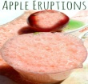 | 7  *COOKING PROJECT*  FRIENDSHIP TRAIL MIX  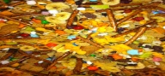 | 8
9 WEEK # 9  PAY IT FORWARD  (CONTINUED)  Get inspired to give back to our community. | 10  BUILDERS & BULLDOZERS  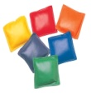 | 11  SPECIAL VISIT OF A  COMMUNITY HELPER | 12 WATER PLAY  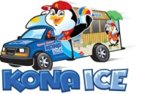 | 13  SCIENCE FUN  I’M A DENTIST | 14  *COOKING PROJECT*  FRIENDSHIP FRUIT SALAD  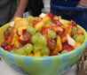 | 15
16 WEEK #10  SUMMER WRAP UP  It’s time to wrap up our super summer! We will end our Passport to Adventure with a celebration of summer | 17  PURPLE BUBBLE BLOWING  Wear purple day | 18  *COOKING ACTIVITY*  GRAPE SMOOTHIES  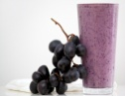 | 19  END-OF-SUMMER BASH  (t.b.d.) | 20  RAINBOW SPAGHETTI PAINTING  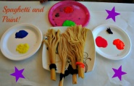 | 21  PROFESSIONAL DEVELOPMENT DAY | 22
23 | 24  FIRST DAY OF SCHOOL | 25 | 26 | 27 | 28 | 29
30 | 31 | Notes:  On Water play days, please bring your child in his/her swimsuit, a cover-up and water shoes. Sunscreen and insect repellent should be applied at home.  **Some activities may be canceled due to inclement weather**

