 | SUMMER CAMP ~ July 2015
Sun | Mon | Tue | Wed | Thu | Fri | Sat
 |  |  | 1  ROAD TRIP CAR WASH  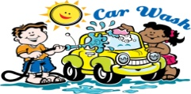 | 2  CALIFORNIA  GRAPE VALLEY | 3  SCHOOL IS CLOSED  in observance of July 4th | 4
5  WEEK # 5  SUMMER SUPER HERO  Our awesome super hero campers will strengthen their super powers through group activities | 6  Dress as a Super Hero  ENJOY A LASER MAZE | 7  SCIENCE EXPERIMENT  Super Hero Bubbles | 8 WATER PLAY  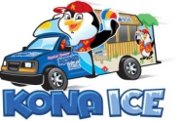 | 9  Dress as a Super Hero  PHOTO OPS | 10  *COOKING ACTIVITY*  HIGH FLYING  FRUIT FLOATS | 11
12  WEEK # 6  RAINFOREST  Let’s pack our bags and head out on a mysterious journey through the rainforest | 13  Rainforest  Animal Yoga  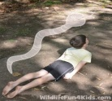 | 14  Parrot Parade  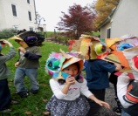 | 15 WATER PLAY | 16  RAINFOREST  In-house speaker & show  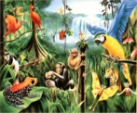 | 17  *COOKING ACTIVITY*  ALLIGATOR PIES  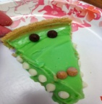 | 18
19  WEEK # 7  NATURE EXPLORERS  Campers will be encouraged to use their five senses as they explore our local environment | 20  YOGA IN THE YARD | 21  RECYCLING RELAY  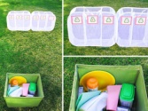 | 22  WATER PLAY  CREEPY CRAWLERS  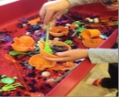 | 23  SCIENCE FUN  Dancing raisins  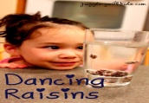 | 24  *COOKING ACTIVITY*  CATERPILLAR SKEWERS  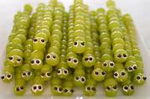 | 25
26  WEEK # 8  JR. OLYMPICS  Campers will develop their gross motor & team building skills by joining us in a fun-filled week | 27  OPENING CEREMONY | 28  FLOOR ROUTINE | 29  WATER PLAY  OBSTACLE COURSE  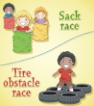 | 30  TUMBLING GYM | 31  MEDAL CEREMONY | Notes:  **Some activities may be canceled due to inclement weather**

