**October**

**News**

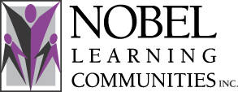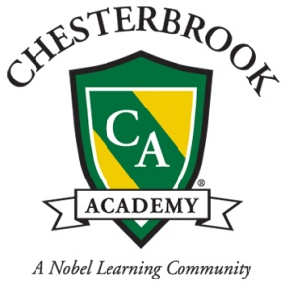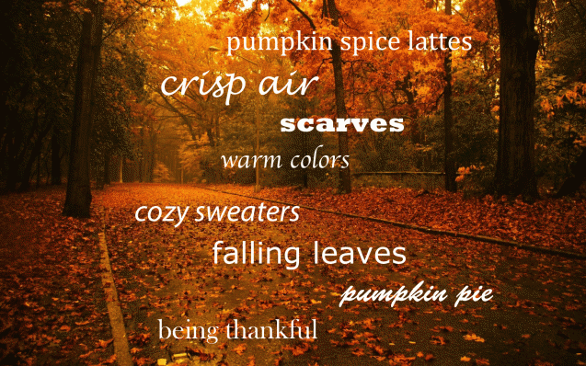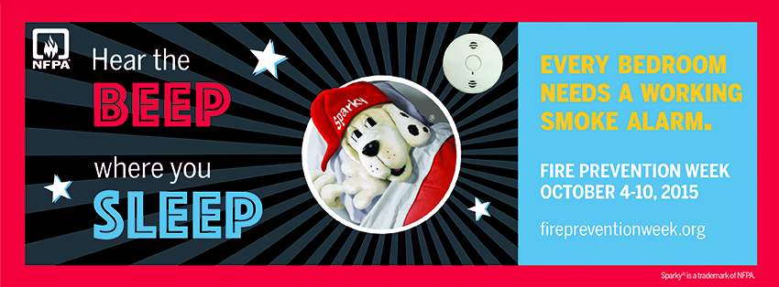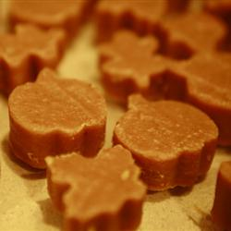

# NLCI Principal Conference

Every October, Nobel Learning Communities, Inc., holds a principal’s conference. The principal, Regina Miller, will be out of the office from Monday, October 19th through Friday, October 23rd. During this week, I will not be able to have much access to email, but will respond to all emails and questions as soon as I return.

In lieu of our back-to-school night that had to be rescheduled, we are hosting a morning for our families to join your student in their classroom. During your class’ scheduled time, your child will show you what they have been working on in the classroom so far, observe and participate in a classroom activity, and have the opportunity to ask your child’s teacher questions and learn about our curriculum throughout the rest of the year. We understand that the timing may not work for every family, so we are also offering you the opportunity to schedule an in-person or phone conference with your child’s teacher. If you are unable to make it to the parent day and would like this opportunity instead, please email Regina Miller at [regina.miller@nlcinc.com](mailto:regina.miller@nlcinc.com) or Jenn Kume at [jenn.kume@nlcinc.com](mailto:jenn.kume@nlcinc.com) to schedule a time for you.

Infants & Toddlers: Monday, October 12th from 9:30am-10:30am

Beginners & Intermediates: Tuesday, October 13th from 9:30am-10:30am

Pre-K: Thursday, October 15th from 9:30am-10:30pm

# Parent’s Morning

# Columbus Day- We’re Open!

Although public schools are closed, we will remain open on Columbus Day and have drop-in care available for school age students (sign up available on classroom door).

Parent’s Morning

Open- Columbus Day

NLCI Principal Conference

Fire Prevention Week

Fall Festival

Recipe of the Month

Looking Forward

October 1st, 2015

Summary:

October 12:

*PWC Student Holiday: Drop in available

October 23:

Fall Festival 6:30PM-8:30PM

October 30:

Fall Costume Parade & Parties

November 2-3:

*PWC Student Holiday: Drop in available

November 11-Veterans Day:

(Wednesday): We will be **closed** for our annual professional development day.

November 26:

Closed for Thanksgiving

November 27:

Limited hours- sign up on doors the week prior

Throughout the week, students will learn about fire safety and prevention, and complete activities with Sparky the dog. The Nokesville Fire Department will stop by for a visit!

## Looking Forward

Enjoy *Face Painting

*Hotdogs, Cotton Candy, Popcorn, and Fried Oreos!!

*Super Fun Carnival Games

*Corn hole and Bean Bag Toss

*Prizes & Raffles!

*Mad Scientist Room!

Starting on Monday, October 19th and throughout the week, families are asked to participate in our pumpkin carving/decorating contest. Write your family name on the *bottom* of the pumpkin and 1st, 2nd, and 3rd place winners will be announced at the Fall Festival.

Friday, October 23rd 6:30 PM-8:30 PM

Fall Festival

# Fire Prevention Week: October 5-9th

**Recipe of the Month**

**Pumpkin Fudge**

*Courtesy of allrecipes.com*

**Ingredients**

*makes 1 9x9 inch pan*

2 tablespoons butter

2 1/2 cups white sugar

2/3 cup evaporated milk

1 cup white chocolate chips

7 ounces marshmallow creme

3/4 cup canned pumpkin

1 teaspoon ground cinnamon

1 teaspoon vanilla extract

### Directions

1. Line a 9x9 inch pan with aluminum foil, and set aside.

2. In a 3 quart saucepan, heat milk and sugar over medium heat. Bring to a boil, stirring occasionally with a wooden spoon.

3. Mix in pumpkin puree and cinnamon; bring back to a boil. Stir in marshmallow creme and butter. Bring to a rolling boil. Cook, stirring occasionally, for 18 minutes.

4. Remove from heat, and add white chocolate chips and vanilla. Stir until creamy and all chips are melted. Pour into prepared pan. Cool, remove from pan, and cut into squares. Store in a cool, dry place.