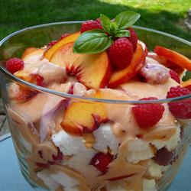

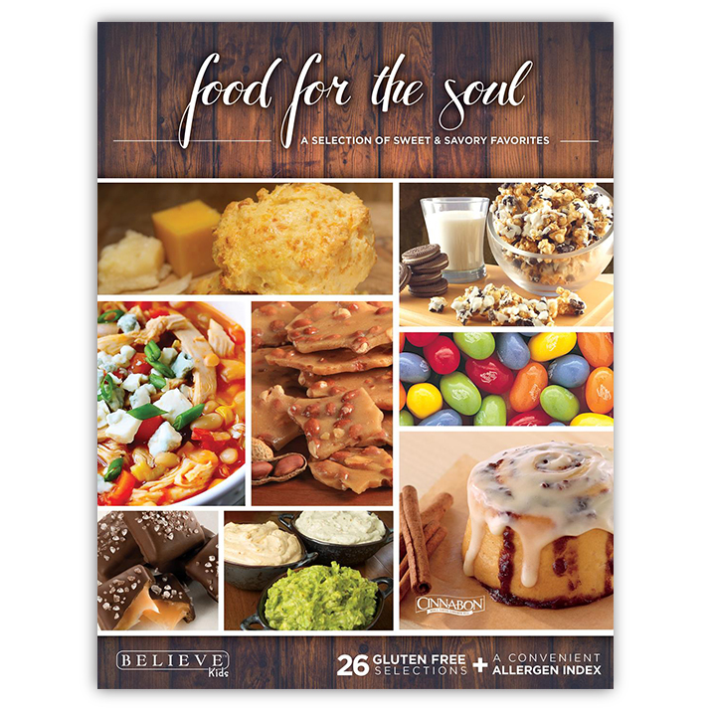

Our Food for the Soul Fundraiser is here! It is perfect for the upcoming fall season! Everything is online, which means you can view all of the products available online from the comfort of your own phone or tablet! There are many partnerships with this fundraiser that support small business owners as well as local business owners. You can get everything from magazines to chocolates! Take a few minutes to check out everything that is available! All orders are due by Friday, Sept. 11th and

will be delivered the week of Oct. 10th.

# Believe Kids

# Back-to-School Night

Please note that our Back-to-School night that was originally scheduled for September will have to be rescheduled for a later date. Since it is still so early in the year and our teachers are getting their classes situated, a later date will help to show you what our students are working on in their new classes. As soon as a new date is chosen, we will let you know. Thank you for your understanding.

# CLOSED for Labor Day

Monday, September 7th

Enjoy your long weekend!

Closed for Labor Day

Back-to-School Night: Rescheduled

Happy Feet

Believe Kids

Bite Size Chefs

Recipe of the Month

Looking Forward

**September**

**News**

September 1st, 2015

Summary:

September 11th:

Jersey Day

September 25th:

Pajama Day

October 4-10th:

Fire Prevention Week

October 19-23rd:

Principal’s Conference

October 30-

Fall Festival

## Looking Forward

# Bite Size Chefs

Begins September 14th at 9:30 AM

We will be introducing a new class this year! It is called Bite Size Chefs. Classes will be every Tuesday at $10 per class. This class teaches math, measurements, social skills, science, and sensory all in one! If interested, there are signup sheets in the front office. Please fill one out and return it to the front desk.

We are happy to offer our students, ages 2-5, the opportunity to participate in a fun and exciting soccer program this fall. Happy Feet is a soccer program that comes to Chesterbrook Academy every Thursday morning.

**Benefits of Happy Feet include:**

Improvement of Child Fitness, Quicker Skill Acquisition, Tremendous Fun, and a Head Start on Lifelong Self-Confidence & Beliefs. To learn more about Happy Feet, please visit [www.happyfeetsoccer.com](http://www.happyfeetsoccer.com) or stop by the front desk.

A free trial class will be held on *Wednesday, September 16th at9:30am* for all students. If you are interested, registration forms will be available after the demonstration.

# Happy Feet

**Recipe of the Month**

**Fresh Peach Trifle**

*Courtesy of allrecipes.com*

**Ingredients**

*makes 8 servings*

6 large ripe peaches - peeled, pitted and sliced

1 tablespoon fresh lemon juice

2 (8 ounce) containers vanilla yogurt

1 teaspoon lemon zest

1 (10 inch) prepared angel food cake

### Directions

1. Place peaches in a large bowl, and gently toss with lemon juice. Place 1 cup of peaches in a blender, set aside remaining slices, and blend until smooth. Place yogurt into a bowl; stir in the peach puree and lemon zest until well blended.
2. Cut the angel food cake into squares and place half in the bottom of a glass dish. Spoon half of the peach slices over the cake. Cover with half of the yogurt mixture. Place remaining cake squares over the yogurt. Top with peaches, reserving 5 or 6 slices for garnish. Cover with remaining yogurt mixture. Garnish with peach slices. Refrigerate until ready to serve.