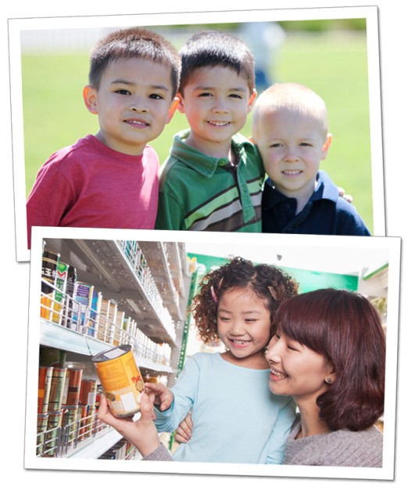
4 Ways to Instill Thankfulness in Young Children
It’s never too early to teach your child about thankfulness. By learning concepts of generosity and compassion, children strengthen their connection to their community and become sensitive to the feelings of others.
The holiday season is quickly approaching, so now is a great time to reinforce the importance of thankfulness and giving back to those in need.
Below are age appropriate activities that we implement in the classroom, as well as activities for you and your child to do at home.
TODDLERS: Be a good role model
In the classroom: Our teachers introduce “please” and “thank you” to our toddlers by using sign language and verbal communication. Students practice good manners with their dolls, stuffed animals and each other.
At home: Modeling positive behaviors is a great way to teach your child good manners. Say “please” before asking him to do something, and always follow with “thank you.”
Recommended reading: Little Critter® I Am Helping by Mercer Mayer
BEGINNERS: Share your gratitude out loud
In the classroom: Our teachers encourage our Beginner students to name a few of their favorite toys and games, and bring one in from home to share with friends. By sharing their belongings, children nurture connections with their classmates, and build necessary problem-solving skills.
At home: Talk with your child about the things in your life for which you are thankful, and ask him to name a few as well. Extend the discussion beyond physical possessions. For instance, if he is thankful for a favorite toy, say “Grandma bought you that toy, and we are thankful for her.”
Recommended reading: Spot Helps Out by Eric Hill
INTERMEDIATES: Show appreciation through actions
In the classroom: By age three, children begin to understand the concept of appreciation. They create birthday cards for their teachers, make art projects for friends, and write thank you cards for classroom visitors.
At home: Go shopping with your child, and buy a small token of appreciation for a friend or family member. Ask your child to draw a picture or write a thank you note to accompany the gift.
Recommended reading: Clifford's Good Deeds by Norman Bridwell
PRE-K/PRE-K2: Give back to those in need
In the classroom: During the holidays, many of our schools host donation drives for organizations in need. Our older preschoolers discuss why they are participating, count the items donated, and sometimes have the opportunity to deliver the donations.
At home: Donate canned goods to a local food pantry, and allow your child to choose the food that he would like to donate. Explain to him that you are thankful to have good food to eat, and that you want to make sure that others have the same.
Recommended reading: The Giving Tree by Shel Silverstein
We provide many opportunities for our preschoolers to develop thankfulness and show gratitude towards others. By setting this positive foundation, your child will be more appreciative and generous as he enters elementary school and beyond.
- Lauren Starnes, PhD – Director of Early Childhood Education

