November is here, the children are enjoying the crisp autumn air, and the holidays are approaching!

The following events are coming up:

~ Chesterbrook will be closed on Veterans Day, Wednesday, November 11th.

~ Thanksgiving Luncheon is coming up on Friday, November 20th at 11:30 am.

~ Chesterbrook will be closed for Thanksgiving on Thursday, November 26th and Friday, November 27th.



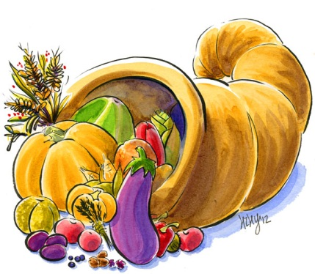

***Happy birthday to all of our November birthdays!!!***



Be sure to check your email for information about upcoming events!

**“Gratitude helps us to see what is there instead of what isn’t.”**