The school year is off to a great start! As we enter into the fall season and the month of October, we have some exciting events coming up!

On Friday, October 9th, you are invited to come join us at our St. Jude’s Fall Festival, where you can enjoy food, rides, and games. All of the proceeds will go to St. Jude’s Children’s Research Hospital.

We will have our annual Trunk or Treat on Friday, October 30th, a fun event to celebrate Halloween!

We are looking forward to the fun month ahead!

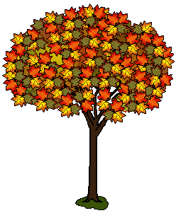

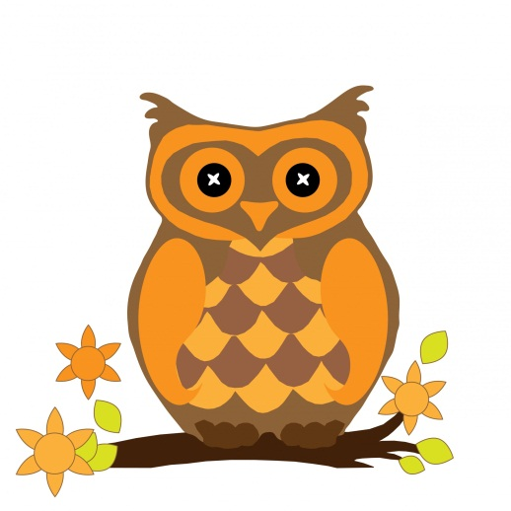

***Happy birthday to all of our October birthdays!!!***



Be sure to check your email for information about upcoming events!

**“Autumn is a second spring, when every leaf is a flower.”**

* **Albert Camus**