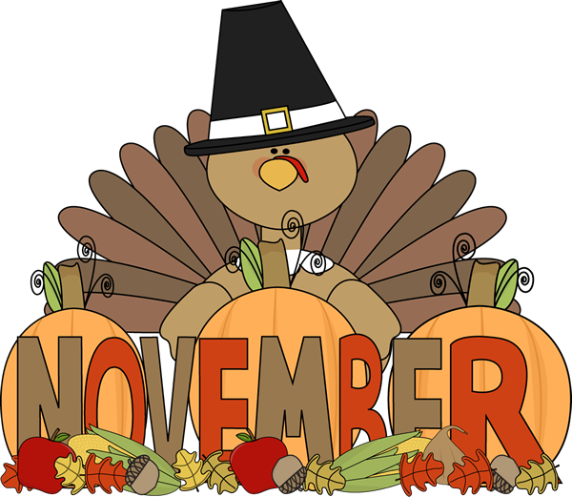

The children enjoyed our Fall Festival on October 30th. Thank you to everyone who donated candy to make it all happen! The winners of the door decorating contest were the Infant Room teachers Nancy Goode and Jennifer Montgomery. The theme for the winning door was “I want my Mummy” and it was adorable ! All of the children were so cute in costume for the parade. I have never felt so safe with the many superheroes walking around in our building! We will send pictures via Parent Share to your email or Iphones this week for you to enjoy!

Reminder: We will be closed three days this month-
Wednesday, November 11 in observance of Veteran’s day. Our teachers and staff will all be working that day on professional development training, however we will not be open to students that day.
We will also be closed Thursday 26th and Friday November 27th in observance of Thanksgiving.
Please mark your calendar for the Chesterbrook Academy annual Thanksgiving lunch held at our school the week before the holiday. It is a traditional meal with all the side dishes made by our wonderful cook, Mrs. Cheryl. You will need to make reservations at the school front desk if planning to attend. I look forward to this event each year!
Important dates to remember!!
November 7th………………..Open House 10:00 – 1:00
November 11th……………….. Staff Professional Development Day / CBA Closed
November 26th …………..Thanksgiving Holiday / CBA Closed
November 27th ……………………….Thanksgiving Holiday / CBA Closed

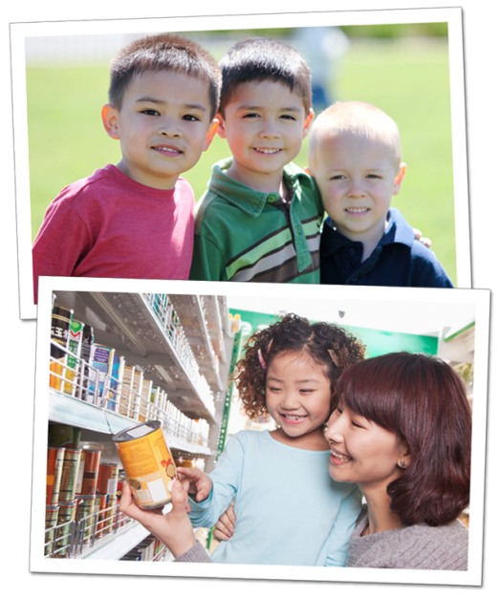
4 Ways to Instill Thankfulness in Young Children
It’s never too early to teach your child about thankfulness. By learning concepts of generosity and compassion, children strengthen their connection to their community and become sensitive to the feelings of others.
The holiday season is quickly approaching, so now is a great time to reinforce the importance of thankfulness and giving back to those in need.
Below are age appropriate activities that we implement in the classroom, as well as activities for you and your child to do at home.
TODDLERS: Be a good role model
In the classroom: Our teachers introduce “please” and “thank you” to our toddlers by using sign language and verbal communication. Students practice good manners with their dolls, stuffed animals and each other.
At home: Modeling positive behaviors is a great way to teach your child good manners. Say “please” before asking him to do something, and always follow with “thank you.”
Recommended reading: Little Critter® I Am Helping by Mercer Mayer
BEGINNERS: Share your gratitude out loud
In the classroom: Our teachers encourage our Beginner students to name a few of their favorite toys and games, and bring one in from home to share with friends. By sharing their belongings, children nurture connections with their classmates, and build necessary problem-solving skills.
At home: Talk with your child about the things in your life for which you are thankful, and ask him to name a few as well. Extend the discussion beyond physical possessions. For instance, if he is thankful for a favorite toy, say “Grandma bought you that toy, and we are thankful for her.”
Recommended reading: Spot Helps Out by Eric Hill
INTERMEDIATES: Show appreciation through actions
In the classroom: By age three, children begin to understand the concept of appreciation. They create birthday cards for their teachers, make art projects for friends, and write thank you cards for classroom visitors.
At home: Go shopping with your child, and buy a small token of appreciation for a friend or family member. Ask your child to draw a picture or write a thank you note to accompany the gift.
Recommended reading: Clifford's Good Deeds by Norman Bridwell
PRE-K/PRE-K2: Give back to those in need
In the classroom: During the holidays, many of our schools host donation drives for organizations in need. Our older preschoolers discuss why they are participating, count the items donated, and sometimes have the opportunity to deliver the donations.
At home: Donate canned goods to a local food pantry, and allow your child to choose the food that he would like to donate. Explain to him that you are thankful to have good food to eat, and that you want to make sure that others have the same.
Recommended reading: The Giving Tree by Shel Silverstein
We provide many opportunities for our preschoolers to develop thankfulness and show gratitude towards others. By setting this positive foundation, your child will be more appreciative and generous as he enters elementary school and beyond.
- Lauren Starnes, PhD – Director of Early Childhood Education

