Dear Chesterbrook Families,
During this holiday season, I would like to encourage you to give the gift of TIME to your child. Find activities that help establish family tradition such as decorating your tree together, taking a nightime walk around your neighborhood to look at the colorful decorations or even baking cookies which can fill an afternoon with fun. Remember to read with your child each day.... There is no APP than can replace your LAP! Children want to share their day with you and talk about what they are learning at school, friends, new songs or even something they have accomplished like writing their name for the very first time. The investment of time spent with your child will definitely make an impact on their success in school.
Please see the calendar for a complete list of dates for events and school closings. Also, please be on the lookout for our holiday signup sheets. This helps us staff better for the holidays! We are hoping for the best weather this winter, but please remember to check our website, check our voicemail and look out for emails from us in case of inclement weather.
Please make sure you are checking your child’s folder/cubby each day for important letters, fundraiser information and other things. Let us know if you have questions!From the teachers and staff at Chesterbrook Academy, we wish your family a season filled with the joy of learning!
Happy Holidays,
Sue Balchin Assistant Principal
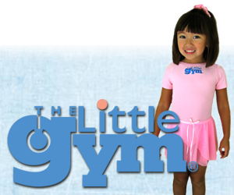

Join our new dance class beginning Thursday, December 10th sponsored by The Little Gym. The class will include tap, creative movement and ballet. It is offered on Thursdays at 3:30pm. Please stop by the front desk for more information and to register.

December 18th …………..Holiday parties at school
Dec 18th – Dec 31st……..Holiday Gap Camp for Afterschool class
December 24th…………...Christmas Eve / Early Dismissal
December 25th …………. School closed for Christmas Holiday
December 31st….. End of Month folders go home
January 1st……………… School closed for New Year’s Day

Kids in the Kitchen: Learning Through Cooking
When you think back to memories of your childhood, you may remember a time when you helped a relative prepare a meal or bake a batch of cookies. You may recall feelings of warmth, closeness, and the joy of working together to create something tasty to eat. Perhaps you have even created this type of memory with your own child. Not only is cooking with your child a wonderful bonding opportunity, many things can be learned through experiences with food.
Children learn by touching, tasting, seeing, feeling, and listening. Cooking activities are ideal for children because all their senses are stimulated. When a child’s senses are engaged as they are during cooking experiences, learning becomes meaningful and memorable. Through experiences with food, children as young as three years old can successfully learn the concept of eating a variety of foods from each of the five food groups.
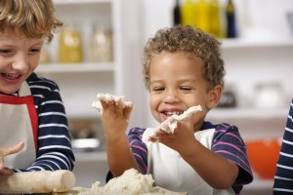Beginning around age four, a child starts to develop his or her adult food preferences, including preferences for familiar foods. Introducing new foods during the early years helps to expand the number and variety of foods children are more likely to eat during their school-age, teenage, and adult years. Positive interactions with food are fundamental in helping children recognize and accept a wide variety of foods.
In addition to nutrition awareness and food-related behaviors, children learn food safety, food history, and new vocabulary during cooking experiences. Children also have opportunities to strengthen and develop fine- and gross-motor skills as they participate in cooking tasks like stirring, kneading, and pouring through cooking experiences. The step-by-step nature of following a recipe helps build children’s comprehension and reasoning skills. Children practice patience, follow directions, enhance their creativity, and build self-confidence.

Cooking experiences also build children’s knowledge and skills in science, math, reading, and communication. Cooking can be thought of as science experiments that children can eat. When cooking, children have the opportunity to observe changes in food ingredients. They learn about temperature (hot and cold), floating, sinking, dissolving, melting, and freezing. During cooking experiences, children learn math skills such as counting, measuring, and following directions. Simple concepts about quantity are learned, and conversations about color, texture, shape, and sizes frequently occur. Cooking also involves reading and communicating. Children’s vocabulary is enriched as they learn new terms in recipes, such as stir, blend, slice, shred, and freeze.
Food nourishes our bodies, provides comfort, and can symbolize love and security. When children help in the preparation of a meal, they feel they are making an important contribution to the adult world. This fills them with a sense of pride, personal satisfaction, and self-confidence. When a child is introduced to cooking and encouraged to participate in the preparation of a meal, we are telling him or her, “You are a big help,” “You can do this,” and “You are important.”

Exploring Holiday Traditions from Around the World
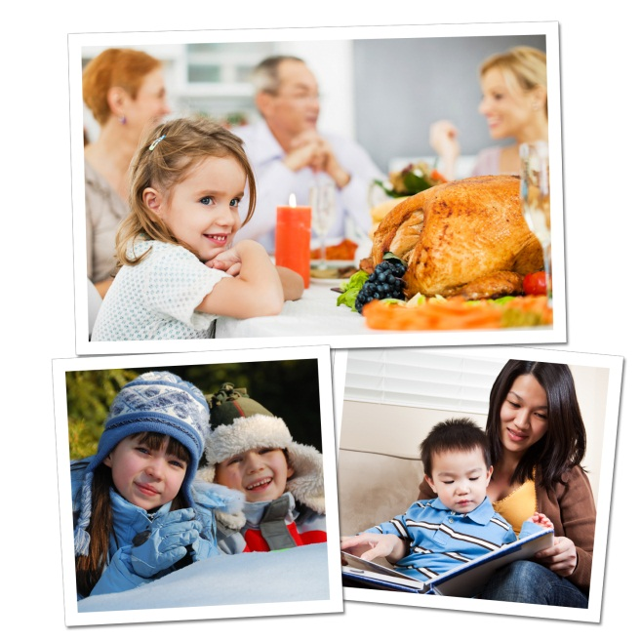
The holiday season is here, providing a wealth of opportunities to enrich the children’s understanding of diverse cultures and traditions around the world. In addition, our students will share their own traditions with others.
Below are age appropriate activities that we use in the classroom, as well as activities for you and your child to do at home.
BEGINNERS (ages 2-3):
In the classroom: As they near the age of two, children begin to recognize the sights and sounds of holidays celebrated by their family. Parents visit our classrooms to share holiday traditions, including unique books, songs and activities.
At home: Gather family photos and point out traditions, such as unwrapping presents, eating holiday dinner at grandma’s house, and making a snowman. Encourage your child to talk about what he sees in the photos.
Recommended reading: Children Around the World Celebrate Christmas by Christine Tangvald, Happy Hanukkah, Corduroy by Don Freeman, My First Kwanzaa by Karen Katz
INTERMEDIATES (ages 3-4):
In the classroom: Children sing holiday songs from around the world and are introduced to holiday symbols that they may see in their communities, such as Christmas trees or Hanukkah menorahs.
At home: Take a drive with your child or bring him to various holiday festivals in your community. Encourage him to look for and identify holiday decorations.
Recommended reading: Christmas Around the World by Calliope Glass, Hanukkah Hop by Erica Silverman, Li’l Rabbit’s Kwanzaa by Donna Washington
PRE-K/PRE-K2 (ages 4-5)
In the classroom: After learning about holiday traditions around the world, our older preschoolers identify countries on a globe. For example, they might learn about Diwali, the festival of lights, and then find India on the globe. They might make tamales, a dish often served on Christmas, and then find Mexico on the globe.
At home: Ask your child to help you prepare your family’s favorite holiday foods. Talk about the long-standing traditions in which these foods are rooted. For instance, you might explain, “I used to bake cookies for the holidays with my mom. Now we can start baking cookies together!”
Recommended reading: Children Just Like Me: Celebrations by Anabel Kindersley, Light the Lights: A Story about Celebrating Hanukkah and Christmas by Margaret Moorman, The Story of Kwanzaa by Mary Washington
Exposing children to various holiday traditions helps them build strong social skills, establish a sense of self, and respect the differences of others as they transition into elementary school and beyond.
- Lauren Starnes, PhD – Director of Early Childhood Education

-

