Linking Learning with Nature
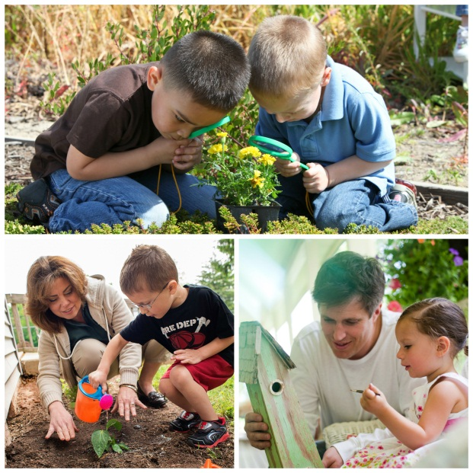
Spring is here! Flowers are blooming, days are getting longer and the weather is getting warmer. Now is a great time for children to explore these environmental changes happening in the world around them.
Not only are children curious about nature, but research shows that it has a profound influence on their problem solving skills, creativity, imagination and cognitive ability. Because of this, our teachers incorporate nature in all aspects of our Links to Learning curriculum.
Below are ways we connect learning with nature, as well as activities you can do with your child at home.
INFANTS/TODDLERS:
In the classroom: After reading a book about springtime, teachers bring children outdoors to explore and investigate objects in nature. The children have fun crumbling leaves, smelling flowers and looking at clouds.
At home: Take tummy time outdoors and allow your infant to explore different sights, sounds and textures. Encourage him to move and grab things by placing objects just beyond his reach. For toddlers, ask questions like, “Who made that chirping sound” or “Can you point to the flowers?”
Recommended reading: Wake Up! Wake Up! A Springtime Lift-the-Flap Book by Kathryn Davis, Welcome Spring by Little Scholastic
BEGINNERS (ages 2-3):
In the classroom: Our Beginners read books about seasonal changes, then bring the story to life by going outdoors to find real-world examples.
At home: Help make your child aware of the seasonal changes going on around him. Talk a walk with him and ask questions such as “Why do we see flowers growing now?” or “What do flowers need in order to grow?” Encourage him to use his creativity when answering.
Recommended reading: Over in the Meadow by Olive Wadsworth, Mouse’s First Spring by Lauren Thompson
INTERMEDIATES (ages 3-4):
In the classroom: Students plant seeds in their school garden and learn about the importance of caring for them. Through this activity, they practice math skills such as measuring, sorting, counting and making predictions.
At home: Set up a bird feeder outside a window that your child can easily see. Let him help you fill it with birdfeed. As the birds come to eat, ask your child to talk about them. “What color are they?” “Are they big or small?” “What are they doing?”
Recommended reading: Little Seed by Eric Carle, Planting a Rainbow by Lois Ehlert
PRE-K/PRE-K 2 (ages 4-5):
In the classroom: Pre-K and Pre-K 2 students explore the sounds they hear in nature while playing outdoors. They then use recycled and natural materials, such as string and pine cones, to make their own wind chime.
At home: Reuse junk mail for a fun arts and crafts activity with your child. Encourage him to look through flyers and magazines to find words and pictures that he recognizes. Then, ask him to create a collage by cutting and gluing them to a piece of paper or poster board.
Recommended reading: And Then It’s Spring by Julie Fogliano, About Springtime, Not a Box by Antoinette Portis
We provide many opportunities for our preschoolers to think creatively and imaginatively about the world around them. By setting this foundation, children build confidence in their own unique thoughts and maintain a thirst for learning as they enter elementary school and beyond.
- Lauren Starnes, PhD – Director of Early Childhood Education

