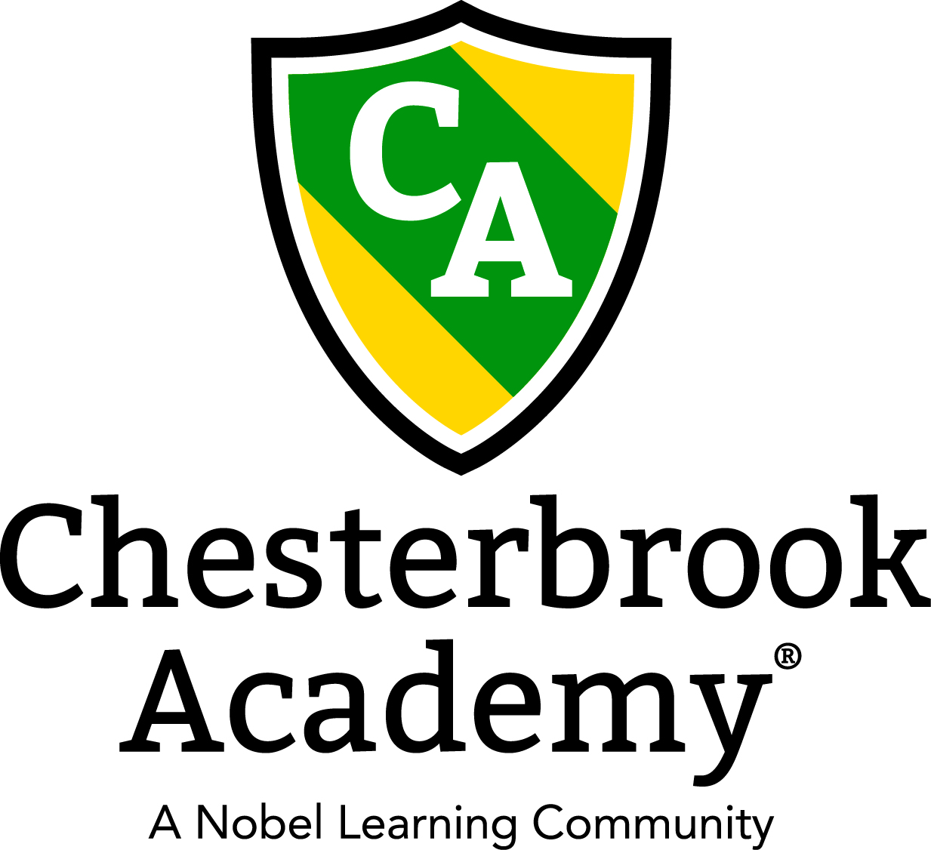

Chesterbrook Academy - Preston

February 2017 Newsletter

From the Principal's Desk
Happy February to you all. It's going to be a great month here at Chesterbrook. My teachers have shared their education calendars for February and it looks like a lot of educational fun! Make sure you check out the teacher's education boards and see all the good stuff that is happening!
My version of the State of Union is going on this month. I am in the process of working my way around the school and meeting with the teachers to discuss classroom performance and classroom needs. All classrooms are being assessed and renovations or are ramping up again. We have some fun changes going on that we are very excited about! I always appreciate our company reinvesting in our school I always want to have our school top notch and it’s great to have the support to do so!
Special Welcome to our new families who have joined our school. We have had quite a few as the word of our excellence is getting out! Please remember to tell me if you refer a family so you earn your referral credit!
Just a quick reminder that we will be closed on Monday, February 20th for Professional Development Day! Thank you very much for making alternative arrangements for your child on that day! It means a lot to me and the teachers to be able to have this opportunity to learn how to better our skills.
Hope you all have a great month!
Tawni S. Connor, Principal

In this Issue
- Important Dates for February
- Center Wide Pajama Day in support of the Leukemia and Lymphoma Society!
- Parent Survey
- Second Quarter Parent Reports
- Operation Snowflake

Important Dates in February
- February 1 – Tuition’s Due
- February 6 – Happy Birthday Miss Danielle!
- February 8 – Happy Anniversary Miss Erika!
- February 14 – Happy Valentine’s Day! Check with your child’s teacher to get party information.
- February 15 – Happy Birthday Miss Debbie!
- February 17– Pajama Day in support of Leukemia and Lymphoma Society! Have your child wear their PJ’s and make a donation to the LLS!
- February 20 – School’s Closed Professional Development Day
- February 28 – Second Quarter Parent Reports Go home!
- February 28 – LTL Folders go home!
- Every Tuesday – Soccer Shots!
- Every Wednesday - Gymnastics Class!
- Every Wednesday – Dance Class!
- Every Thursday – Amazing Athletes!
Pajama Day in Support of the Leukemia and Lymphoma Society!
On Friday, February 17th we will host a center wide Pajama Day in support of the Leukemia and Lymphoma Society. Forms will be coming home if you would like your child to participate in this important cause. All donations raised will go directly to the L & L Society. All you need to do is send your child to school wearing their PJ’s! Please email me if you have any questions!

Parent Surveys!
I just wanted to say thank you to everyone for participating in our Parent Survey. The teachers and I are really striving to make this the best Preschool in Cary! Thank you for noticing our efforts. I appreciate your suggestions and will be sending out a detailed separate email letting you know how I will address your suggestions!

Second Quarter Parent Reports
Time sure is flying! Our Second Quarter Parent Reports will go home on Tuesday, February 28th! We do not have conferences required at this time but you are more than welcome to schedule one with your child’s teacher. Please email me as soon as possible if you are interested in scheduling a parent conference.

Operation Snowflake
In the event of severe weather, we will make every effort to open on schedule and to remain open during the course of our regular hours of operation. In the event that severe weather requires us to close our school, delay our school or close early, parents will be notified initially by Links to Home email. Please make sure we have your most current email address and that you have added us to your address book so our message does not go to spam. Parents may also call the school's voicemail at 919-319-9400 and listen to the prerecorded message by 6 a.m. for information regarding the operating hours. Information will also be posted to the school's website which is http://www.preston.chesterbrookacademy.com You can also tune in to _WRAL_ for closing information. Remember that we DO NOT follow Wake County’s school closing schedule.

