Due to popular demand, this year our uniform includes an approved Chesterbrook hoodie. This is to be worn in conjunction with the school uniform in lieu of any other type or brand/label (e.g. Nike, Gap, Aeropostale etc).

Order yours today for only $35

[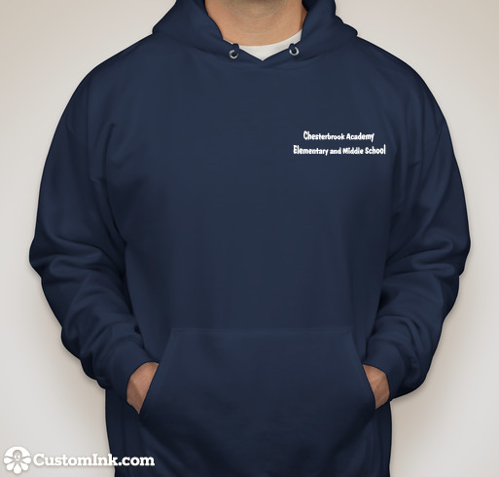](http://www.customink.com/lab?cid=ybv0-00a5-fexd)

Write the quantity next to the size selected:

____Youth Small ____Youth Medium ____Youth Large ____Youth XL

____Adult Small ____Adult Medium ____Adult Large ____Adult XL