sensational september
September was SENSATIONAL! We spent the month making new friends, reviewing old skills and learning new ones. Our teachers spent the first few weeks assessing their students in order to better personalize each student's learning experience. When I am in the classrooms I see our students challenged and thriving. They are engaged, eager, and excited to learn.

My thanks to our students, staff, and families for making me feel welcome and collaborating for a smooth transition into the 2019-2020 school year.

I wish you all an Outrageous October.

Lydia

september cheetah chat notes
On the 24th I held our first Cheetah Chat. I had 4 parents attend and I shared with them what I had been focusing on my first 90 days as principal:

- Completing and Opening Modular
- Facility Repairs
- Hired new cleaning company who also comes mid-day to service restrooms and take out garbage
- All classrooms painted
- Ordered curriculum and resources for teachers and classrooms
- General Policies & Procedures for students, staff, and parents
- Establishing consistent communication between school and home
- Getting to know my students and their families

Parents shared that some people are still trying to enter the parking lot from Cary Parkway vs Waldo Rood, especially in the morning. To ameliorate this, we did place a staff member at the entrance two mornings this week to remind parents not to enter our school via Cary Parkway.

I shared that the communication from Special's teachers will be sent by me at the end of each month. These communications will advise families what was covered that month, what is coming up next month, and some resources for students and parents.

Parents asked about structure of After School care and having children in the hallways after going to restroom. At a scheduled After School Care Staff Meeting Thursday, I asked that the staff begin using walkie talkies so they can communicate with Ms. Bolden when a child comes in from outside to use the bathroom. She will then make sure that they return outside right away. After Care staff will begin planning indoor activities as soon the students will not be able to spend all afternoon outside. In order to communicate with families participating in after school care, effective October 31st, a monthly communication will go home letting families know what activities students engaged in during after care.

Our next Cheetah Chat is scheduled for October 30th at 8:30 am and the topic will be adding Middle School for the 2020-2021 school year!

cheetah fierce
In This School We Will be Stronger, Braver, Kinder and UNSTOPPABLE. In This School We Will Be...CHEETAH FIERCE.

An addition to our curriculum this year is SEL (Social Emotional Learning). I held off on introducing it earlier, as I wanted to make sure that we had a strong foundation of student readiness-students are happy, feel safe, and engaged in school.

Research has shown that increasingly, schools need to include new plans and resources to address our students’ social, emotional, and health needs and the impact on their learning and in our classrooms. Now we are clearly defining the competencies and connecting the pieces in order to have a comprehensive, cohesive program with common school goals and language that goes beyond the typical one-layer program and includes character education, social and emotional learning, health, and even outlets in design thinking and service learning. These multiple components connect naturally and when put together, result in a robust, whole child program designed to develop happy, healthy learners.

Through the CHEETAH FIERCE platform, all students will be developing the FIERCE competencies and skillsets through:

• Weekly lessons centered around a FIERCE Focus (learning skills), FIERCE Feelings (feelings & emotions), and FIERCE Actions (problem-solving, serving others)

• Design thinking projects that build in complexity each year and combine health, SEL, FIERCE, and FLE knowledge and understandings

At the end of each month, each staff member will have the opportunity to recognize a student who has exhibited qualities of being Cheetah Fierce-kind, brave, strong, respectful, responsible, etc.

I am really excited about bringing this to our school and I firmly believe it will support our students in becoming better thinkers, more self-aware, kinder citizens, and healthy happy children.
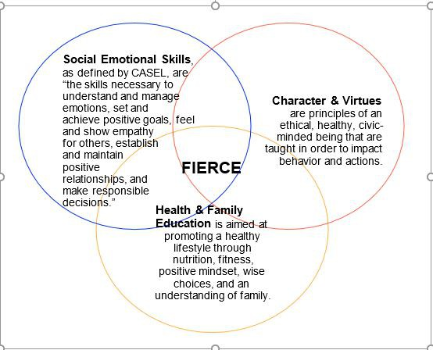

odyssey of the mind
An general informational meeting was held on Friday, September 27th for all families interested in having their child(ren) participate in the program. Thanks to Ashley Galloway for coordinating the meetings and sharing all her knowledge about the program. There was a nice turnout and we are excited to expand the program this year. I will keep you posted on OM@CBA as the year continues.

pto pizza day
Yesterday was the PTO's inaugural debut of PTO PIZZA DAY. Many thanks to the PTO for sponsoring this great program for our students. Thanks to Scott Ellis whom we now affectionately refer to as the PTO PIZZA PRINCE for coordinating this program with Buffalo Brothers Pizza & Wing Company off Kildaire Farm Road and delivering the pizzas!

Please note: If you did not sign up your child for this program and pay the $60.00 fee to the PTO, your child must bring lunch from home. There is no other school lunch option. There were a handful of children who did not have lunch yesterday and the PTO graciously gave them pizza. Please get your form and payment in on Monday.

fall picture day
On Tuesday, October 1st we will have a Formal Uniform Day as it will be our Fall Picture Day and these photos are used for our yearbook. Only individual photos will be taken this day.

On October 30th, we will have our second Formal Uniform Day of the month as we will take class photos (also to be used for yearbook) and make up individual photos for children who were absent on the 1st.

Please refer to the 2019-2020 School Uniform Policy below.
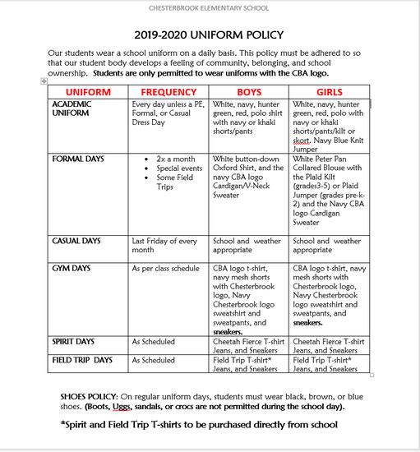

half day on friday, october 11th
Before School care will start at 7:00 am with the school day starting at 8:30 am. The students will be dismissed early today and we will have a staggered dismissal.

11:30: Pre-K-Walk in and pick up child
11:45: K-2nd-Car Pool
12:00: 3rd-5th-Car Pool

For families, siblings will be dismissed during the youngest child's time. For example a pre-k and 2nd grader would both be picked up at 11:30 and a 2nd grader and 5th grader would both be picked up at 11:45

fall festival 2019
One of the most anticipated school year events is right around the corner!

Fall Festival

WHEN: Saturday, October 12th from 11:00 am to 2:00 pm

WHERE: Chesterbrook Elementary School Backyard

WHAT: Games, Attractions, Silent Auction, Bake Sale, Food, and lots of smiles and laughter!

WHY: Enjoy Fall Fun with family, friends, classmates, neighbors, and CBA staff

More details will be sent out leading up to this big event. Make sure to RSVP on the Fall Festival Communication that went out on 9/26/2019

halloween showcase and trunk or treat
We will end October with a Halloween Showcase and Trunk or Treat.

Students will come to school dressed in their uniforms. After lunch they will change into their Halloween costumes.

At 12:45 pm we will hold an assembly during which each class will go up on the stage and sing a Halloween or fall song.

At 1:50 pm, each class will be called to go Trunk or Treating in our parking lot. We will request volunteers to come and deck out their trunks and hand out candy.

At 3:00 pm the event will wrap up and students may leave school or remain for after school care if enrolled.

More details will be sent out later in the month.

principals conference
Each October, Nobel Learning Communities gathers all its principals for a week long training. This year the training will be held the week of October 21st. I will have extremely limited email access, so please contact our Admissions Director, Alicia Shedd in my absence.

october calendar
