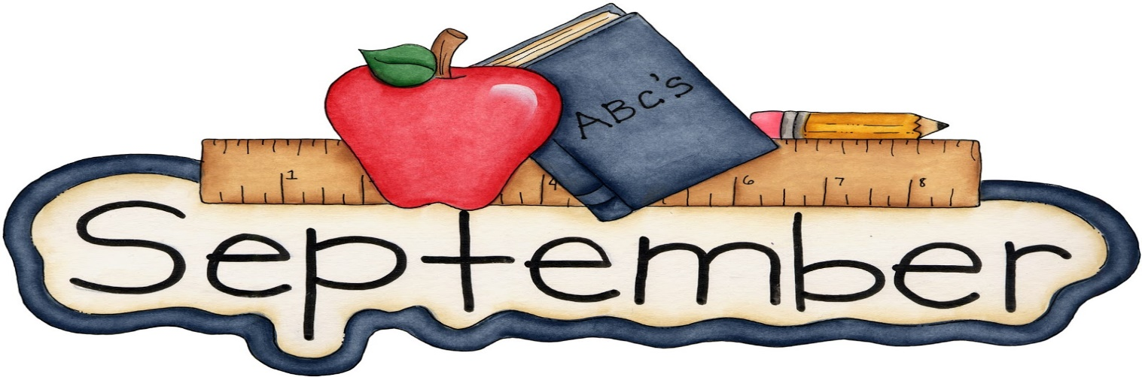

Welcome back to school!
This month at Chesterbrook we will be focusing on welcoming all of our new students into the classroom. The first day of school is August 28th. Thank you to everyone who came to our Back to School night and joined us for Sweet Frog! It was a wonderful event.
Please continue to bring sunscreen and water bottles since the children will still be going outside regularly. Also, as the weather begins to get cooler please remember to switch out your child’s clothes in their cubby. Children should begin to wear their uniforms for the school year.
Chesterbrook will be closed for Labor Day, September 4th.
Do you want a free week of tuition? If you refer a friend who enrolls at our school you will receive a referral week, which means a FREE week! Help us spread the word about our school by referring friends and family.
As a reminder, tuition is due every Friday for the following week. Any payments received after Tuesday at noon will be considered late.
Thank you to all of our families for being here with us, you are greatly appreciated!

Please see below for additional dates to remember.
Dates to Remember:
Sept 1: Random Acts of Kindness Day
Sept 4: CLOSED for Labor Day
Sept 8: Jersey Day, Football season begins
Sept 13: Roald Dahl Day
Sept 22: First Day of Fall
Sept 26: Johnny Appleseed Day
Sept 29: World Heart Day, Wear RED, Heart Healthy Activities

