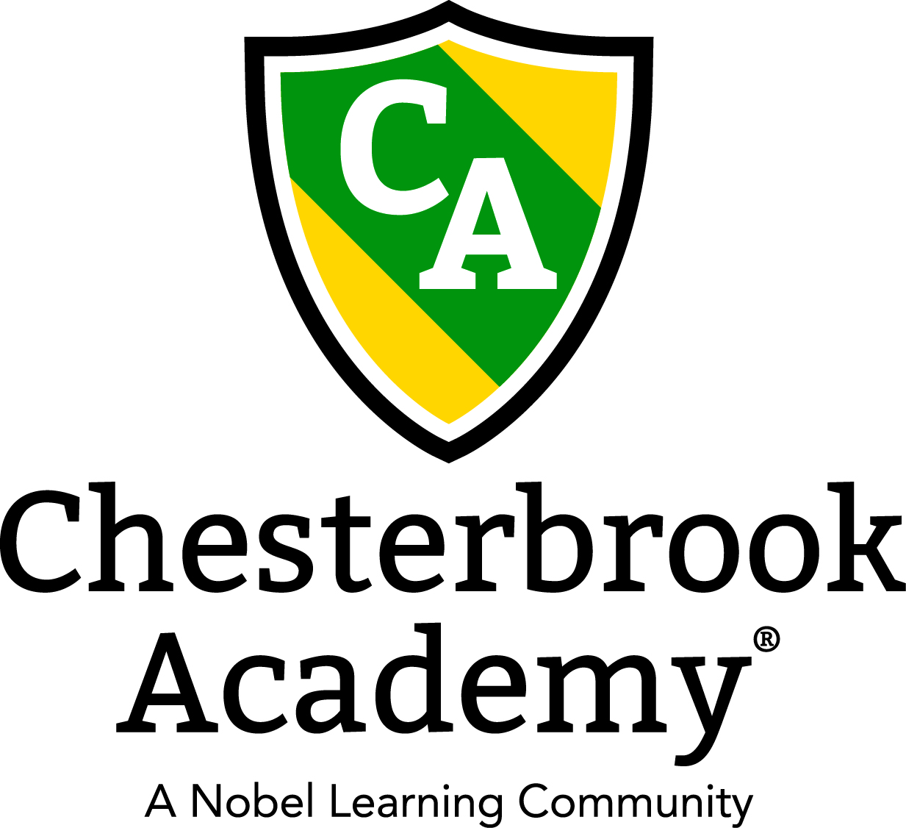

Chesterbrook Academy – Preston October Newsletter

From the Principal's Desk
Happy October Everyone! I have been overjoyed over the past month watching our new students adjust to school life and our current students adjust to their new big boy or big girl classrooms! All of our students are off to a great start of a new school year! I have such a wonderful and talented teaching staff that really put their hearts into their classrooms and it shows! Thank you also for the support that you show them! Your comments, emails, phone calls, and parent reviews on greatschools.org mean so much to us! We truly are a family working together to raise educated, well rounded, beautiful children!
Please join us in welcoming our new families to Chesterbrook Academy! We are so happy to have you all join our school! Have a great month!
Tawni S. Connor, Principal
In this Issue
- Important Dates for October
- CBA Pumpkin Patch Adventure
- Holiday Photos
- Fall Harvest Costume Parade
Important Dates in October
- October 2 - Tuition's Due
- October 3 – Happy Anniversary Miss Lily!
- October 19 – CBA Pumpkin Patch Adventure!
- October 21 – Happy Anniversary Miss Danyelle!
- October 23-27 – Miss Tawni is away at Principal's Conference!
- October 28 – Happy Anniversary Miss Hemali!
- October 27 – LTL Folders Go Home!
- October 29 - Happy Birthday Miss Hemali!
- October 30 – Holiday Photos
- October 31 – Fall Harvest Costume Parade!
- Every Tuesday: Happy Feet Soccer!
- Every Wednesday: Tap and Tumble Dance and Gymnastic Classes!
- Every Thursday: Amazing Athletes!
- Every Friday: Yoga!

CBA Pumpkin Patch Adventure!
On Thursday, October 19th we will hold our Annual CBA Pumpkin Patch Adventure! It will be a fun afternoon for our students filled with pumpkins, crafts, and yummy treats! Mark your calendar and feel free to come by for our event. It will begin at 3:00 pm. Each child will have an opportunity to pick a pumpkin and enjoy a cool sensory experience! We are asking that each parent donate a child sized pumpkin and a few gourds for the event. Please bring the pumpkins and gourds in by Monday, October 16th. Your child will not necessarily receive the exact pumpkin that you bring in, so please do not write their name on it. We put them on the playground and let the kids pick! It’s so much fun! Thank you! Hope to see you there!

Holiday Photos!
On Monday, October 30th LifeTouch Portraits will return to take Holiday Photos. Have your child come in their Holiday Best and with lots of smiles! Photos will be taken and packages will arrive in a few weeks! Just as the fall photos, there is no obligation to purchase. Class photos will also be taken at that time. Remember, if you are part time, you are more than welcome to come in with your child on that day, stay with them, and have their photo taken.

Fall Harvest Costume Parade
On Tuesday, October 31st, we will have our Fall Harvest Costume Parade. Please mark your calendars as you will not want to miss this one! Please arrive before 3:00 to witness our parade of cuteness as our students show off their Halloween costumes! More details will come closer to the event date!!

