October

Child’s Name
_________________________
Classroom
Date | 1 | 2 | 3
Oct 2
Oct 3
Oct 4
Oct 5
Oct 6 **
Oct 9
Oct 10
Oct 11
Oct 12
Oct 13 **
Oct 16
Oct 17
Oct 18
Oct 19
Oct 20 **
Oct 23
Oct 24
Oct 25
Oct 26
Oct 27 **
_________________________

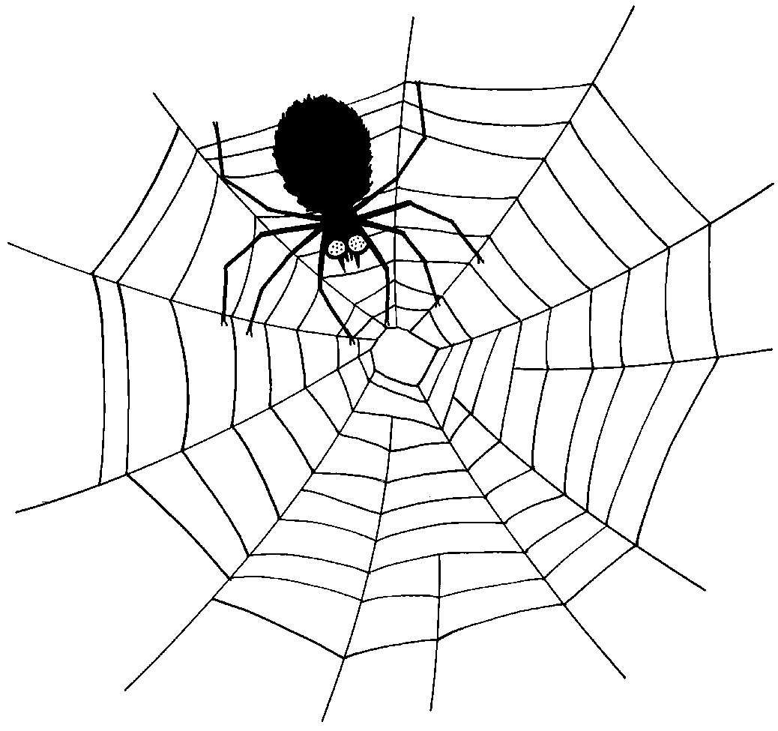
Monday | Tuesday | Wednesday | Thursday | Friday
2  Baked Chicken Nuggets, Roasted Seasonal Veggies, Fresh Fruit  Low Fat Penne Alfredo & Chicken, Roasted Seasonal Veggies, Fresh Fruit  Low Fat Penne Alfredo, Roasted Seasonal Veggies, Fresh Fruit | 3  Breakfast for Lunch-French Toast, Eggs, Fresh Fruit  Pasta w/Turkey Bolognese, Roasted Seasonal Veggies, Fresh Fruit  Pasta w/Olive Oil, Roasted Seasonal Veggies, Fresh Fruit | 4  Picadillo, Baked Plantains, Brown Rice, Fresh Fruit  Grilled Chicken & Cheddar Sandwich, Roasted Seasonal Veggies, Fresh Fruit  Grilled Cheese, Roasted Veggies, Fresh Fruit | 5  Turkey Burger, Baked Tater Tots, Fresh Fruit  Turkey Meatballs, Baked Tater Tots, Fresh Fruit  Mac & Cheese, Roasted Seasonal Veggies, Fresh Fruit | 6  Cuban Style Marinated Chicken Rice (Braised Chicken, Diced Tomatoes, Onions on top of Brown Rice) w/Mango Salsa, Black Beans, Fresh Fruit  Cheese Pizza, Veggies & Dip, Fresh Fruit  Cheese Pizza, Veggie Chips, Fresh Fruit
9  Chicken Cacciatore w/Tomato Sauce over Pasta, Roasted Seasonal Veggies, Fresh Fruit  Baked Chicken Nuggets Roasted Zucchini, Fresh Fruit  Baked Tofu Nuggets, Roasted Zucchini, Fresh Fruit | 10  Lean Beef Tacos, Rice & Beans, Fresh Fruit  Veggie Crumble Tacos, Rice & Beans, Fresh Fruit  Cheese Tortellini w/Tomato Sauce, Roasted Seasonal Veggies, Fresh Fruit | 11  Honey Soy Glazed Chicken w/Veggie Fried Rice, Sautéed Veggies, Fresh Fruit  Honey Soy Glazed Chicken Sandwich, Sautéed Veggies, Fresh Fruit  Grilled Cheese, Roasted Veggies, Fresh Fruit | 12  Lean Beef Burger, Roasted Sweet Peas, Fresh Fruit  Lean Beef Meatballs w/Tomato Sauce, Roasted Sweet Peas, Roll, Fresh Fruit  Mac & Cheese, Roasted Sweet Peas, Fresh Fruit | 13  Buffalo Chicken Hero, Baked Chips, Fresh Fruit  Cheese Pizza, Veggies & Dip, Fresh Fruit  Cheese Pizza, Veggie Chips, Fresh Fruit

- Check off your child’s lunch order for each day.
- Every day you have a choice of Milk, Chocolate Milk, or Water. Please put a M, C, or W in the box for that day.
- Each meal is $4.00. A full Menu for the Month is $80.00
- Order is due no later than Friday, September 22nd.

Meals x $4.00 = __________
Paid by: check # _____or cash

“yummy in my tummy” Organic Caterers.

Monday | Tuesday | Wednesday | Thursday | Friday
16  Pasta alla Rosa w/Chicken, Roasted Seasonal Veggies, Fresh Fruit  Pasta alla Rosa, Roasted Seasonal Veggies, Fresh Fruit  Baked Chicken Nuggets, Roasted Veggies, Fresh Fruit | 17  Lean Beef & Cheese Burrito, Black Beans, Baked Plantains, Fresh Fruit  Cheese Burrito, Black Beans, Baked Plantains, Fresh Fruit  Cheese Tortellini w/Tomato Sauce, Roasted Seasonal Veggies, Fresh Fruit | 18  Baked Chicken Piccata, Roasted Rosemary Potatoes, Fresh Fruit  Grilled Chicken Sandwich, Roasted Rosemary Potatoes, Fresh Fruit  Grilled Cheese, Roasted Rosemary Potatoes, Fresh Fruit | 19  Baked Fish Sticks w/Slaw (on the side), Roasted Potato Wedges, Fresh Fruit  Breaded & Baked Fish Sandwich w/Slaw (on the side), Roasted Potato Wedges, Fresh Fruit  Mac & Cheese, Roasted Veggies, Fresh Fruit | 20  Romesco Lean Beef Sandwich w/Provolone on Cuban Bread, Roasted Seasonal Veggies, Fresh Fruit  Cheese Pizza, Veggies & Dip, Fresh Fruit  Cheese Pizza, Veggie Chips, Fresh Fruit
23  Cheese Ravioli w/Tomato Sauce, Roasted Seasonal Veggies, Fresh Fruit  Baked Chicken Nuggets, Roasted Veggies, Fresh Fruit  Baked Tofu Nuggets, Roasted Veggies, Fresh Fruit | 24  Lighter Butternut Squash Pasta Alfredo w/Chicken, Roasted Veggies, Fresh Fruit  Breakfast for Lunch--Waffles, Eggs, Fresh Fruit  Breakfast for Lunch--Egg & Cheese Muffin, Roasted Potatoes, Fresh Fruit | 25  Ropa Vieja, Baked Plantains, Brown Rice, Fresh Fruit  Lean Beef Sloppy Joe’s, Roasted Seasonal Veggies, Fresh Fruit  Grilled Cheese, Baked Tater Tots, Fresh Fruit | 26  Braised Chicken & Cheese Empanadas, Black Beans, Brown Rice, Fresh Fruit  Cheese & Sautéed Veggie Empanadas, Black Beans, Brown Rice, Fresh Fruit  Mac & Cheese, Roasted Veggies, Fresh Fruit | 27  Reuben on Rye, Roasted Seasonal Veggies, Fresh Fruit  Cheese Pizza, Veggies & Dip, Fresh Fruit  Cheese Pizza, Veggie Chips, Fresh Fruit

