November
Child’s Name
_________________________
Classroom
Date | 1 | 2 | 3
Oct 30
Oct 31
Nov 1
Nov 2
Nov 3 **
Nov 6
Nov 7
Nov 8
Nov 9
Nov 10 ** | CL | OS | ED
Nov 13
Nov 14
Nov 15
Nov 16
Nov 17 **
Nov 20
Nov 21 |  | FEA | ST
Nov 22
Nov 23 | CL | OS | ED
Nov 24 ** | CL | OS | ED
Nov 27
Nov 28
Nov 29
Nov 30
Dec 1 **
_________________________

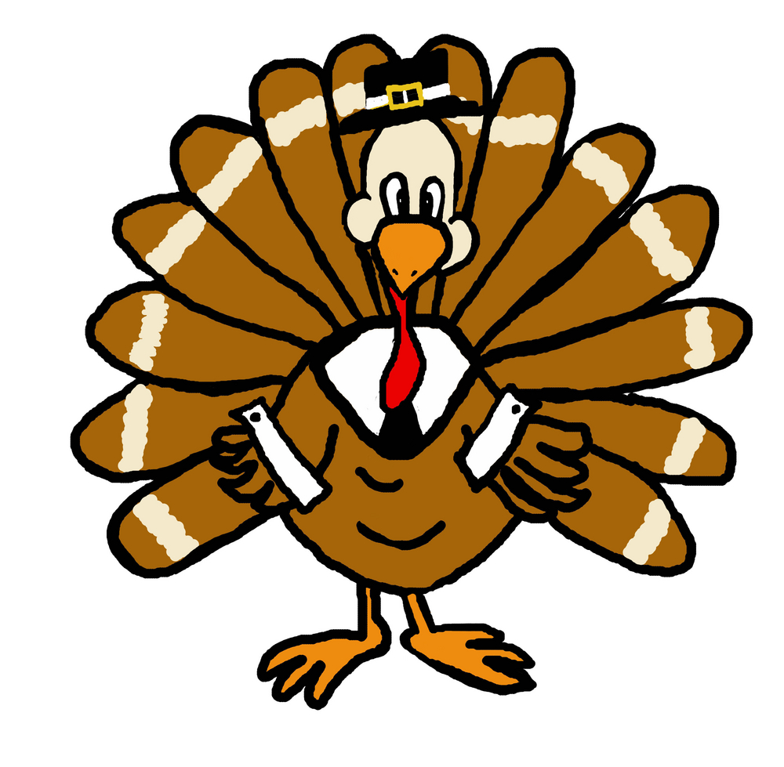 November 2017
Monday | Tuesday | Wednesday | Thursday | Friday
Oct 30  Baked Chicken Nuggets, Roasted Veggies, Fresh Fruit  Penne Carbonera, Roasted Veggies, Fresh Fruit  Penne w/Olive Oil, Roasted Veggies, Fresh Fruit | Oct 31  Chicken Caprese, Roasted Veggies, Roll, Fresh Fruit  Chicken Caprese (w/o Cheese), Roasted Veggies, Fresh Fruit  Pasta w/Lean Beef Meatballs & Tomato Sauce, Roasted Veggies, Fresh Fruit | Nov 1  Philly Cheesesteak, Roasted Seasonal Veggies, Fresh Fruit  BBQ Beef Sandwich, Roasted Seasonal Veggies, Fresh Fruit  Grilled Cheese, Roasted Seasonal Veggies, Fresh Fruit | Nov 2  Mojito Grilled Chicken w/Black Bean Salsa, Baked Plantains, Brown Rice, Fresh Fruit  Mojito Tofu w/Black Beans Salsa, Baked Plantains, Brown Rice, Fresh Fruit  Mac & Cheese, Roasted Seasonal Veggies, Fresh Fruit | Nov 3  Lean Beef Cheeseburger, Roasted Veggies, Fresh Fruit  Cheese Pizza, Veggie Chips, Fresh Fruit  Cheese Pizza, Veggies & Dip, Fresh Fruit
Nov 6  Pasta w/Turkey Bolognese Sauce, Roasted Seasonal Veggies, Fresh Fruit  Penne w/Olive Oil, Roasted Seasonal Veggies, Fresh Fruit  Baked Chicken Nuggets, Roasted Seasonal Veggies, Fresh Fruit  - Check off your child’s lunch order for each day (select a meal)  - Every day you have the option of Water, Milk, or Chocolate Milk.  - Each meal is $4.00. Feast is $7.00. A full menu for the month is $91.00  - Tear off the completed form and RETURN WITH PAYMENT by FRIDAY OCTOBER 20th. | Nov 7  Breakfast for Lunch--Egg & Cheese Burrito, Roasted Potatoes, Fresh Fruit  Breakfast for Lunch--Sweet Potato Pancakes, Eggs, Fresh Fruit  Baked Ziti, Roasted Seasonal Veggies, Garlic Bread, Fresh Fruit | Nov 8  Turkey & Cheese Enchiladas, Black Beans & Brown Rice, Fresh Fruit  Cheese Enchiladas, Black Beans & Brown Rice, Fresh Fruit  Grilled Cheese, Roasted Veggies, Fresh Fruit | Nov 9  BBQ Chicken, Baked Beans, Corn Bread, Fresh Fruit  BBQ Chicken Sandwich, Baked Beans, Corn Bread, Fresh Fruit  Mac & Cheese, Roasted Veggies, Fresh Fruit | Nov 10

Nov 21st is our Thanksgiving Feast

Meals x $4.00 =
Paid by: check # or cash

November 2017
Monday | Tuesday | Wednesday | Thursday | Friday
Nov 13  Pasta w/Tomato Sauce, Roasted Seasonal Veggies, Fresh Fruit  Pasta w/Olive Oil, Roasted Seasonal Veggies, Fresh Fruit  Baked Chicken Nuggets, Roasted Veggies, Fresh Fruit | Nov 14  Roasted Chicken w/Smashed Potatoes, Roasted Sweet Peas, Fresh Fruit  Rigatoni Genovese w/Chicken, Roasted Veggies, Fresh Fruit  Rigatoni Genovese, Roasted Veggies, Fresh Fruit | Nov 15  Arroz con Pollo, Baked Plantains, Fresh Fruit  Carne Guisada (Braised Beef), Brown Rice, Baked Plantains, Fresh Fruit  Grilled Cheese, Roasted Seasonal Veggies, Fresh Fruit | Nov 16  Lean Beef Burgers, Roasted Veggies, Fresh Fruit  Lean Beef Meatballs w/Tomato Sauce, Roll, Roasted Veggies, Fresh Fruit  Mac & Cheese, Roasted Seasonal Veggies, Fresh Fruit | Nov 17  Baked Fish Sticks w/Slaw (on the side), Roasted Potato Wedges,, Fresh Fruit  Cheese Pizza, Veggies & Dip, Fresh Fruit  Cheese Pizza, Veggie Chips, Fresh Fruit
Nov 20  Fusilli w/Low Fat Alfredo Sauce w/Chicken, Roasted Veggies, Fresh Fruit  Fusilli w/Olive Oil, Roasted Veggies, Fresh Fruit  Baked Chicken Nuggets, Glazed Carrots, Fresh Fruit | Nov 21  Thanksgiving Feast  Sliced Turkey w/Gravy (includes stuffing), Vanilla Maple Glazed Carrots, Mashed Sweet Potatoes, Pumpkin Cranberry Bread  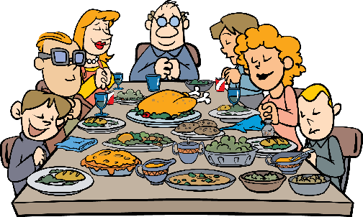 | Nov 22  Sweet & Sour Chicken w/Veggie Fried Rice, Steamed Edamame, Fresh Fruit  Sweet & Sour Tofu w/Veggie Fried Rice, Steamed Edamame, Fresh Fruit  Grilled Cheese, Steamed Edamame, Fresh Fruit | Nov 23  NO YUMMY LUNCHES  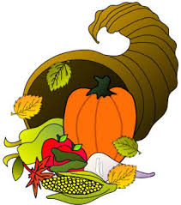  HAPPY THANKSGIVING | Nov 24  NO YUMMY LUNCHES

Monday | Tuesday | Wednesday | Thursday | Friday
Nov 27  Pasta w/Beef Tips & Mushroom Sauce, Roasted Veggies, Fresh Fruit  Pasta w/Olive Oil, Roasted Veggies, Fresh Fruit  Baked Chicken Nuggets, Roasted Veggies, Fresh Fruit | Nov 28  Maple Mustard Glazed Sliced Turkey, Roasted Veggies, Roll, Fresh Fruit  Maple Mustard Glazed Turkey Po’ Boy, Roasted Veggies, Fresh Fruit  Cheese Tortellini w/Tomato Sauce, Roasted Veggies, Fresh Fruit | Nov 29  “Make Your Own Yummy...” Chicken Fajitas, Brown Rice, Black Beans, Fresh Fruit  “Make Your Own Yummy...” Tofu Fajitas, Brown Rice, Black Beans, Fresh Fruit  Grilled Cheese, Roasted Seasonal Veggies, Fresh Fruit | Nov 30  Baked Fish Cakes w/Slaw (on the side), Roasted Veggies, Fresh Fruit  Breaded & Baked Fish Sandwich w/Slaw (on the side), Roasted Veggies, Fresh Fruit  Mac & Cheese, Roasted Veggies, Fresh Fruit | Dec 1  Beef Gyro w/Tzatziki, Sautéed Peppers, Tomatoes & Onions, Baked Chips, Fresh Fruit  Cheese Pizza, Veggies & Dip, Fresh Fruit  Cheese Pizza, Veggie Chips, Fresh Fruit

“yummy in my tummy” Organic & Natural Caterers.

