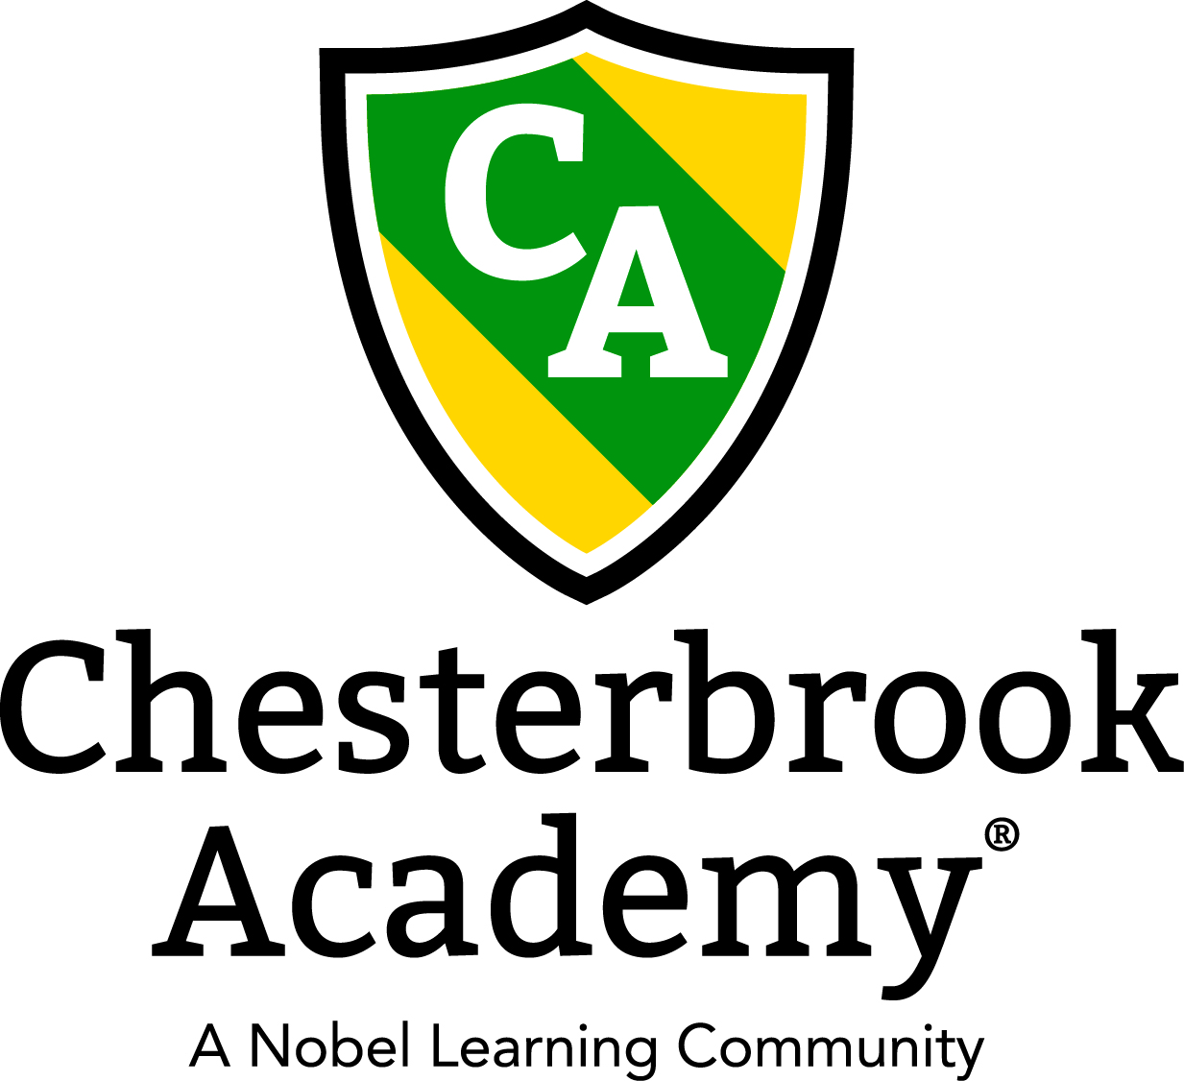

Chesterbrook Academy –Preston

December Newsletter

From the Principal's Desk
Happy Holiday Season to everyone! I can hardly believe that December is upon us. The school year is flying by! I was so impressed when I was reading our November Parent Reports and witnessing the educational growth of our students. Our teachers and students are working very hard and it shows!
I would love to invite you all to come to our Holiday Celebration on Tuesday, December 19th beginning at 9:30 am. We will have Breakfast in our classrooms and two special visitors!! Santa and Mrs. Clause will be our special guests! Santa and Mrs. Clause will be in our Atrium so you can enjoy watching your child celebrate with them! Each classroom will take a turn visiting. If you are coming to our celebration, please block out your morning as I cannot tell exactly when each class will go up to see Santa. Classroom breakfast parties will go on at the same time so you can enjoy that while waiting for your turn. Please also extend the invitation to grandparents or other relatives that may be in town! The more the merrier!
Hope you all have a wonderful holiday season and a great month!
Tawni S. Connor, Principal

In this Issue
- Important Dates for December
- Holiday Community Service Project
- Holiday Celebration
- Dr. Lauren Starnes' Educational Article

Important Dates in December
- December 1 – Tuition’s Due
- December 7 - Happy Birthday Miss Claudette!
- December 11 – 15 Make a Wish Foundation Week!
- December 14 – Happy Anniversary Miss Faryal!
- December 15 – PJ Day!
- December 18 – Happy Birthday Miss Christina!
- December 19 – Holiday Celebration! 9:30 am
- December 22 – Make a Wish Ornaments go home!
- December 25 - School's Closed!
- January 1 - School's Closed!
- Every Tuesday: Soccer Shots
- Every Wednesday: Tap and Tumble Gymnastics / Dance Class
- Every Thursday: Amazing Athletes
- Every Friday: Yoga!

Holiday Community Service Project
In the spirit of giving for this holiday season, we will be raising funds in support of the Make a Wish Foundation. “Granting wishes to kids with life-threatening medical conditions gives them more than an amazing experience. A wish come true has the power to make kids feel stronger, more courageous, and more determined to overcome their illnesses. Many families and healthcare providers believe the wish experience is the turning point in a wish kid's battle against their illness.” Our special “Wish Week” will be held December 11 – 15. During that week, you will have the opportunity to purchase an ornament for our Wish Tree for $5.00. The ornament will be personalized with your child’s name on it and you will be able to take the ornament home on Friday, December 22. We would really love to beat our goal of $500 so please help out as much as you can. It is a worthy cause and a great learning opportunity for our students! All money collected will go directly to the Make A Wish Foundation! I will send out reminders as the date approaches. Donations can be made online, in cash at the school or check made payable to the Make A Wish Foundation. Thank you for supporting this program.

Holiday Celebration
Our Holiday Celebration will be held on Tuesday December 19th beginning at 9:30 am! Our special guests (Santa and Mrs. Clause) will be joining us for breakfast. We are asking that each parent brings in a wrapped gift for your child to receive from Santa. Please have the value be no more than $10.00. Your child will receive this gift so please clearly mark your child’s name on the gift. Please bring in all wrapped gifts to the office before Friday, December 15th. Mark your calendar now so that you will be able to attend! Grandparents and older siblings are also invited too!

Education Article - December

Exploring Holiday Traditions from Around the World
By Lauren Starnes, PhD
Director of Early Childhood Education

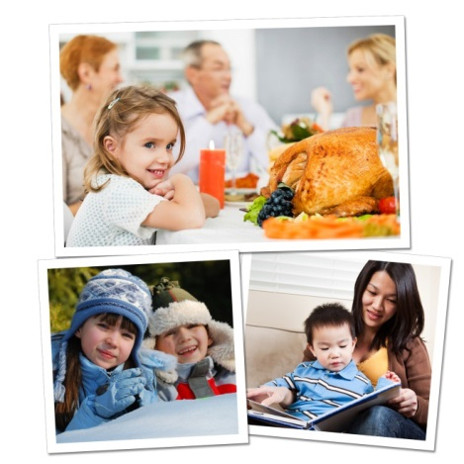
The holiday season is here, providing a wealth of opportunities to enrich the children’s understanding of diverse cultures and traditions around the world. In addition, our students will share their own traditions with others. Below are age appropriate activities that we use in the classroom, as well as activities for you and your child to do at home.

BEGINNERS (ages 2-3):
In the classroom: As they near the age of two, children begin to recognize the sights and sounds of holidays celebrated by their family. Parents visit our classrooms to share holiday traditions, including unique books, songs and activities.
At home: Gather family photos and point out traditions, such as unwrapping presents, eating holiday dinner at grandma’s house, and making a snowman. Encourage your child to talk about what he sees in the photos.
Recommended reading: Children Around the World Celebrate Christmas by Christine Tangvald, Happy Hanukkah, Corduroy by Don Freeman, My First Kwanzaa by Karen Katz
INTERMEDIATES (ages 3-4):
In the classroom: Children sing holiday songs from around the world and are introduced to holiday symbols that they may see in their communities, such as Christmas trees or Hanukkah menorahs.
At home: Take a drive with your child or bring him to various holiday festivals in your community. Encourage him to look for and identify holiday decorations.
Recommended reading: Christmas Around the World by Calliope Glass, Hanukkah Hop by Erica Silverman, Li’l Rabbit’s Kwanzaa by Donna Washington
PRE-K/PRE-K2 (ages 4-5):
In the classroom: After learning about holiday traditions around the world, our older preschoolers identify countries on a globe. For example, they might learn about Diwali, the festival of lights, and then find India on the globe. They might make tamales, a dish often served on Christmas, and then find Mexico on the globe.
At home: Ask your child to help you prepare your family’s favorite holiday foods. Talk about the long-standing traditions in which these foods are rooted. For instance, you might explain, “I used to bake cookies for the holidays with my mom. Now we can start baking cookies together!”
Recommended reading: Children Just Like Me: Celebrations by Anabel Kindersley, Light the Lights: A Story about Celebrating Hanukkah and Christmas by Margaret Moorman, The Story of Kwanzaa by Mary Washington
Exposing children to various holiday traditions helps them build strong social skills, establish a sense of self, and respect the differences of others as they transition into elementary school and beyond.

