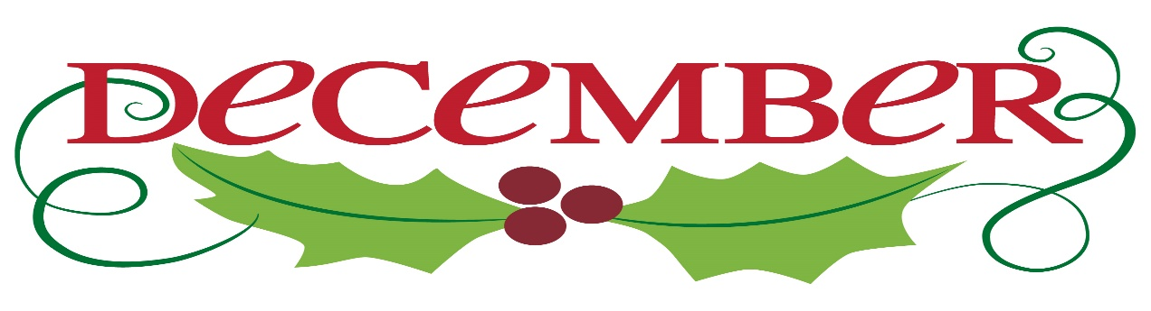
Happy Holidays everyone!
Can you believe it is the holiday season already? Chesterbrook will be kicking off December with the Brambleton Holiday Open House. Please come visit us in the Brambleton Town Center for Winter Wonderland from 1pm to 5pm on December 2nd.
The scholastic book fair will be joining us the week of December 4th through the 8th. Mark your calendars now for the Holiday Art show on December 11th. The students have been hard at work creating beautiful pieces of art and they will be for sale!
Now that we are into the cold weather months, please remember to send appropriate clothing to school. The students will still be going outside, weather and temperature permitting. This includes gloves, hats, scarves, etc.
Tuition is due every Friday for the upcoming week. Any payments received after Tuesday at noon will receive a late fee. Drop a check to avoid these fees!
As a reminder, our door code has changed. Please do NOT hold the door for anyone who does not attend Chesterbrook. If you need the new door code, please see Ms. Rachel or Jessica. We want to ensure our precious children are kept safe at all times.
Please see below for more dates to save!
Thank you to all of our families, students and teachers for everyone’s hard work and dedication to our school!

Save the Date:
12/2: Brambleton Winter Wonderland 1pm-5pm, located in Brambleton Town Center
12/4: Scholastic Book Fair Week
12/11: Holiday Art Show and Sale
12/15: Classroom Holiday Parties and Ugly Sweater Day
12/22: Polar Express Day and Pajama Day
12/25: CBA Closed for Christmas
12/29: New Years’ Noon Countdown
12/31: Happy New Year
1/1: Closed for New Years’ Day

