September 2018
Child’s Name
_________________________
Classroom
Date | 1 | 2 | 3
Sept 3
Sept 4
Sept 5
Sept 6
Sept 7 **
Sept 10
Sept 11
Sept 12
Sept 13
Sept 14 **
Sept 17
Sept 18
Sept 29
Sept 20
Sept 21 **
Sept 24
Sept 25
Sept 26
Sept 27
Sept 28 **
_________________________

September 2018
Monday | Tuesday | Wednesday | Thursday | Friday
3  NO YUMMY LUNCHES  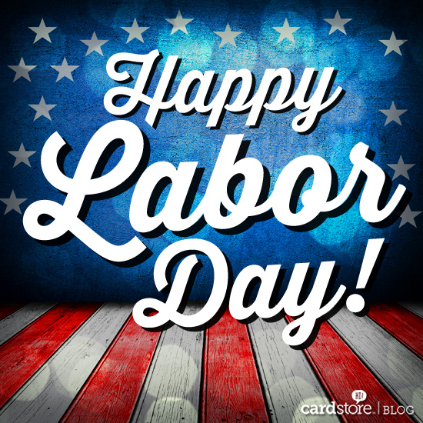 | 4  Cheese Ravioli w/Tomato Sauce, Roasted Seasonal Veggies, Fresh Fruit  Baked Chicken Nuggets, Sautéed Broccoli & Garlic, Fresh Fruit  Baked Quorn Nuggets, Sautéed Broccoli & Garlic, Fresh Fruit | 5  Chicken w/Sautéed Mushroom Sauce, Roll, Roasted Veggies, Fresh Fruit  Grilled Chicken Sandwich, Roasted Veggies, Fresh Fruit  Grilled Cheese, Roasted Potato Wedges, Fresh Fruit | 6  Lean Beef Burger, Roasted Veggies, Fresh Fruit  Lean Beef Meatballs w/Tomato Sauce, Roasted Veggies, Roll, Fresh Fruit  Mac & Cheese, Roasted Veggies, Fresh Fruit | 7  Braised Chicken & Black Bean Stew, Brown Rice, Roasted Veggies, Fresh Fruit  Cheese Pizza, Veggies & Dip, Fresh Fruit  Cheese Pizza, Veggie Chips, Fresh Fruit
10  Chicken Parmesan w/Pasta, Roasted Seasonal Veggies, Fresh Fruit  Baked Chicken Nuggets, Roasted Veggies, Fresh Fruit  Baked Quorn Nuggets, Roasted Veggies, Fresh Fruit | 11  Pasta w/Turkey Bolognese, Roasted Veggies, Fresh Fruit  Pasta w/Olive Oil, Roasted Veggies, Fresh Fruit  Breakfast for Lunch--Waffles, Eggs, Fresh Fruit | 12  Arroz con Pollo, Baked Plantains, Fresh Fruit  Braised Chicken, Brown Rice, Baked Plantains, Fresh Fruit  Grilled Cheese, Roasted Veggies, Fresh Fruit | 13  Massaman Curried Chicken w/Brown Rice, Roasted Seasonal Veggies, Fresh Fruit  Grilled Chicken Sandwich, Roasted Seasonal Veggies, Fresh Fruit  Mac & Cheese, Roasted Veggies, Fresh Fruit | 14  Cuban Sandwich, Baked Chips, Fresh Fruit  Cheese Pizza, Veggies & Dip, Fresh Fruit  Cheese Pizza, Veggie Chips, Fresh Fruit

Meals x $4.00 =
Paid by: check # or cash
- Check off your child’s lunch order for each day (select a meal)
- Every day you have the option of Water, Milk, or Chocolate Milk.
- Each meal is $4.00. A full menu for the month is $76.00
- Tear off the completed form and RETURN WITH PAYMENT by FRIDAY AUGUST 24th.

September 2018
Monday | Tuesday | Wednesday | Thursday | Friday
17  Low Fat Penne Alfredo w/ Chicken, Roasted Veggies, Fresh Fruit  Baked Chicken Nuggets, Roasted Veggies, Fresh Fruit  Baked Quorn Nuggets, Roasted Veggies, Fresh Fruit | 18  Ground Turkey & Cheese Burrito, Black Beans, Roasted Veggies, Fresh Fruit  Cheese Burrito, Black Beans, Roasted Veggies, Fresh Fruit  Cheese Tortellini w/Olive Oil, Roasted Veggies, Fresh Fruit | 19  Lean Beef Sloppy Joe’s, Roasted Sweet Potato Veggies, Fresh Fruit  Veggie Crumble Sloppy Joe’s, Roasted Seasonal Veggies, Fresh Fruit  Grilled Cheese, Roasted Veggies, Fresh Fruit | 20  Baked Fish Sticks w/Slaw (on the side), Roasted Potato Wedges,, Fresh Fruit  Breaded & Baked Fish Sandwich w/Slaw (on the side), Roasted Potato Wedges, Fresh Fruit  Mac & Cheese, Roasted Veggies, Fresh Fruit | 21  Cuban Mojo Turkey Sandwich, Cilantro Lime Roasted Corn, Baked Yucca Fries, Fresh Fruit  Cheese Pizza, Veggie Chips, Fresh Fruit  Cheese Pizza, Veggies & Dip, Fresh Fruit:
24  Pasta w/Lean Beef & Mushroom Ragout, Roasted Veggies, Fresh Fruit  Baked Chicken Nuggets, Roasted Veggies, Fresh Fruit  Baked Quorn Nuggets, Roasted Veggies, Fresh Fruit | 25  Chicken Paella, Baked Plantains, Fresh Fruit  Marinated Sliced Chicken, Brown Rice, Baked Plantains, Fresh Fruit  Cheese Ravioli w/Veggie Tomato Sauce, Roasted Seasonal Veggies, Fresh Fruit | 26  Maple Glazed Sliced Turkey, Roasted Veggies, Fresh Fruit  Maple Glazed Turkey Po’ Boy Sandwich, Roasted Veggies, Fresh Fruit  Grilled Cheese, Roasted Veggies, Fresh Fruit | 27  Philly Cheesesteak, Roasted Veggies, Fresh Fruit  BBQ Beef Sandwich, Roasted Veggies, Fresh Fruit  Mac & Cheese, Roasted Veggies, Fresh Fruit | 28  Grilled Chicken Chop w/Yellow Rice, Black Beans, Fresh Fruit  Cheese Pizza w/Veggie Chips, Fresh Fruit  Cheese Pizza, Veggies & Dip, Fresh Fruit

