November
Child’s Name
_________________________
Classroom
Date | 1 | 2 | 3
Oct 29
Oct 30
Oct 31
Nov 1
Nov 2 **
Nov 5
Nov 6
Nov 7
Nov 8
Nov 9 **
Nov 12
Nov 13
Nov 14
Nov 15
Nov 16 **
Nov 19
Nov 20 | FEA | ST | x
Nov 21
Nov 22 | CL | OS | ED
Nov 23 ** | CL | OS | ED
Nov 26
Nov 27
Nov 28
Nov 29
Nov 30 **
_________________________

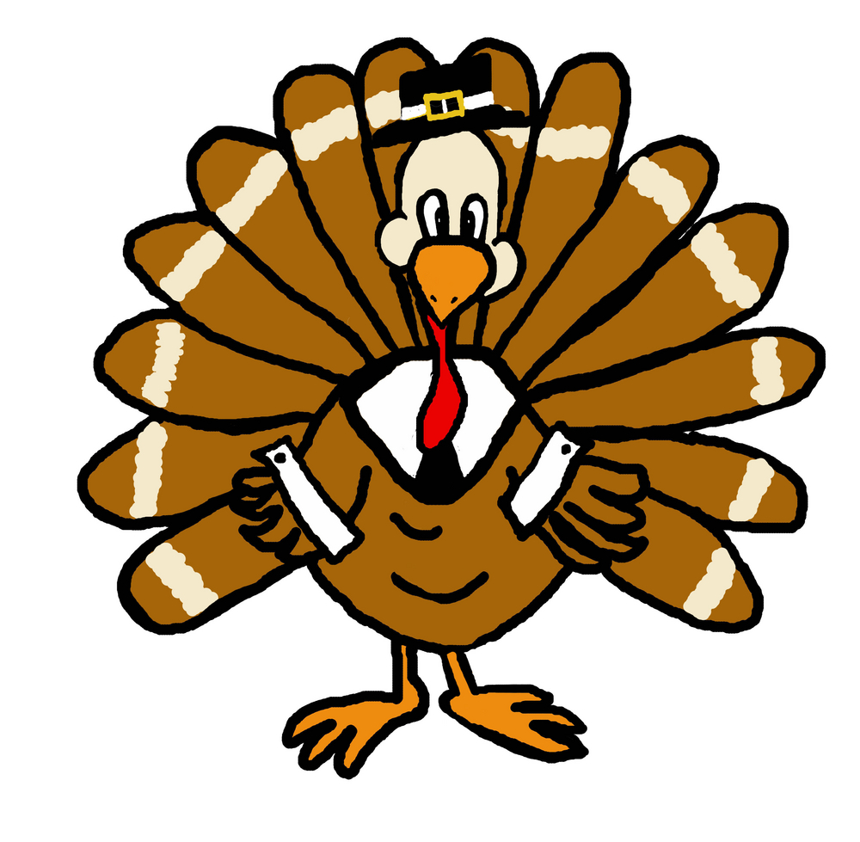 November 2018
Monday | Tuesday | Wednesday | Thursday | Friday
Oct 29  Baked Chicken Nuggets, Roasted Seasonal Veggies, Fresh Fruit  Pasta w/Lean Beef Meatballs & Tomato Sauce, Roasted Veggies, Fresh Fruit  Pasta w/Olive Oil, Roasted Veggies, Fresh Fruit | Oct 30  Chicken Caprese Sandwich, Roasted Veggies, Roll, Fresh Fruit  Pasta Primavera, Roasted Seasonal Veggies, Fresh Fruit  Pasta w/Olive Oil, Roasted Seasonal Veggies, Fresh Fruit | Oct 31  Philly Cheesesteak, Roasted Seasonal Veggies, Fresh Fruit  BBQ Beef Sandwich, Roasted Seasonal Veggies, Fresh Fruit  Grilled Cheese, Roasted Seasonal Veggies, Fresh Fruit | Nov1  Mojo Grilled Chicken w/Black Bean Salsa, Baked Plantains, Brown Rice, Fresh Fruit  Mojo Tofu w/Black Beans Salsa, Baked Plantains, Brown Rice, Fresh Fruit  Mac & Cheese, Roasted Seasonal Veggies, Fresh Fruit | Nov 2  Lean Beef Cheeseburger, Roasted Veggies, Fresh Fruit  Cheese Pizza, Veggie Chips, Fresh Fruit  Cheese Pizza, Veggies & Dip, Fresh Fruit
Nov 5  Pasta w/Turkey Bolognese Sauce, Roasted Seasonal Veggies, Fresh Fruit  Pasta w/Olive Oil, Roasted Seasonal Veggies, Fresh Fruit  Baked Chicken Nuggets, Roasted Seasonal Veggies, Fresh Fruit | Nov 6  Breakfast for Lunch--Sweet Potato Pancakes, Eggs, Fresh Fruit  Baked Ziti, Roasted Seasonal Veggies, Garlic Bread, Fresh Fruit  Pasta w/Olive Oil, Garlic Bread, Roasted Seasonal Veggies, Fresh Fruit | Nov 7  Lean Ground Beef & Cheese Enchiladas, Rice & Beans, Fresh Fruit  Cheese Enchiladas, Rice & Beans, Fresh Fruit  Grilled Cheese, Roasted Veggies, Fresh Fruit | Nov 8  BBQ Chicken, Baked Beans, Corn Bread, Fresh Fruit  BBQ Chicken Sandwich, Baked Beans, Corn Bread, Fresh Fruit  Mac & Cheese, Roasted Veggies, Fresh Fruit | Nov 9  Pulled Beef & Cheese Nachos, Black Beans, Fresh Fruit  Cheese Pizza, Veggies & Dip, Fresh Fruit  Cheese Pizza, Veggie Chips, Fresh Fruit

Nov 20th is our Thanksgiving Feast

- Check off your child’s lunch order for each day.
- Every day you have a choice of Milk, Chocolate Milk, or Water. Please put a M, C, or W in the box for that day.
- Each meal is $4.50. A full menu for the month is $94.50.
- Order is due no later than Friday, October 19th.

Meals x $4.50 =
Paid by: check # or cash

November 2018
Monday | Tuesday | Wednesday | Thursday | Friday
Nov 12 | Nov 13  Baked Chicken Nuggets, Roasted Veggies, Fresh Fruit  Baked Quorn Nuggets, Roasted Veggies, Fresh Fruit  Rigatoni Genovese w/Chicken, Roasted Veggies, Fresh Fruit | Nov 14  Arroz con Pollo, Baked Plantains, Fresh Fruit  Marinated Chicken, Baked Plantains, Brown Rice, Fresh Fruit  Grilled Cheese, Roasted Seasonal Veggies, Fresh Fruit | Nov 15  Lean Beef Burgers, Roasted Veggies, Fresh Fruit  Lean Beef Meatballs w/Tomato Sauce, Roll, Roasted Veggies, Fresh Fruit  Mac & Cheese, Roasted Seasonal Veggies, Fresh Fruit | Nov 16  Baked Fish Sticks w/Slaw (on the side), Roasted Potato Wedges, Fresh Fruit  Cheese Pizza, Veggies & Dip, Fresh Fruit  Cheese Pizza, Veggie Chips, Fresh Fruit
Nov 19  Fusilli w/Low Fat Alfredo Sauce w/Chicken, Roasted Veggies, Fresh Fruit  Pasta w/Low Fat Alfredo Sauce, Roasted Veggies, Fresh Fruit  Baked Chicken Nuggets, Glazed Carrots, Fresh Fruit | Nov 20  *On a separate form*  Thanksgiving Feast  Sliced Turkey w/Gravy (includes stuffing), Vanilla Maple Glazed Carrots, Mashed Sweet Potatoes, Pumpkin Cranberry Bread  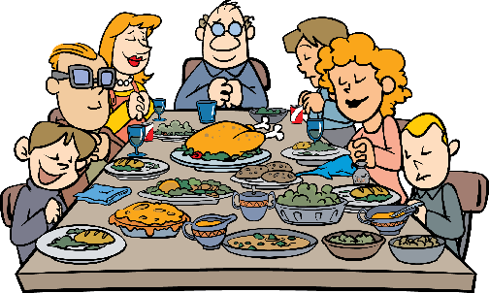 | Nov 21  Sweet & Sour Chicken w/Veggie Fried Rice, Steamed Edamame, Fresh Fruit  Sweet & Sour Tofu w/Veggie Fried Rice, Steamed Edamame, Fresh Fruit  Grilled Cheese, Steamed Edamame, Fresh Fruit | Nov 22  NO YUMMY LUNCHES  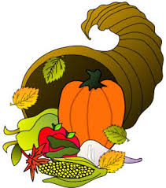  HAPPY THANKSGIVING | Nov 23  NO YUMMY LUNCHES  “yummy in my tummy” Organic & Natural Caterers.  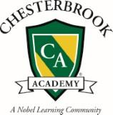

Monday | Tuesday | Wednesday | Thursday | Friday
Nov 26  Baked Chicken Nuggets, Roasted Veggies, Fresh Fruit  Baked Quorn Nuggets, Roasted Veggies, Fresh Fruit  Pasta w/Sirloin & Mushroom Sauce, Roasted Seasonal Veggies, Fresh Fruit | Nov 27  Maple Mustard Glazed Sliced Turkey, Roasted Sweet Potato Fries, Roll, Fresh Fruit  Cheese Tortellini w/Tomato Sauce, Roasted Seasonal Veggies, Fresh Fruit  Cheese Tortellini w/Olive Oil, Roasted Seasonal Veggies, Fresh Fruit | Nov 28  “Make Your Own Yummy...” Chicken Fajitas, Brown Rice, Black Beans, Fresh Fruit  “Make Your Own Yummy...” Tofu Fajitas, Brown Rice, Black Beans, Fresh Fruit  Grilled Cheese, Roasted Seasonal Veggies, Fresh Fruit | Nov 29  Baked Fish Cakes w/Slaw (on the side), Roasted Veggies, Fresh Fruit  Breaded & Baked Fish Sandwich w/Slaw (on the side), Roasted Veggies, Fresh Fruit  Mac & Cheese, Roasted Veggies, Fresh Fruit | Nov 30  Beef Gyro w/Tzatziki, Sautéed Peppers, Tomatoes & Onions, Veggie Chips, Fresh Fruit  Cheese Pizza, Veggies & Dip, Fresh Fruit  Cheese Pizza, Veggie Chips, Fresh Fruit

