October

Child’s Name
_________________________
Classroom
Date | 1 | 2 | 3
Oct 1
Oct 2
Oct 3
Oct 4
Oct 5 **
Oct 8
Oct 9
Oct 10
Oct 11
Oct 12 **
Oct 15
Oct 16
Oct 17
Oct 18
Oct 19 **
Oct 22
Oct 23
Oct 24
Oct 25
Oct 26 **
_________________________

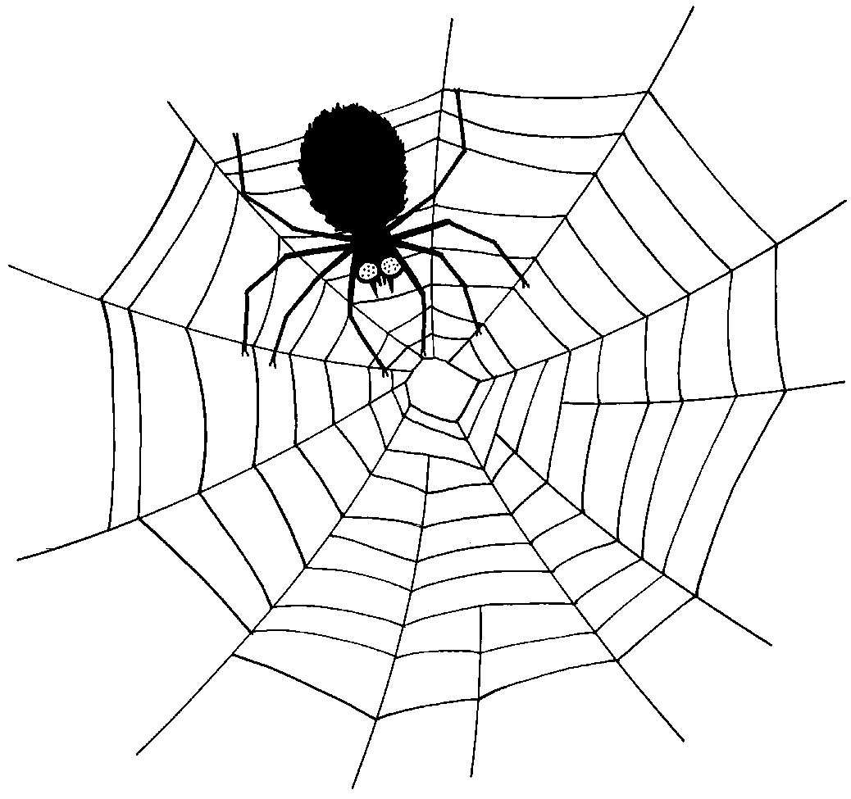
Monday | Tuesday | Wednesday | Thursday | Friday
1  Baked Chicken Nuggets, Roasted Seasonal Veggies, Fresh Fruit  Baked Quorn Nuggets, Roasted Seasonal Veggies, Fresh Fruit  Low Fat Penne Alfredo & Chicken, Roasted Seasonal Veggies, Fresh Fruit | 2  Breakfast for Lunch—French Toast, Eggs, Fresh Fruit  Pasta w/Turkey Bolognese Sauce, Roasted Seasonal Veggies, Fresh Fruit  Penne w/Olive Oil, Roasted Seasonal Veggies, Fresh Fruit | 3  Picadillo, Baked Plantains, Brown Rice, Fresh Fruit  Grilled Chicken & Cheddar Sandwich, Roasted Seasonal Veggies, Fresh Fruit  Grilled Cheese, Roasted Veggies, Fresh Fruit | 4  Turkey Meatballs, Baked Tater Tots, Fresh Fruit  Veggie Crumble Meatballs w/Tomato Sauce, Baked Tater Tots, Fresh Fruit  Mac & Cheese, Roasted Seasonal Veggies, Fresh Fruit | 5  Cuban Style Marinated Chicken Brown Rice, w/Mango Salsa, Black Beans, Fresh Fruit  Cheese Pizza, Veggies & Dip, Fresh Fruit  Cheese Pizza, Veggie Chips, Fresh Fruit
8  Chicken Cacciatore w/Tomato Sauce over Pasta, Roasted Seasonal Veggies, Fresh Fruit  Baked Chicken Nuggets Roasted Seasonal Veggies, Fresh Fruit  Baked Quorn Nuggets, Roasted Seasonal Veggies, Fresh Fruit | 9  Lean Beef Tacos, Rice & Beans, Fresh Fruit  Cheese Ravioli w/Tomato Sauce, Roasted Seasonal Veggies, Fresh Fruit  Cheese Ravioli w/Olive Oil, Roasted Seasonal Veggies, Fresh Fruit | 10  Honey Soy Glazed Chicken w/Veggie Fried Rice, Sauteed Veggies, Fresh Fruit  Honey Soy Glazed Chicken Sandwich, Sauteed Veggies, Fresh Fruit  Grilled Cheese, Roasted Veggies, Fresh Fruit | 11  Lean Beef Burger, Roasted Sweet Peas, Fresh Fruit  Lean Beef Meatballs w/Tomato Sauce, Roasted Sweet Peas, Roll, Fresh Fruit  Mac & Cheese, Roasted Sweet Peas, Fresh Fruit | 12  Spice Rubbed Chicken w/Israeli Couscous, Roasted Seasonal Veggies, Fresh Fruit  Cheese Pizza, Veggies & Dip, Fresh Fruit  Cheese Pizza, Veggie Chips, Fresh Fruit

- Check off your child’s lunch order for each day.
- Every day you have a choice of Milk, Chocolate Milk, or Water. Please put a M, C, or W in the box for that day.
- Each meal is $4.50. A full menu for the month is $90.00
- Order is due no later than Friday, September 21st.

Meals x $4.50 = __________
Paid by: check # _____

“yummy in my tummy” Organic Caterers.

Monday | Tuesday | Wednesday | Thursday | Friday
15  Pasta w/alla Rosa Sauce & Chicken, Roasted Seasonal Veggies, Fresh Fruit  Baked Chicken Nuggets, Roasted Seasonal Veggies, Fresh Fruit  Baked Quorn Nuggets, Roasted Seasonal Veggies, Fresh Fruit | 16  Lean Beef & Cheese Burrito, Black Beans, Roasted Veggies, Fresh Fruit  Cheese Tortellini w/Tomato Sauce, Roasted Veggies, Fresh Fruit  Cheese Tortellini w/Olive Oil, Roasted Veggies, Fresh Fruit | 17  Baked Chicken Piccata, Roasted Seasonal Veggies, Fresh Fruit  Grilled Chicken Sandwich, Roasted Seasonal Veggies Fresh Fruit  Grilled Cheese, Roasted Rosemary Potatoes, Fresh Fruit | 18  Baked Fish Sticks w/Slaw (on the side), Roasted Potato Wedges, Fresh Fruit  Breaded & Baked Fish Sandwich w/Slaw (on the side), Roasted Potato Wedges, Fresh Fruit  Mac & Cheese, Roasted Veggies, Fresh Fruit | 19  Romanesco Lean Beef Sandwich w/Provolone on Cuban Bread, Roasted Seasonal Veggies, Fresh Fruit  Cheese Pizza, Veggies & Dip, Fresh Fruit  Cheese Pizza, Veggie Chips, Fresh Fruit
22  Lighter Butternut Squash & Browned Butter Pasta Alfredo w/Chicken, Roasted Veggies, Fresh Fruit  Baked Chicken Nuggets, Sauteed Broccoli & Garlic, Fresh Fruit  Baked Quorn Nuggets, Sauteed Broccoli & Garlic, Fresh Fruit | 23  Cheese Lasagna, Roasted Seasonal Veggies, Fresh Fruit  Pasta w/Olive Oil, Roasted Seasonal Veggies, Fresh Fruit  Breakfast for Lunch--Egg & Cheese Muffin, Roasted Potatoes, Fresh Fruit | 24  Ropa Vieja, Baked Plantains, Brown Rice, Fresh Fruit  Lean Beef Sloppy Joe’s, Roasted Seasonal Veggies, Fresh Fruit  Grilled Cheese, Roasted Seasonal Veggies, Fresh Fruit | 25  Maple Mustard Glazed Sliced Turkey, Roasted Veggies, Roll, Fresh Fruit  Maple Mustard Glazed Turkey Po’ Boy, Roasted Veggies, Fresh Fruit  Mac & Cheese, Roasted Veggies, Fresh Fruit | 26  Braised Chicken & Cheese Empanadas, Black Beans, Roasted Seasonal Veggies, Fresh Fruit  Cheese Pizza, Veggies & Dip, Fresh Fruit  Cheese Pizza, Veggie Chips, Fresh Fruit

