OCTOBER NEWSLETTER
Hello families! We have many activities planned for October so please make sure you keep track of all important dates.

Here are some important dates to remember:
*October 3rd- Speech Screening
*October 8th – Columbus Day SCHOOL OPEN
*October 13th- Fall Festival @ CBA Elementary 11:00-2:30
*October 15th and 16th- Picture Day @7:00-11:30 A.M.
*October 17th- Vision Screening
*October 20th- 26th- Principals Conference
*October 31st – Costume Parade and Party @ 3:30 P.M.

Parent Reminders:
**Make sure you are checking your child(ren) in and out every day with the Ipad.
**If something comes home that is not your child’s please return it the next day
**To ensure the health and safety of all of our children and staff, please remember to adhere to our sick policy. If you have any questions please see the front office.
**We do have a late payment policy which states that all payments by check must be submitted by Friday before the following week. If no payment is received, a late payment fee of $25 will be applied

As always, we look forward to a wonderful fall season and we are here to serve all of your family’s needs. Our office is always open if you have any questions or concerns, or even just to have a friendly chat. Go CBA!

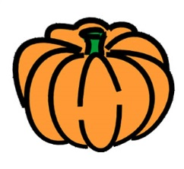

Mrs. Lauren and Ms. Lesley

