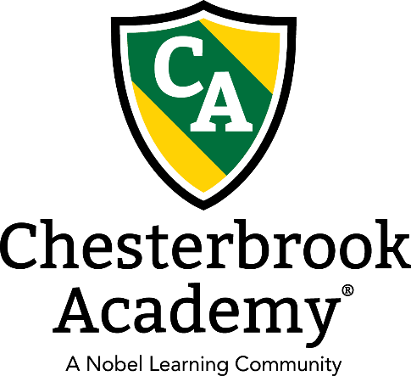

**Hello Parents! We have had such an exciting July! From celebrating our country’s independence to so many fun field trips and exciting activities, we have had so much fun! Although the summer is almost over, we are not slowing down, and our field trips, shows, and activities are in full swing! We have an Open House on August 3rd, and have our registration promotion going on until then, if you register for the fall, your registration fee is 50% off! Many of you have already registered, but this is a great opportunity for you to refer your friends. They get their registration 50% off and after they’re enrolled for 6 months, you get a free week of tuition! It’s a win-win! Thank you all for your participation in our Kids Helping Kids initiative this summer! (Our art show raised $542 for the Leukemia and Lymphoma Society!). We are grateful for the opportunity to watch our students serve others these past few weeks and appreciate the role you all had in this.**

**We still have a few more weeks of summer, but our teachers are hard at work preparing our classrooms for the new school year. Many of our students will be transitioning into new classrooms this month, and classroom specific information will be sent home soon. Please let us know if you have any questions or concerns.**

**With summer coming to an end, don’t forget to fill out a vacation request for any time off you need to make sure you are billed correctly! We have had such a great summer, and are looking forward to the 2019-2020 school year!**

**Important Dates**

**August 3rd –** Open House 10:00 AM- 1:00 PM

**August 14th** – Orientation for our Intermediate Program 6:30-7:30PM

**August 21st**- Orientation for our Pre-K Program 6:30-7:30 PM

**August 21st-**  End of summer party

**August 22nd** - First day of LCPS

**August 26th**- Chesterbrook’s first day of school (uniforms start)

**Water Play Every Wednesday**

|  |
| --- |
|  |
|  |
|  |