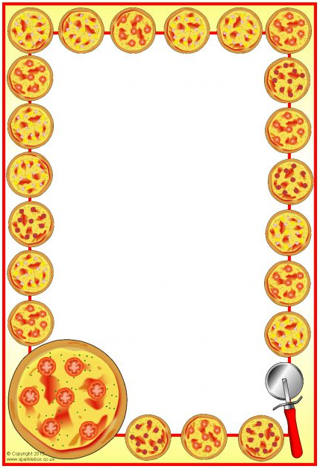

Order accepted by:_________________

*Any proceeds will be used to support the CECPTO activities throughout the year.*

CEC PTO PIZZA

On the Last Friday of each month, the PTO will provide **2 slices of cheese or pepperoni pizza, a drink and a treat** for each child who is signed up to participate. The cost is $60/child for the entire year. If you would like to participate, please complete this form and return it to the school with your child.

Child’s Name_______________________________________________

Child’s Grade________________________________________________

Parent’s Name______________________________________________

**$60** Payment Provided:

Cash __________ Check/Check Number ________________________

Pizza Choice: Cheese _____________ Pepperoni ______________

Please send all inquiries to: Heather Ellis, PTO President [hlellis2006@gmail.com](mailto:hlellis2006@gmail.com)

PTO Pizza will be offered available on the following dates:

**Sept. Oct. Nov.**

**Dec. Jan. Feb.**

**Mar. Apr. May**