September 2019
Child’s Name
_________________________
Classroom
Date | 1 | 2 | 3
Sept 3
Sept 4
Sept 5
Sept 6 **
Sept 9
Sept 10
Sept 11
Sept 12
Sept 13 **
Sept 16
Sept 17
Sept 18
Sept 19
Sept 20 **
Sept 23
Sept 24
Sept 25
Sept 26
Sept 27 **
_________________________

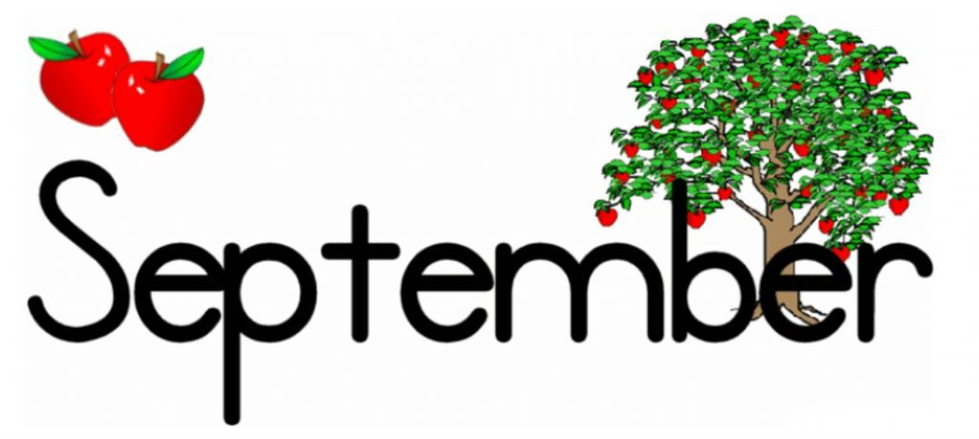
Monday | Tuesday | Wednesday | Thursday | Friday
2  NO YUMMY LUNCHES  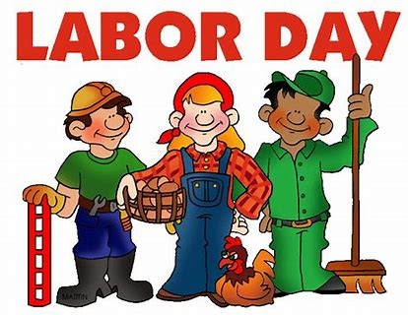  TODAY!! | 3  Pasta Genovese (Creamy Garlic Sauce) w/Chicken, Roasted Seasonal Veggies, Fresh Fruit  Baked Chicken Nuggets, Roasted Seasonal Veggies, Fresh Fruit  Baked Quorn Nuggets, Roasted Seasonal Veggies, Fresh Fruit | 4  Orange Chicken w/Lo Mein Noodles, Steamed Veggies, Fresh Fruit  Grilled Chicken Sandwich, Roasted Veggies, Fresh Fruit  Grilled Cheese, Roasted Potato Wedges, Fresh Fruit | 5  Lean Beef Burger, Roasted Veggies, Fresh Fruit  Lean Beef Meatballs w/Tomato Sauce, Roasted Veggies, Roll, Fresh Fruit  Mac & Cheese, Roasted Veggies, Fresh Fruit | 6  Pesto Chicken, Spinach, Tomatoes & Mozzarella Pressed Sandwich, Veggie Chips, Fresh Fruit  Cheese Pizza, Veggies & Dip, Fresh Fruit  Cheese Pizza, Veggie Chips, Fresh Fruit
9  Chicken Parmesan w/Pasta, Roasted Seasonal Veggies, Fresh Fruit  Pasta w/Olive Oil, Roasted Seasonal Veggies, Fresh Fruit  Baked Chicken Nuggets, Roasted Veggies, Fresh Fruit | 10  Pasta w/Turkey Bolognese, Roasted Veggies, Fresh Fruit  Pasta w/Tomato Sauce, Roasted Veggies, Fresh Fruit  Breakfast for Lunch--Waffles, Eggs, Fresh Fruit | 11  Arroz con Pollo, Baked Plantains, Fresh Fruit  Braised Chicken, Brown Rice, Baked Plantains, Fresh Fruit  Grilled Cheese, Roasted Veggies, Fresh Fruit | 12  Korean Beef Bowl w/Rice, Sautéed Veggies, Fresh Fruit  Veggie Crumble Sloppy Joe’s, Roasted Veggies, Fresh Fruit  Mac & Cheese, Roasted Veggies, Fresh Fruit | 13  Massaman Curried Chicken w/Brown Rice, Roasted Seasonal Veggies, Fresh Fruit  Cheese Pizza, Veggies & Dip, Fresh Fruit  Cheese Pizza, Veggie Chips, Fresh Fruit

Meals x $4.50 = ________
Paid by: check # _______
- Check off your child’s lunch order for each day (select a meal) with beverage of choice.
- Every day you have the option of Water (W), Milk (M), or Chocolate Milk (CM).
- Each meal is $4.50. A full menu for the month is $85.50
- Tear off and return the completed form by Friday, August 23rd.

Monday | Tuesday | Wednesday | Thursday | Friday
16  Low Fat Penne Alfredo w/ Chicken, Roasted Veggies, Fresh Fruit  Baked Chicken Nuggets, Roasted Veggies, Fresh Fruit  Baked Quorn Nuggets, Roasted Veggies, Fresh Fruit | 17  Ground Turkey & Cheese Burrito, Black Beans, Roasted Veggies, Fresh Fruit  Cheese Burrito, Black Beans, Roasted Veggies, Fresh Fruit  Cheese Tortellini w/Olive Oil, Roasted Veggies, Fresh Fruit | 18  Philly Cheesesteak, Roasted Veggies, Fresh Fruit  French Dip, Roasted Veggies, Fresh Fruit  Grilled Cheese, Roasted Veggies, Fresh Fruit | 19  Baked Fish Sticks w/Slaw (on the side), Roasted Potato Wedges, Fresh Fruit  Breaded & Baked Fish Sandwich w/Slaw (on the side), Roasted Potato Wedges, Fresh Fruit  Mac & Cheese, Roasted Veggies, Fresh Fruit | 20  Cuban Mojo Turkey, Cilantro Line Roasted Corn, Baked Yucca Fries, Fresh Fruit  Cheese Pizza, Veggie Chips, Fresh Fruit  Cheese Pizza, Veggies & Dip, Fresh Fruit
23  Baked Chicken Nuggets, Roasted Seasonal Veggies, Fresh Fruit  Pasta w/Lean Beef & Eggplant Bolognese, Roasted Seasonal Veggies, Fresh Fruit  Pasta w/Olive Oil, Roasted Seasonal Veggies, Fresh Fruit | 24  Maple Glazed Sliced Turkey, Roll, Roasted Seasonal Veggies, Fresh Fruit  Maple Glazed Turkey Po’ Boy Sandwich, Roasted Seasonal Veggies, Fresh Fruit  Pasta w/Pomodoro Sauce, Roasted Veggies, Fresh Fruit | 25  Chicken Paella, Black Beans, Roasted Seasonal Veggies, Fresh Fruit  Marinated Sliced Chicken, Black Beans, Saffron Rice, Fresh Fruit  Grilled Cheese, Roasted Seasonal Veggies, Fresh Fruit | 26  Beef Barbacoa over Rice, Mexican Veggie Skillet, Fresh Fruit  BBQ Beef Sandwich, Roasted Veggies, Fresh Fruit  Mac & Cheese, Roasted Veggies, Fresh Fruit | 27  Chicken Tikka Masala w/Couscous, Roasted Veggies, Fresh Fruit  Cheese Pizza w/Veggie Chips, Fresh Fruit  Cheese Pizza, Veggies & Dip, Fresh Fruit

