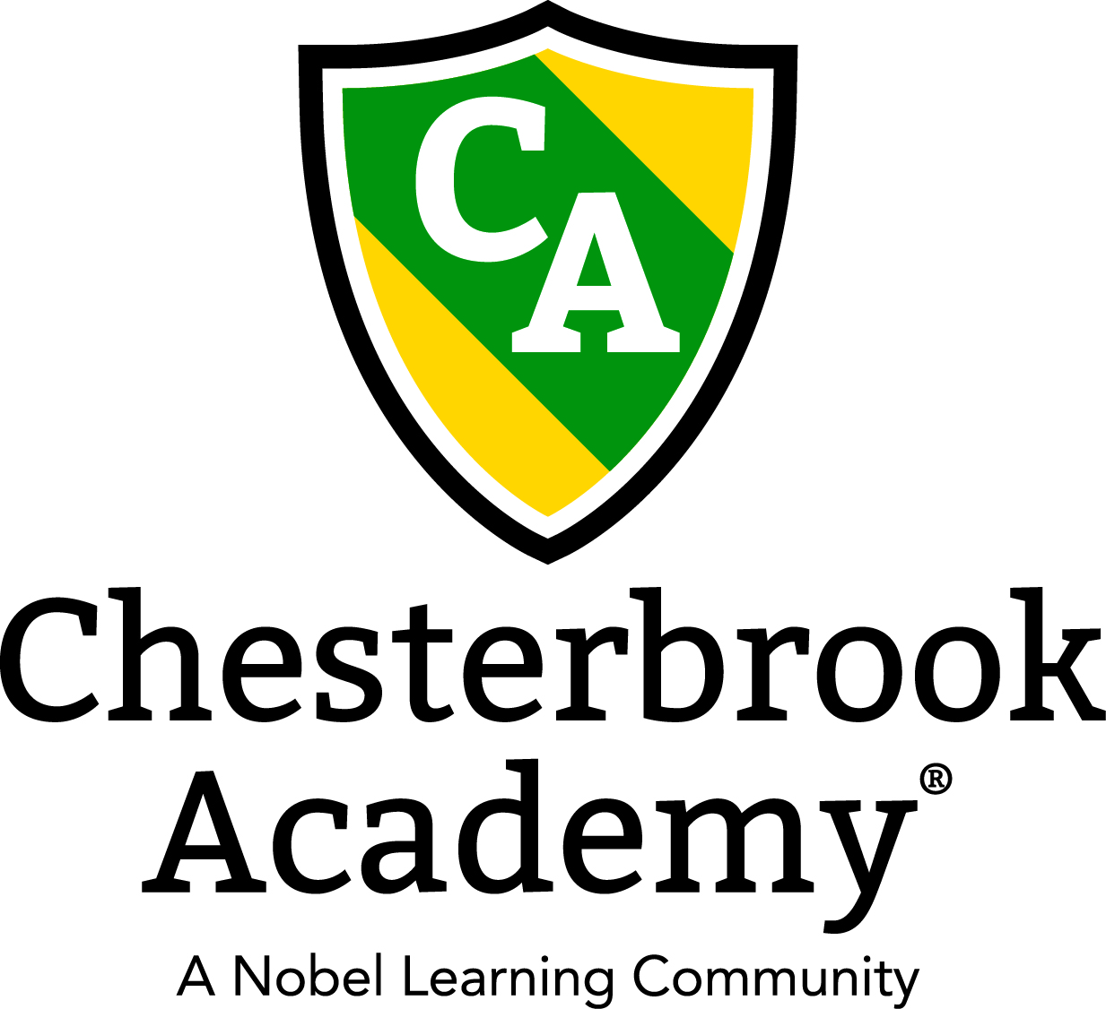

Chesterbrook Academy – Preston
November Newsletter

From the Principal's Desk
November is upon us and it is a great time to remember all that we are thankful for. I am taking the time this November to reflect on all that I am thankful for. I am thankful for the teachers who work for me at this school as they are the most dedicated and talented group of ladies I have met. I am thankful for the friendly families and the adorable children who dawn my school's doorstep each morning. I am thankful to work with the most amazing ladies —Miss Susan and Miss Debbie. And I am most thankful to be blessed with three wonderful children (Mitchell, Izzy and Lindsay). I hope you all take the time this November to pause and think about how much you all have to be thankful for as well! Happy Thanksgiving to everyone!
Hope you all have a wonderful Thanksgiving holiday and a great month!
Tawni S. Connor, Principal

In this Issue
- Important Dates for November
- Professional Development Day!
- Parent Conferences Offered!
- Fall Harvest Celebration Luncheon
- Educational Article

Important Dates in November
- November 1 - Tuition's Due
- November 5 – Happy Birthday Miss Jennifer
- November 10 – Happy Birthday Miss Alexis
- November 11 – School’s Closed Professional Development Day!
- November 15 – Trike A Thon
- November 18 – Happy Birthday Miss Kim!
- November 19 – Happy Anniversary Miss Toya!
- November 21 – Fall Harvest Luncheon
- November 21 – Happy Anniversary Miss Jade!
- November 22 – Parent Reports go home!
- November 25– Parent Conferences Available
- November 26 – Parent Conferences Available
- November 27 – Happy Anniversary Miss Rudra
- November 28 – School’s Closed Happy Thanksgiving
- November 29 – School’s Closed Happy Thanksgiving
- Every Monday – Kids Tech Korner Computer Class
- Every Tuesday: Soccer Shots classes
- Every Wednesday: Dance / Tap and Tumble Gymnastics Class
- Every Thursday: Amazing Athletes!
- Every Friday: Yoga Class
Professional Development Day!
On Monday, November 11th our school will be closed to hold our Bi Annual Professional Development Day for our teachers. Please be sure to make arrangements for your child on this day. We have a lot planned for our teachers to make them even better than they already are!
Parent Conferences Offered!
On Monday, November 25 – Tuesday, November 26, we will offer an opportunity for you to have a personal conference with your child’s teacher. The conferences are available by appointment only. You must email me at tawni.connor@nlcinc.com to request a conference and tell me your preferred time. Conferences will be offered either 7-8:30 am or 4-5:30 pm. Times are not guaranteed but I will try very hard to accommodate everyone’s wishes. We can also offer phone conferences at lunch time if that works better for you! Conferences will last for a maximum of 30 minutes. Please email me by Friday, November 15th to request a conference.
Harvest Celebration Luncheon
Once again, Chesterbrook Academy – Preston will hold its annual Harvest Celebration Luncheon on Thursday, November 21st from 11:30am – 12:30 pm. Our Harvest Celebration Luncheon is the perfect opportunity for you to come and have a feast with your child, their little friends, your child’s teachers, and Miss Susan, Miss Debbie and I. Chesterbrook will provide the Turkey, Gravy, and Mashed Potatoes! You all will provide the sides! This is a great opportunity to share your culture and bring an authentic family dish! I will be bringing my Memmy’s Pennsylvania Dutch Style Stuffing! There will be a sign up sheet at the front desk! I hope to see you all there! Thanksgiving foods are the best!

Learning Through the Joy of Cooking
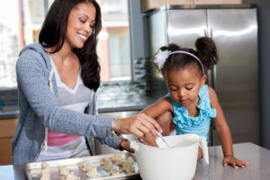
With cooler weather and Thanksgiving right around the corner, many of us will be spending more time in the kitchen. Use this time to invite your child to join you in the meal-making experience.
As he is exposed to new foods and food preparation, he will begin to feel more comfortable in the kitchen, while building healthy eating habits. Along with habits of self-help and good nutrition, children learn so much more from cooking, including important academic, social and physical skills.
Our teachers integrate cooking activities into many aspects of our Links to Learning curriculum. After reading “Stone Soup,” for example, teachers ask students to bring in different vegetables to make their own Stone Soup in the classroom. Other hands-on activities include taste testing different vegetables, blending fruits to make healthy smoothies, measuring ingredients, and practicing pouring liquids into containers.
Below are some fun cooking activities you can do with your child to connect learning at school to learning at home.
Math:
Cooking is a fun way for children to learn and practice basic math skills, such as counting, measuring and using sequence words. While making breakfast, ask your child to count eggs as you crack them or count pancakes on a plate. Older preschoolers can help pour the pancake batter into a measuring cup. Afterward, ask him to recall the steps you took to make the meal. Listen for words like “first,” “second,” and “next.”
Literacy:
When children assist in the kitchen, they practice listening skills and learn new vocabulary words such as “mix,” “blend,” and “roll.” Read a recipe aloud with your child, pointing to the words as you read. Then, ask him to help you complete each step. Say, “First, we have to mix together the sugar and butter. Can you help me mix?” or “Now, we have to roll the cookie dough into balls. Can you help me roll the dough?”
Multi-Sensory:
We all know the familiar battle of trying to get our children to eat a variety of fruits and vegetables, and branch out beyond favorites like macaroni and cheese and chicken nuggets. One way to solve this problem is by making healthy snacks with your child, for example, a vegetable boat with dip. Together, scoop out the inside of a pepper and fill it with hummus or yogurt dip. Serve with baby carrots, celery and broccoli. He’ll be exposed to new sights, smells and textures as he helps retrieve, wash and dip the ingredients. In many instances, he’ll want to taste the food he helped prepare!
Physical:
Cooking helps develop important fine motor skills, including hand strength and coordination. Give your child plastic cooking utensils, such as spoons and spatulas, along with a large bowl filled with bite-sized pieces of fruit. Ask him to help make a fruit salad by using the utensils to mix the fruit together. Choose utensils with different sized handles, so he learns how to grasp and hold objects in various ways.
Social-Emotional:
When children follow recipes, they build confidence, a sense of pride, independence, and problem solving skills. Depending on your child’s age, ask him to help bake cookies by following one-, two-, or multi-step directions. Afterward, name the dish after your child and announce it to your family before serving. For example, say, “Tonight for dessert, we’re having Andrew’s Scrumptious Sugar Cookies!”
By introducing children to the joy of cooking in the preschool years, they are likely to grow, flourish and learn important skills that will help them succeed in kindergarten and beyond.

