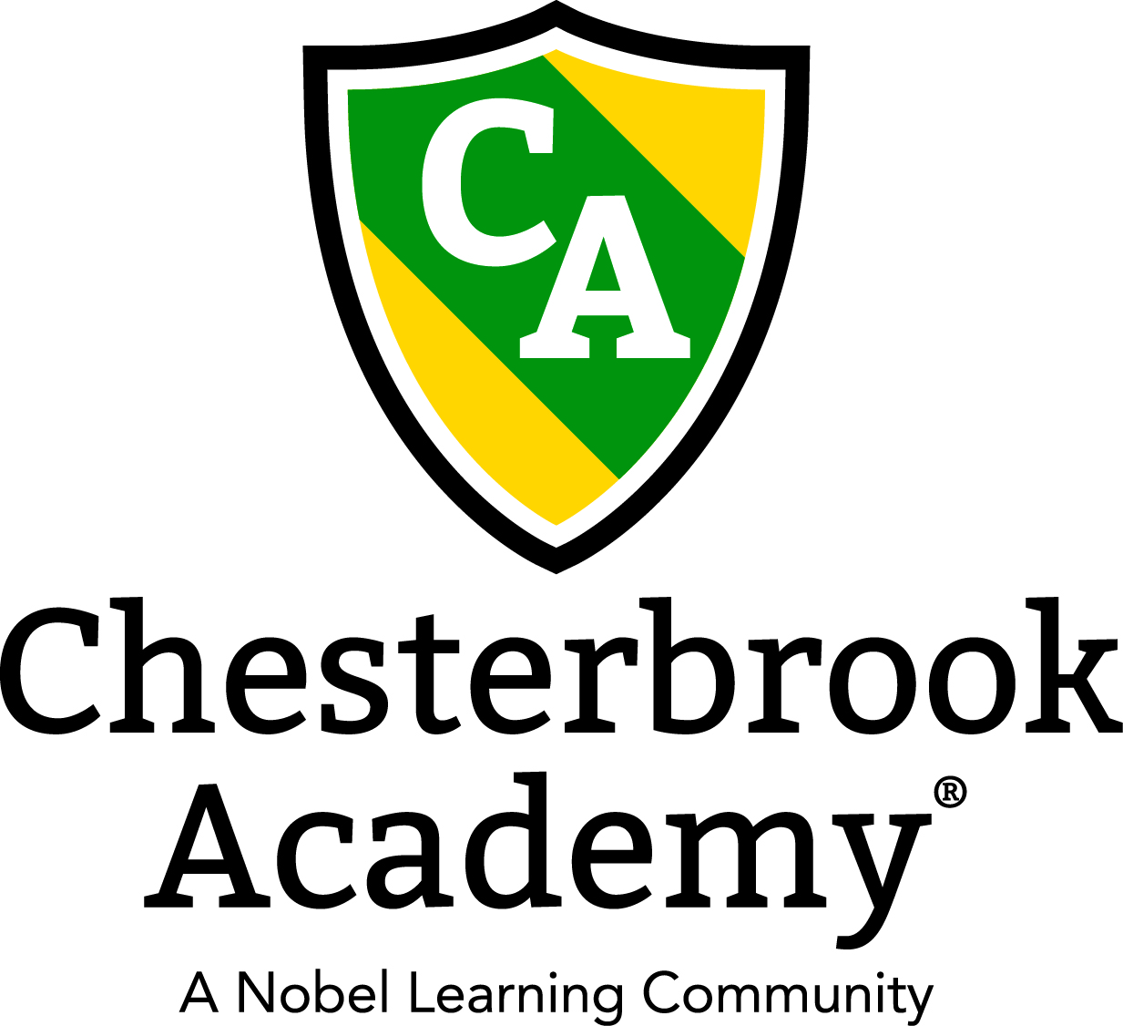

Chesterbrook Academy – Preston October Newsletter

From the Principal's Desk
Happy October Everyone! I have been overjoyed over the past month watching our new students adjust to school life and our current students adjust to their new big boy or big girl classrooms! All of our students are off to a great start of a new school year! I have such a wonderful and talented teaching staff that really put their hearts into their classrooms and it shows! Thank you also for the support that you show them! Your comments, emails, phone calls, and parent reviews on greatschools.org and google mean so much to us! We truly are a family working together to raise educated, well rounded, beautiful children!
Please join us in welcoming our new families to Chesterbrook Academy! We are so happy to have you all join our school! Have a great month!
Tawni S. Connor, Principal
In this Issue
- Important Dates for October
- Holiday Photos
- Fall Harvest Costume Parade
Important Dates in October
- October 1 - Tuition's Due
- October 3 – Happy Anniversary Miss Lily!
- October 11 – Charleston Wrap Fundraiser orders due!
- October 18 – Happy Birthday Miss Gloria!
- October 21 – Happy Anniversary Miss Danyelle!
- October 21-25 – Miss Tawni is away at Principal's Conference!
- October 27 – Happy Diwali!
- October 28 – Holiday Photos!
- October 28 – Happy Anniversary Miss Hemali!
- October 29 - Happy Birthday Miss Hemali!
- October 31 – Fall Harvest Costume Parade!
- October 31 – LTL Folders Go Home!
- Every Monday – Kids Tech Corner!
- Every Tuesday: Soccer Shots!
- Every Wednesday: Tap and Tumble Dance and Gymnastic Classes!
- Every Thursday: Amazing Athletes!
- Every Friday: Yoga!

Holiday Photos!
On Monday, October 28th LifeTouch Portraits will return to take Holiday Photos. Have your child come in their Holiday Best and with lots of smiles! Just as the fall photos, there is no obligation to purchase. You will receive a Proof Sheet that you can use to select your photos online. After making your selections, you may bring in a check (made out to LifeTouch) in the provided envelop or pay online. If you pay online, you will receive a purchasing number. Please be sure to email Miss Susan the purchasing number as we will need to track the codes. You can choose to have the photos sent here for free or to your home for a fee. If your child does not come on that day, you can request to add a day or have someone bring your child in to have their photo taken. Sibling photos can be taken so please inform your child’s teacher of that wish.

Fall Harvest Costume Parade
On Thursday, October 31st, we will have our Fall Harvest Costume Parade. Please mark your calendars as you will not want to miss this one! Please arrive before 3:00 to witness our parade of cuteness as our students show off their Halloween costumes! More details will come closer to the event date!!

