

dglxasset[1]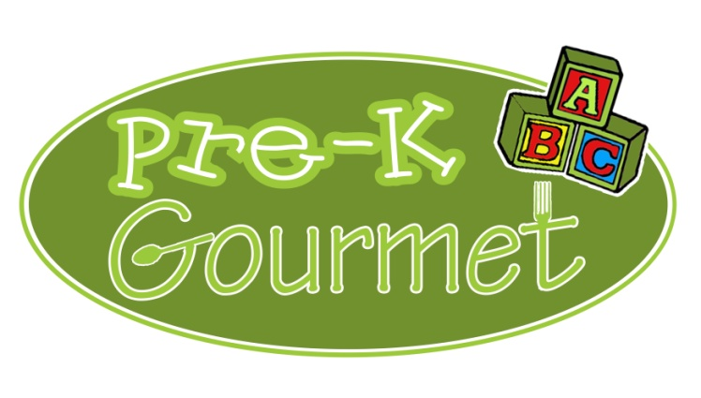

 **February 2020**

|  |  |  |  |  |
| --- | --- | --- | --- | --- |
| **MONDAY** | **TUESDAY** | **WEDNESDAY** | **THURSDAY** | **FRIDAY** |
| **3**  **Chicken noodle casserole**  **California vegetables**  **Apple sauce** | **4**  **Cheese quesadilla**  **Tossed salad/peas (T)**  **Pineapple** | **5**  **Beef Stroganoff**  **Carrots**  **Banana Half** | **6**  **Hot Turkey & Cheese sandwich on wheat bread**  **Green beans**  **Sliced Pears** | **7**  **Mini Cheese Pizza**  **Mixed Vegetables**  **Sliced Apples** |
| **10**  **Beefaroni**  **Green beans**  **Sliced Peaches** | **11**  **Chicken BBQ on a wheat roll**  **Sweet Potatoes & Green beans**  **Pineapple** | **12**  **Mac n Cheese**  **Carrots**  **Apple sauce** | **13**  **Beefy Mexican Rice Casserole**  **Tossed salad/peas (T)**  **Banana half** | **14**  **Chicken Fajitas**  **California Vegetables**  **Sliced Apples** |
| **17**  **Sloppy Joe on a wheat roll**  **Mixed Vegetables**  **Pineapple** | **18**  **Sweet & Sour Chicken Casserole**  **Green beans**  **Sliced Pears** | **19**  **Grilled cheese sandwich on wheat bread**  **Sweet Peas**  **Banana half** | **20**  **Whole wheat pasta w/meat sauce**  **Carrots**  **Apple sauce** | **21**  **BBQ Turkey sandwich on a wheat roll**  **Mashed Potatoes**  **Corn/Peas(T)** |
| **24**  **Veggie Mac ‘n’ cheese**  **California vegetables**  **Sliced Peaches** | **25**  **Lazy Lasagna**  **Green beans**  **Apple sauce** | **26**  **Beef soft tacos**  **Tossed salad/peas (T)**  **Fresh Watermelon** | **27**  **Hot Chicken Sandwich w/ gravy**  **Roasted Potatoes/Green Beans**  **Banana half** | **28**  **Mini Cheese Pizza**  **Carrots**  **Pineapple** |
|  |  |  |  | dglxasset[1] |

**!**