September 2020
Child’s Name
_________________________
Classroom
Date | 1 | 2 | 3 | 4
Sept. 8
Sept. 9
Sept. 10
Sept. 11
Sept. 14
Sept. 15
Sept. 16
Sept. 17
Sept. 18
Sept. 21
Sept. 22
Sept. 23
Sept. 24
Sept. 25
Sept. 28
Sept. 29
Sept. 30
_________________________

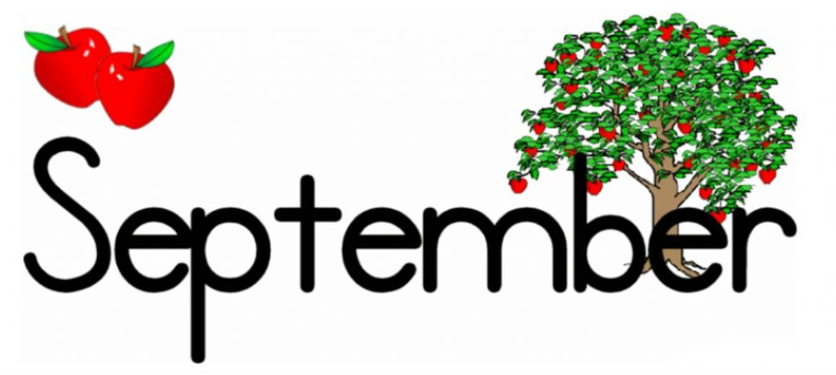
Monday | Tuesday | Wednesday | Thursday | Friday
 | 1  MENU DUE to OFFICE | 2 | 3 | 4
7  NO YUMMY LUNCHES  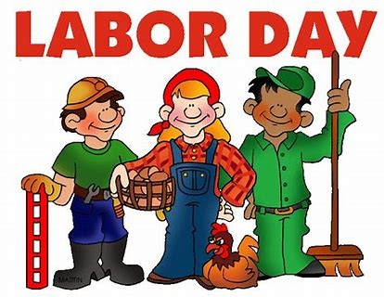  TODAY!! | 8  Baked Chicken Nuggets, Roasted Seasonal Veggies, Fresh Fruit  3 Cheese Pasta Bake, Roasted Seasonal Veggies, Fresh Fruit  Bagel w/Cream Cheese, Veggies & Hummus, Fresh Fruit  Turkey Sandwich, Veggie Chips, Fresh Fruit | 9  Arroz con Pollo, Baked Plantains, Fresh Fruit  Grilled Cheese, Roasted Seasonal Veggies, Fresh Fruit  Bagel w/Cream Cheese, Veggies & Hummus, Fresh Fruit  Turkey Sandwich, Veggie Chips, Fresh Fruit | 10  Korean Beef Bowl w/Rice, Sautéed Veggies, Fresh Fruit  Mac & Cheese, Roasted Seasonal Veggies, Fresh Fruit  Bagel w/Cream Cheese, Veggies & Hummus, Fresh Fruit  Turkey Sandwich, Veggie Chips, Fresh Fruit | 11  Havana Style Pulled Pork Cuban Sandwich, Veggie Chips, Fresh Fruit  Grilled Cheese, Roasted Seasonal Veggies, Fresh Fruit  Bagel w/Cream Cheese, Veggies & Hummus, Fresh Fruit  Turkey Sandwich, Veggie Chips, Fresh Fruit

Meals x $4.50 = ________
Paid by: check # _______
- Check off your child’s lunch order for each day (select a meal) with beverage of choice.
- Every day you have the option of Water (W), Milk (M), or Chocolate Milk (CM).
- Each meal is $5. A full menu for the month is $105
- Tear off and return the completed form by Monday September 1st.

Monday | Tuesday | Wednesday | Thursday | Friday
14  Low Fat Penne Alfredo w/ Chicken, Roasted Seasonal Veggies, Fresh Fruit  Baked Chicken Nuggets, Roasted Seasonal Veggies, Fresh Fruit  Bagel w/Cream Cheese, Veggies & Hummus, Fresh Fruit  Turkey Sandwich, Veggie Chips, Fresh Fruit | 15  Ground Turkey & Cheese Burrito, Black Beans, Roasted Seasonal Veggies, Fresh Fruit  Cheese Tortellini w/Olive Oil (Sauce on the Side), Roasted Seasonal Veggies, Fresh Fruit  Bagel w/Cream Cheese, Veggies & Hummus, Fresh Fruit  Turkey Sandwich, Veggie Chips, Fresh Fruit | 16  Philly Cheesesteak, Roasted Seasonal Veggies, Fresh Fruit  Grilled Cheese, Roasted Seasonal Veggies, Fresh Fruit  Bagel w/Cream Cheese, Veggies & Hummus, Fresh Fruit  Turkey Sandwich, Veggie Chips, Fresh Fruit | 17  Baked Fish Sticks w/Slaw (on the side), Roasted Potato Wedges, Fresh Fruit  Mac & Cheese, Roasted Seasonal Veggies, Fresh Fruit  Bagel w/Cream Cheese, Veggies & Hummus, Fresh Fruit  Turkey Sandwich, Veggie Chips, Fresh Fruit | 18  “Make Your Own Yummy…” Chicken Ramen w/Veggies, Broth, Fresh Fruit  Grilled Cheese, Roasted Seasonal Veggies, Fresh Fruit  Bagel w/Cream Cheese, Veggies & Hummus, Fresh Fruit  Turkey Sandwich, Veggie Chips, Fresh Fruit
21  Baked Chicken Nuggets, Roasted Seasonal Veggies, Fresh Fruit  Pasta w/Lean Beef Bolognese, Roasted Seasonal Veggies, Fresh Fruit  Bagel w/Cream Cheese, Veggies & Hummus, Fresh Fruit  Turkey Sandwich, Veggie Chips, Fresh Fruit | 22  Chicken Paella, Black Beans, Roasted Seasonal Veggies, Fresh Fruit  Pasta w/Pomodoro Sauce w/Chicken, Roasted Seasonal Veggies, Fresh Fruit  Bagel w/Cream Cheese, Veggies & Hummus, Fresh Fruit  Turkey Sandwich, Veggie Chips, Fresh Fruit | 23  Beef Barbacoa over Rice, Mexican Veggie Skillet, Fresh Fruit  Grilled Cheese, Roasted Seasonal Veggies, Fresh Fruit  Bagel w/Cream Cheese, Veggies & Hummus, Fresh Fruit  Turkey Sandwich, Veggie Chips, Fresh Fruit | 24  Maple Glazed Sliced Turkey, Roll, Roasted Seasonal Veggies, Fresh Fruit  Mac & Cheese, Roasted Seasonal Veggies, Fresh Fruit  Bagel w/Cream Cheese, Veggies & Hummus, Fresh Fruit  Turkey Sandwich, Veggie Chips, Fresh Fruit | 25  Chicken Tikka Masala w/Couscous, Roasted Seasonal Veggies, Fresh Fruit  Grilled Cheese, Roasted Seasonal Veggies, Fresh Fruit  Bagel w/Cream Cheese, Veggies & Hummus, Fresh Fruit  Turkey Sandwich, Veggie Chips, Fresh Fruit
Monday | Tuesday | Wednesday | Thursday | Friday
28  Baked Chicken Nuggets, Roasted Seasonal Veggies, Fresh Fruit  Low Fat Penne Alfredo & Chicken, Roasted Seasonal Veggies, Fresh Fruit  Bagel w/Cream Cheese, Veggies & Hummus, Fresh Fruit  Turkey Sandwich, Veggie Chips, Fresh Fruit | 29  Breakfast for Lunch—French Toast, Eggs, Lyonnaise Potatoes, Fresh Fruit  Baked Penne, Roasted Seasonal Veggies, Fresh Fruit  Bagel w/Cream Cheese, Veggies & Hummus, Fresh Fruit  Turkey Sandwich, Veggie Chips, Fresh Fruit | 30  Picadillo, Roasted Seasonal Veggies, Brown Rice, Fresh Fruit  Grilled Chicken & Cheddar Sandwich, Roasted Seasonal Veggies, Fresh Fruit  Bagel w/Cream Cheese, Veggies & Hummus, Fresh Fruit  Turkey Sandwich, Veggie Chips, Fresh Fruit

