Christmas Cheer week!
December 14-18

Monday: Rock your red and green

Tuesday: Holiday hat day

Wednesday: Ugly sweater or Christmas shirt day
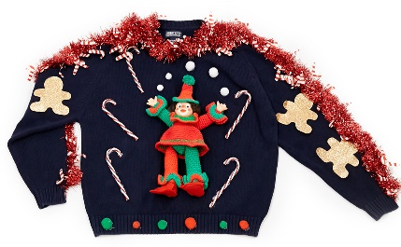

Thursday: Long Winter’s nap- Christmas PJ day
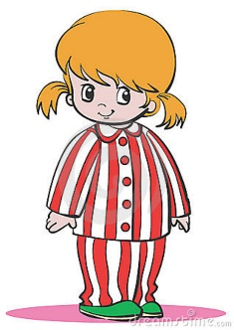
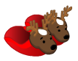

Friday: Elf yourself day
