Fun Valentine’s Day Themed Activities to Reinforce Math Skills
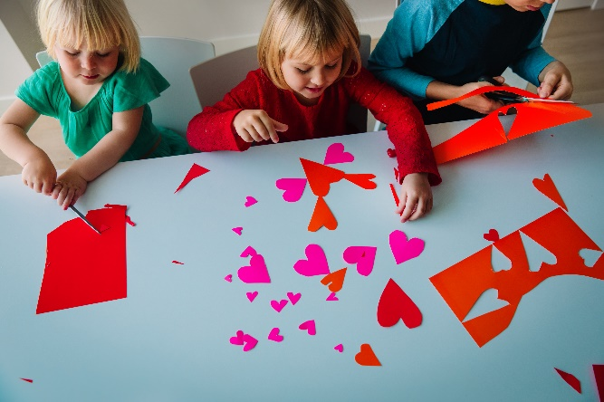
Continue the learning at home this month with these hands-on math activities inspired by Valentine’s Day! Your little one will have a blast practicing their math skills, thinking critically, and developing problem-solving strategies.
- Candy Hearts Addition Game
Provide your child with candy hearts and a simple addition problem written on an index card. Ask them to read the card and place the correct number of candy hearts in two piles. For example, if the problem is 3+4, your child should place 3 candy hearts in one pile and 4 candy hearts in another. Encourage them to count all the hearts to get a total.
- Red Smoothies
Spending time in the kitchen is a great way to practice counting, following instructions and measuring. Make a Valentine’s Day inspired smoothie with your child using a handful of ice, ½ cup raspberries, ½ cup strawberries, ½ banana and 1 cup yogurt. Ask your child to wash and measure the produce, count as he adds the ingredients to the blender, and press the “on” button.
- Sort and Compare Activity
Provide your child with small items in Valentine’s Day colors (i.e., red hearts, pink pom poms, white buttons). Ask them to sort the objects by color and compare the number of items in each group. Listen for words such as more than, less than and equal to.
- Bar Chart of Favorite Gifts
Give your child a piece of paper and crayons. Encourage them to ask family members which Valentine’s Day gift (i.e., flowers, candy or cards) they like the best. Ask your child to record the results on the bar chart to see which gift is the favorite.

