4 Indoor Wintery Activities to Do with Your Preschooler
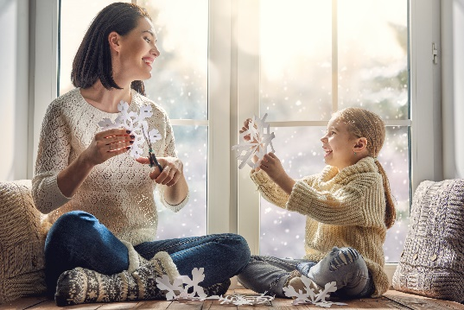
Are you stuck inside trying to figure out how to keep your little one busy this winter? Let him burn off some energy, while still actively learning, with these four fun indoor activities.
Cotton Ball Snowman
Draw a few large snowmen on paper, cut them out, and write a number in the middle of each. Provide your child with cotton balls, a glue stick, and the snowmen cut-outs. Encourage him to read the number and count as he glues on the appropriate amount of cotton balls. For older children, write simple addition or subtraction problems on the snowmen instead.
Ice Melting Experiment
Conduct a fun experiment to see where ice would melt the fastest inside your house. Place ice cubes in bowls in different rooms throughout your house (i.e. bedroom, kitchen, garage). Ask your child to predict which bowl of ice would melt the fastest.
Winter-Themed Books
Books are a great resource to teach your child about animals who live in cold climates and hibernation.
Some of our favorites include Never Touch a Polar Bear by Stuart Lynch (0-2 years), Gregory’s Shadow by Don Freeman (3-5 years), Sleep Big Bear Sleep by Maureen Wright (3-5 years), How Do Birds Find Their Way by Roma Gans (4-5 years), and Over and Under the Snow by Kate Messner (4-6 years).
Snowflake Garland
Provide your child with cupcake liners or coffee filters, safety scissors, markers, stickers, glitter glue, and ribbon. Fold the liners in triangles and make small cuts. Unfold the liners to see the unique snowflake design. Encourage your child to decorate the snowflakes and help him thread ribbon through each to make garland. Let your child decide where he’d like to hang his fun artwork.

