5 Fun Family Activities to Do Before the Summer Ends
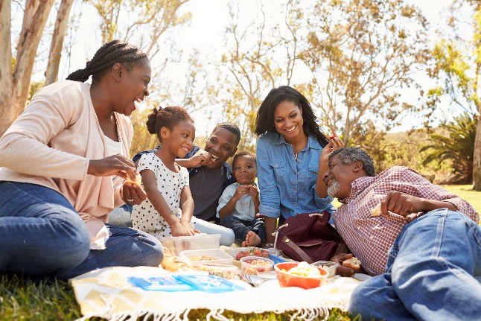
August can be bittersweet. Summer camps are coming to an end and the school year is starting soon. However, there’s still time to cross off the rest of your summer bucket list before the season ends.
Make great new memories by trying some of the activities below with your family.
Make Your Own Bubbles
Making bubbles is a fun science experiment for children of all ages. Gather 4 cups water, ½ cup sugar and ½ cup dish soap. Encourage your child to measure, whisk and pour the ingredients into a large bowl or tray. For additional fun, add a few drops of food coloring. Use this as an opportunity to discuss how colors combine to form new ones. Ask your child which color is their favorite.
Build a Backyard Obstacle Course
Obstacle courses are a great way to practice gross motor skills and balance. Use hula hoops, chairs, pool noodles, jump ropes and other materials found around your home. Ask your child to perform a certain task at each obstacle. For example, say “Hop over the pool noodle” or “Jump rope 10 times.” Set a timer and see which family member can complete the course the fastest.
Set up a Lemonade Stand
A lemonade stand allows your child to practice creativity, money skills, following directions and giving back to those in need. Set out art supplies and ask them to make a colorful sign for their stand. Work together to make and sell the lemonade to your neighbors and friends. When the sale is complete, donate the proceeds to a charity of your child’s choosing.
Grow Fresh Herbs
Decide which herbs you’d like to grow and take your child with you to purchase the seeds. Plant the seeds in mason jars, plastic cups or cans and place them on your porch or windowsill. Ask your child to help you water the herbs and measure how tall the plants are growing each week. Harvest the herbs together and use them in an upcoming family meal.
Picnic in the Park
Gather a blanket, your family’s favorite lunch and a frisbee or ball, and head to a nearby park. Set up a picnic with your family's favorite fruits and veggies. Take time to sample them and describe each flavor. Enjoy the fresh air and quality time with your loved ones and have fun!

