4 Children’s Books that Celebrate National Hispanic Heritage Month
National Hispanic Heritage Month (September 15 - October 15) recognizes and celebrates the positive impact and contributions of Hispanic Americans. In honor of this month, we’ve rounded up four children’s books that you can read together with your preschooler that explore the culture and traditions of the Hispanic community.
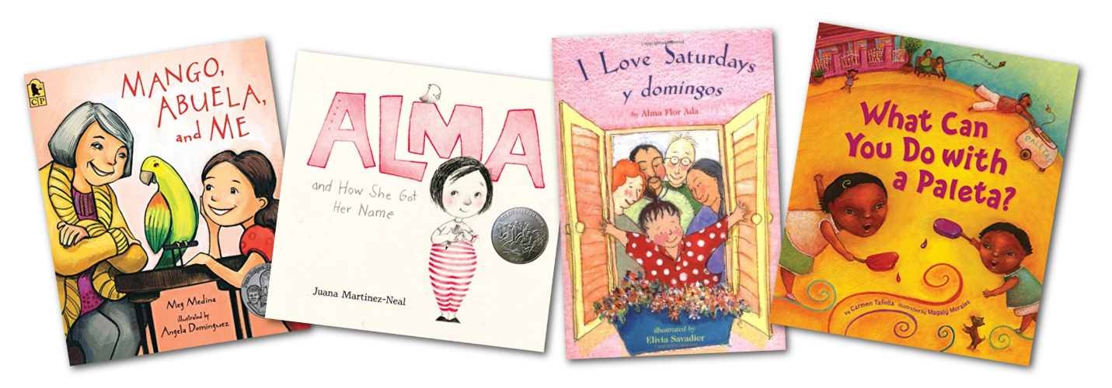
- Mango, Abuela, and Me by Meg Medina
Mango, Abuela, and Me is a heartwarming story about a grandmother and granddaughter relationship. Mia’s grandmother comes to visit Mia and her family, but she doesn’t speak English. With help from a parrot, Mia and her grandmother teach each other their languages and get to know each other more.
- Alma and How She Got Her Name by Juana Martinez-Neal
Names are an important part of our identify, but Alma Sofia Esperanza Jose Pura Candela thinks hers is too long. After speaking with her father about her long name, she learns the history behind it and grows proud of her ancestry. This book teaches children about self-esteem and what makes them unique and special.
- I Love Saturdays y domingos by Alma Flor Ada
The little girl in this story has very exciting weekends. On Saturdays, she visits her Grandma and Grandpa who come from a European-American background. On Sundays, she visits her Abuelito and Abuelita who are Mexican American. Although the two sets of grandparents are different, the love for their granddaughter is the same.
- What Can You Do with a Paleta? By Carmen Tafolla
The main character introduces readers to a paleta, a frozen, fruit-flavored treat, and all the fun things you can do with one. The vivid illustrations will keep your little one engaged as you read this book together. There is some Spanish used throughout, which helps children learn vocabulary while learning the importance of community and Hispanic heritage.

