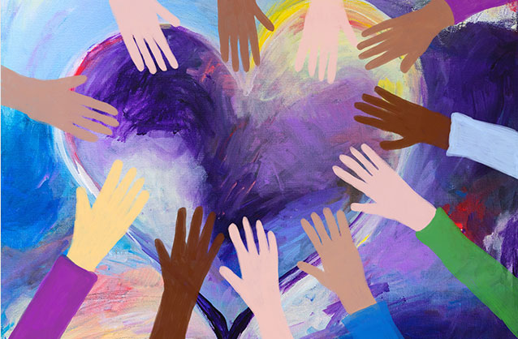
Meaningful Ways to Celebrate Martin Luther King, Jr.
With Your Preschooler
January is a great time to reflect on the important work of Martin Luther King, Jr. Although we explore diversity and inclusion all year, we have many activities planned this month to celebrate his life specifically. We’ll be reading books, making arts and crafts, discussing the importance of acceptance and belonging, and much more.
Continue the fun at home by participating in some of our ideas below.
- Perform an Act of Service
Honor the work of Martin Luther King Jr. by spreading kindness and compassion. Some ideas include donating winter accessories to your local homeless shelter, baking cookies for a neighbor, or making cards for loved ones needing a smile.
- Read About His Accomplishments
Books are a great way to learn about Martin Luther King, Jr. and the theme of equality in a way your child can understand. Age-appropriate titles include, “Happy Birthday, Martin Luther King, Jr.” by Jean Marzollo, “The Story of Martin Luther King, Jr.” by Johnny Ray Moore, and “I am Martin Luther King, Jr.” by Brand Meltzer. After reading, ask your child to discuss their own hopes and dreams.
- Host a Birthday Party
Children love and can relate to birthday parties, so host one to celebrate Martin Luther King, Jr.! Ask your child to help you bake a birthday cake, talk about kindness, sing songs, make decorations, and watch snippets of the “I Have a Dream Speech.”
- Help Your Child Understand and Respect Differences
Martin Luther King, Jr. believed that everyone, no matter skin color, should be treated equally. Reinforce this message at home by reading some of our favorite stories: “Whoever You Are” by Mem Fox, “The Colors of Us” by Karen Katz, and “All Are Welcome” by Alexandra Penfold.

