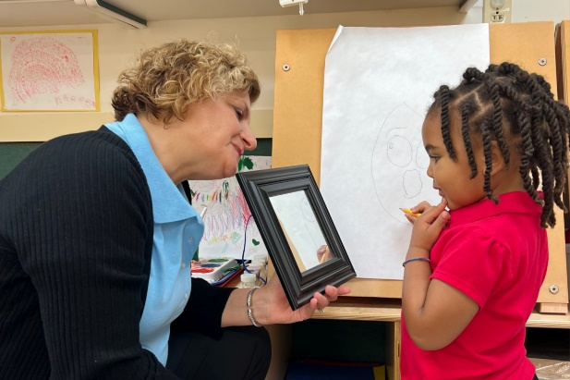
What Diversity, Inclusion, and Belonging Looks Like in Our Classrooms
Children learn best, develop self-confidence, and thrive when they feel valued and supported. Because of this, diversity, inclusion, and belonging are hallmarks of our school community. Our teachers strive to cultivate learning environments that foster respect and acceptance and encourage students to learn from and with each other.
Our classrooms contain a range of materials to provoke children’s questions, ideas, and attitudes about their own identities and about differences and similarities among others. Items in our classrooms highlight each student's culture in a positive way and include rich literature that holistically reflect the students in the classroom community and showcase diverse family structures, dolls with various skin tones, a variety of art and musical instruments from other countries, music in multiple genres and languages, and culturally diverse dramatic play props.
Below are some specific examples of what diversity, inclusion, and belonging looks like in each of our classrooms.
Infants (0-1 year)
A common activity in our Infant classroom is looking at similarities and differences in front of a mirror. For example, the teacher may say, “Liam, you have big brown eyes! Let’s look at Zoey’s reflection. Look! She has big green eyes!” Teachers may also adhere pictures of the children’s families to the mirror and talk about the photographs while viewing the reflections in the mirror.

Toddlers (1-2 years)
In our Toddler classrooms, we listen to songs that celebrate diversity, such as “Dance Tunes from Many Lands” by Ella Jenkins. Teachers provide multicultural instruments (maracas, drums, rain sticks, chimes), ribbons, and scarves, and encourage the children to dance along to the music while discussing the different rhythms, tempos, and lyrics.

Beginners (2-3 years)
We ask our Beginner students to bring in props from home that relate to personal experiences, such as empty food containers they enjoy sharing with their family or pieces of clothing that represent their family’s heritage. Teachers place these props in the dramatic play center for students to use while sharing and interacting with their peers.

Intermediates (3-4 years)
Intermediate teachers encourage students to bring in family photos. Teachers cut the portraits into interconnecting pieces varying in size and amount, meeting the needs of the individual students. All the puzzles are placed in the manipulative center for independent student exploration. This activity incorporates diversity, inclusion, and belonging, while also reinforcing mathematical skills of problem-solving and reasoning.

Pre-K (4-5 years)
In our Pre-K classrooms, we ask students to bring in pictures of a special family celebration, meal, or tradition. Students glue their picture to a piece of paper and are encouraged to discuss the photo and write or draw about the photo underneath. Teachers collect all the pictures to create a classroom book titled, “Our Family Memories.”

