4 Books to Read with Your Preschooler
During National Hispanic Heritage Month

National Hispanic Heritage Month (September 15 to October 15) is a time to honor the cultures and contributions of American citizens whose ancestors came from Spain, Mexico, the Caribbean, and Central and South America. Books are an easy and interactive way to expand your child’s awareness and appreciation of Hispanic culture. Below are four of our favorite titles to read this month.
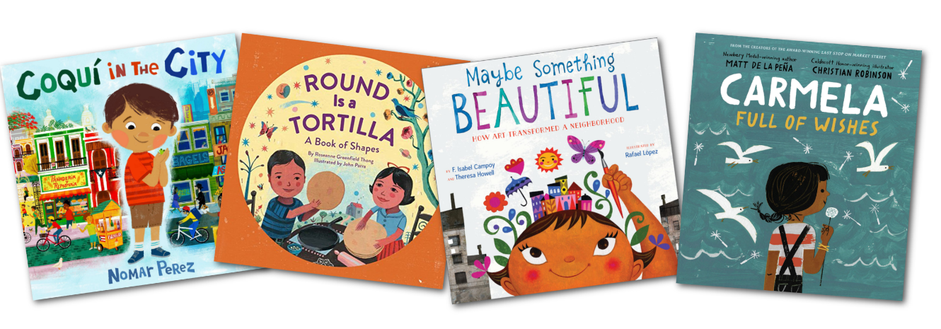

Coquí in the City by Nomar Perez
Coqui in the City is a book about a little boy named Miguel who lives in San Juan, Puerto Rico with his parents and pet frog, Coquí. Miguel learns that his family is moving to New York City, and he’ll have to leave Coquí behind. Miguel realizes that his new home is more like Puerto Rico than he originally thought. Read along as he finds a way to keep his heritage and his love for Coquí with him as he explores his new neighborhood.

Round is a Tortilla: A Book of Shapes by Roseanne Greenfield Thong
Your child will enjoy reading this multicultural book all about shapes! Round is a Tortilla features shapes found in a child’s typical day paired with colorful illustrations, rhyming text, and Spanish vocabulary appropriate for preschool-aged children.

Maybe Something Beautiful: How Art Transformed a Neighborhood by F. Isabel Campoy and Theresa Howell
Based on the true story of San Diego’s Urban Art Trail, Maybe Something Beautiful features a gray, urban community and a little girl named Mira. Mira loves art and is delighted when a muralist comes to visit. Together, they bring color, joy, and smiles, and truly transform the neighborhood through art.

Carmela Full of Wishes by Matt de la Peña
Carmela Full of Wishes is a vibrant picture book with the themes of hope and perseverance. The story opens with Carmela who wakes up on her birthday and is thrilled to now be old enough to accompany her brother as he runs errands. They visit different parts of their neighborhood, including a bus stop, repair shop, panadería, and laundromat. At the laundromat, Carmela finds a dandelion and makes a wish.

