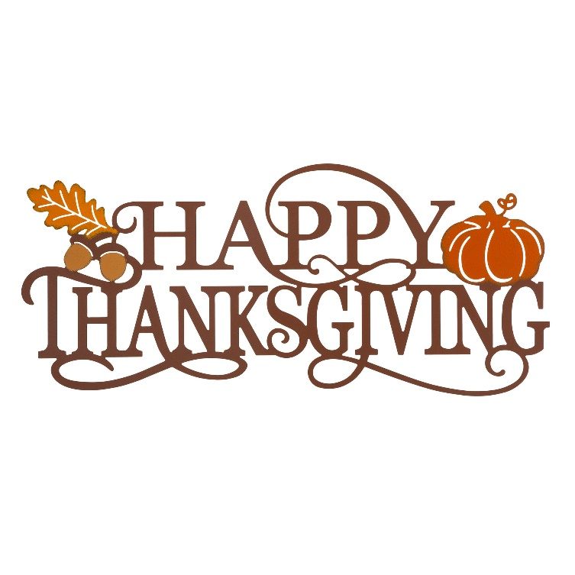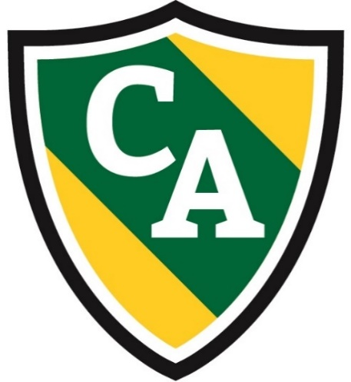

Dear Chesterbrook Academy Families,

It crazy to think how 2022 is already flying by and we are getting ready to fly into November. This is a very exciting time at Chesterbrook Academy as we get to talk about amazing topics including the changing of weather, leaves changing colors, being grateful, what does Thanksgiving mean, and all about election day!

Some friendly reminders for our families:

* Please ensure you take the time to check your child’s cubby to ensure that your child has appropriate clothing for the weather. Our goal is to go outside two times a day, so we want to ensure children have weather appropriate clothing.
* Please ensure you are taking the time to look at your child’s daily report on the Links 2 Home app or in your email. Our staff are working hard to give you insights in your child’s daily development. We also post notifications for families of items your child might need including diapers, etc.
* Please remember that Chesterbrook Academy is a Peanut free school. We want to ensure the safety of all our children and will not be able to serve items that contain Peanut Butter.
* Attached is our monthly Menu and Activity Calendars.

Starting the first week of November, signup sheets will be on classroom doors for the week of Thanksgiving. We ask that you share with us your child’s schedule for this week so we can ensure we staff appropriately for all the days. Chesterbrook Academy is open on Black Friday.

Chesterbrook Academy is **CLOSED** for teacher in-service day on November 11th.

Have a great day,

Mr. Zach

**Help decorate our lobby!**

Help our friend Tom the Turkey not get eaten for Thanksgiving Dinner! With your child, please disguise the turkey however you want and return to school by **November 18th**! We will decorate our lobby with all the turkeys.

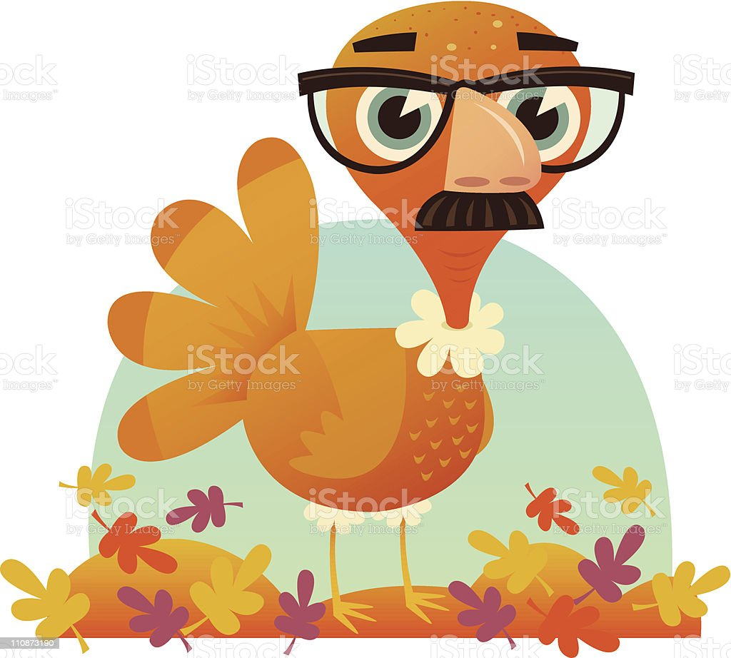

**Principal News**

November 2022