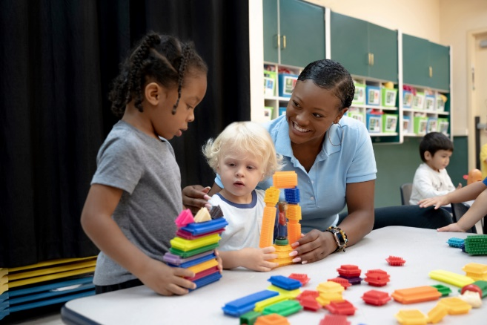
What Scientific Exploration Looks Like in Our Preschool Classrooms
Soda bottle geysers and volcanoes made from baking soda and vinegar might be just some of the things that come to mind when you think about science education for young children. It’s important to note that even simpler activities and everyday experiences can introduce children to scientific concepts and help them gain an understanding of how things work.
Science also helps children to develop important life skills, such as communication, collaboration, perseverance, analytical reasoning, and most importantly, a sense of wonder. We believe science education is critical in the preschool years, and we do so by tapping into children’s natural curiosities to explore the world around them.
Below are ways we foster this in each of our classrooms.

Toddlers (1-2 years)
The Scientific Exploration component of our curriculum begins in our Toddler classroom. Teachers provide toys and materials that allow toddlers to experiment with cause and effect, such as buttons that push to make a sound, knobs that twist to open, and levers that slide open to make an object appear.

Beginners (2-3 years)
Our Beginner students begin to explore engineering concepts. They design and build small structures using various materials, such as toothpicks and playdough or craft sticks and small paper cups. As students design and build, teachers ask open-ended prompts, including, “Tell me about what you made” or “What are you going to do with your new structure?”

Intermediates (3-4 years)
While our Intermediate students are engaged in science activities, teachers offer a variety of tools and technology to support and enrich the learning. For example, when learning about living things, they may explore with magnifying glasses, paper, and writing utensils. While studying the Earth’s environment, students may use balances, thermometers, rain gauges, and sifters.

Pre-K (4-5 years)
Students in our Pre-K classrooms love learning about different animals and their life cycles. After reading related books, students use playdough, paper, and writing utensils to create a 3-D representation of the life cycle of their choosing. They label the different stages and share their unique models with their classmates. Afterward, they write about the life cycle in their science journal.

