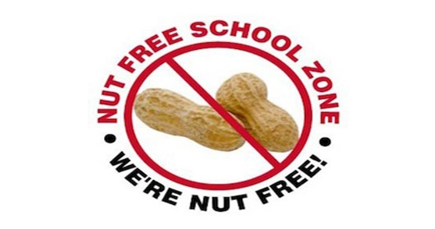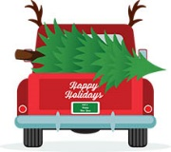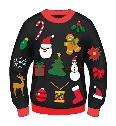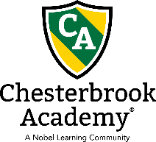

Holiday Parties/ Performances

We will be having Christmas performances Friday December 16th

Classroom parties will start at 3:00pm and snack signup sheets will be posted on classroom doors.

Reminder:

We are a nut free facility so please do not bring in any food items that may contain nuts or processed in a facility with nuts.

Friday Spirit Days

**December 2nd** - Green and Red Day

**December 9th**- Holiday Pajama Day

**December 16th**- Ugly Sweater Day

**December 23rd** – Christmas Hat Day

Important Dates:

**December 5th – 9th –** Parent Teacher Conferences

**December 16th:** Classroom Party at 3pm

**December 23rd -** Close at 12pm

**December 26th -** CLOSED – Merry Christmas

**December 30th –** Closed at 3pm

Chesterbrook Academy 6210 Multiplex Drive, Centreville, VA 20121 703-968-2939

**December 2022 Newsletter**

Winter Break Camp

The public schools are closed from 12/19 – 12/30 but we are open and will be running Winter Break Camp for our school age students!

**Camp Pricing:**

**5 days: $273**

**4 days: $246**

**3 days: $197**

**2 day: $155**

There is a Winter Camp form at the front desk to fill out if you are enrolling your school ager. Please contact Ms. Heather or Ms. Jessica if you have any questions.

Christmas Spirit Week

**December 12th – December 16th**

**Monday December 12th:** Snowflake Day

**Tuesday December 13th:** Candy Cane day; wear red, white, or stripes

**Wednesday December 14th:** Dress like a Christmas tree

**Thursday December 15th:** Dress like a Present

**Friday December 16th:** Ugly Christmas Sweater Day

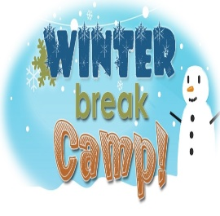



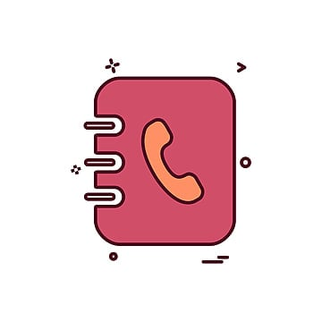

Contact List

**Heather Hyland**

Principal

[Heather.hyland@chesterbrookacademy.com](mailto:Heather.hyland@chesterbrookacademy.com)

**Jessica Kim**

Assistant Principal

[Jessica.Kim@chesterbrookacademy.com](mailto:Jessica.Kim@chesterbrookacademy.com)

**Adrienne Nwude**

Regional Director

[anwude@springedugroup.com](mailto:anwude@springedugroup.com)

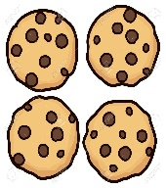

Change of Clothes

As the weather is getting colder, please make sure to dress your child in appropriate clothes and bring extra clothes for their cubbies (extra jacket/sweater, hat, mittens, socks, long pants, and shirts).

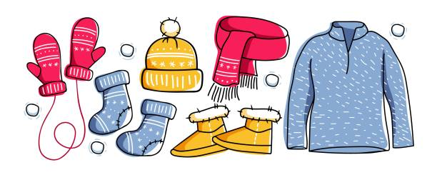

Holiday and Birthday Celebrations

A few reminders about holiday and birthday celebrations. As much as we love homemade treats we as that families please refrain from bringing anything that is homemade. Food items that are store bought need to nut free and not processed in a facility that contains nuts. Also, treats such as cookies or cakes need to be individual servings so that it is easy to distribute to the class.

Parent Statements

End of the year statements can be accessed through ALMA. Please let us know if you need help accessing your account.

