The World is Evolving and So Has Our Curriculum
Our goal has always been to provide a learning environment that fosters curiosity and creativity and prepares children for kindergarten and beyond. We evaluate our proprietary curriculum, Links to Learning, regularly to ensure that we continue delivering the program students need.
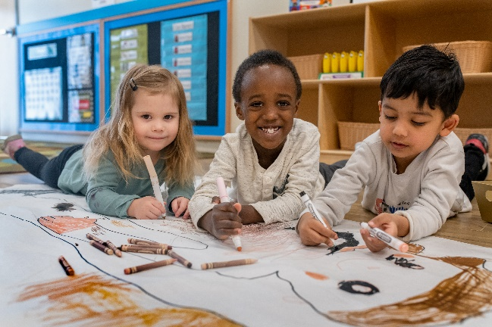
We know that the world is constantly evolving, and the skills children need today are different from what they were even a few years ago. Because of this, we’ve made the following important enhancements to our curriculum.
- Children have more opportunities to practice social-emotional skills.
Social-emotional learning has always been a hallmark of our curriculum, as these skills are just as important as foundational academic skills. We want our students to be happy, thriving, and making friends. Due to the impact of the COVID-19 pandemic, we’ve added even more hands-on activities for children to practice setting goals, problem solving, developing self-confidence, and sharing. As always, our teachers help children by modeling appropriate behaviors, giving effective praise, and providing verbal and visual cues.
- Children participate in more hands-on activities to provoke questions and attitudes about themselves and others.
When children feel emotionally and physically safe, they are more likely to take on challenges and be more comfortable in their learning. We’ve always been steadfast in our commitment to designing classrooms and teaching strategies that support diversity, inclusion, and belonging. We’ve added more items to help facilitate that learning, such as dolls with various skin tones, puzzles and games depicting various cultures, musical instruments from other countries, and culturally diverse dramatic play props.
- We’ve enhanced skills throughout all subject areas to further prepare children for elementary school and beyond.
We’ve integrated more opportunities during the day for your child to strengthen the muscles needed for writing across various subject areas. This includes activities to exercise fine motor skills and hand-eye coordination using safety scissors, tweezers, tongs, and paint brushes. We’ve also adapted a spiralized approach to our Spanish curriculum, meaning that teachers will introduce new vocabulary while reviewing the vocabulary learned in younger classrooms. Children have opportunities to practice Spanish during transitions, centers, and even in outdoor learning experiences.
- We’ve updated our family communication pieces.
We place a premium on making sure our families know what skills their child is working on, how they’re progressing, and what they’re loving most. We’ve included a QR code in our End of the Month folders so families can see digitally all the skills and goals their child achieved that month. Continuing the learning at home is now even easier with our refreshed Baby Sign Language poster, Spanish posters, and activity letters. Our Links 2 Home app and Family Reports have also been updated to give teachers space to showcase how each child is practicing social-emotional skills and the progress they are making.

