Splash-tastic Adventures:
Multi-Sensory Water Activities for Preschoolers

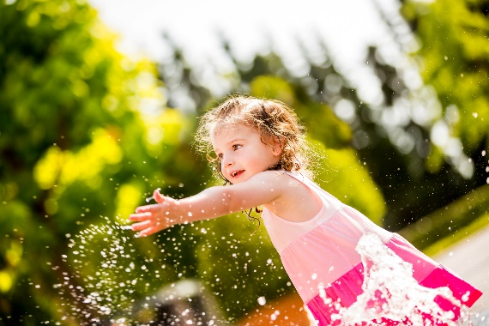
From splashing in puddles to playing with water toys, children love exploring the world of water. It may get messy, but the benefits are worth it. Water play serves as an excellent tool for promoting fine motor skills, hand-eye coordination, and sensory awareness, as well as opportunities for social interaction, taking turns, and sharing materials.
Our teachers leverage the fun of water to reinforce a variety of skills. For instance, students explore the science of melting ice cubes in the warm sunshine. We engage them in critical thinking by asking questions like, “What do you think will happen when we put the ice cube in the sun?” or “How long do you think it will take for the ice cube to melt?” Then, we discuss the results and encourage the students to reflect on the properties of water and the effects of temperature.
In addition to exploring the science of melting ice, we offer opportunities for students to engage in activities that tap into their desire to imitate grown-up tasks. For example, teachers may encourage them to participate in an interactive toy car wash using a bucket of soapy water, toy cars, and a clean towel to dry. This activity reinforces fine motor skills, while instilling a sense of responsibility and independence.
Continue the learning at home with these fun water activities that can be customized for children of any age.

1. Water Obstacle Course
Set up an obstacle course in your backyard or a safe outdoor area using different water play stations. Include activities like crawling under a sprinkler, tossing water balloons into a bucket, and stepping over shallow trays of water. This activity promotes gross motor skills, coordination, and following instructions.

2. Ice Excavation
Freeze small toys or figurines in ice using plastic containers or ice cube trays. Once frozen, place the ice blocks in a large tray. Equip your child with tools like spray bottles filled with warm water, spoons, or toy hammers to melt and excavate the toys from the ice. This engaging activity encourages your child to apply problem-solving skills as they discover new ways to release their frozen treasures.

3. Floating Boats
Foster creativity and engineering skills while experimenting with buoyancy this summer. Challenge your child to design and build their own boats using materials like foam sheets, plastic containers, popsicle sticks, and tape. Once their boats are complete, provide a small tray or inflatable pool filled with water for a boat race. Encourage your child to use straws to create wind to make their boat move across the water.

4. Water Painting
Looking for a mess-free art activity this summer? Provide your child with large paintbrushes and a bucket of water. Go outside and let them “paint” on a sidewalk or fence using the water. Watch as their art creations appear and then disappear in the heat.

