Little Social Butterflies: Tips for Raising a Socially Savvy Preschooler
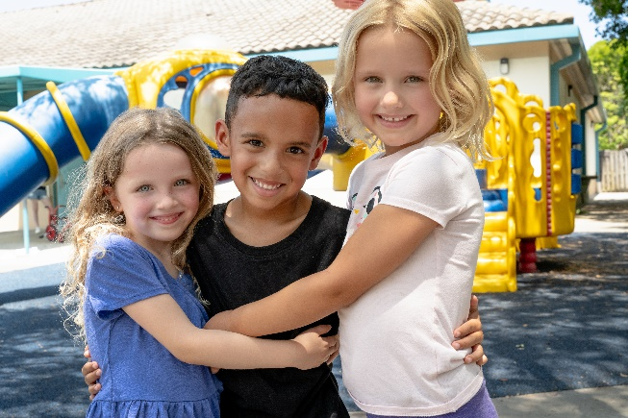
We all want our children to grow up happy, healthy, and thriving – and building strong social skills is a key part in achieving this. At our preschool, we recognize that sharing, making friends, and problem-solving are crucial components for a child’s overall development. That’s why our Links to Learning curriculum is focused on building these skills!

In our classrooms, we strive to incorporate social interactions into every aspect of our students’ schedule and routines. Our teachers implement a variety of techniques, such as using emotion charts to showcase different feelings, displaying photo prompts throughout the classroom to encourage sharing, and facilitating games that require taking turns. Additionally, our teachers serve as role models, demonstrating gratitude and socially appropriate behaviors throughout the school day.

Building strong social skills is an ongoing process that extends beyond the classroom. To help you continue building these skills at home, we’ve put together five simple and fun activities.

- Encourage purposeful play
Purposeful play is an excellent opportunity to boost your child’s social skills. Encourage them to work on activities with you that involve teamwork and communication, such as building towers with blocks, working on a puzzle, or making crafts together. Not only will your child develop important problem-solving skills, but their creativity and imagination will also flourish through playtime.

- Model sharing behavior
Children learn from the behaviors of the adults around them. You can model sharing by offering your child a piece of your snack or sharing a toy with them. Use positive language to describe the behavior, such as “It’s so fun to share my snack with you” or “Sharing makes me feel happy.” When your child sees your actions, they are more likely to follow suit and learn to share with others.

- Introduce the concept of a “worry can”
A “worry can” is a helpful visual tool that can help build your child’s communication skills by encouraging them to express their fears in a positive way. Decorate a special can together, then ask your child to write or draw their worries on a piece of paper and place them in the can. Together, have an open and honest conversation about their worries and help them problem-solve any issues they may have.

- Roleplay different social situations
Roleplaying is a great way to address specific issues, such as shyness or difficulty making friends. By practicing social skills in a safe environment, children can become more comfortable and confident in different situations. To get started, introduce yourself to your child and ask them to do the same. Encourage them to say their name, age, and something they like. Provide positive feedback to boost their confidence.

- Read books about emotions
Books can help your child learn to identify and express their feelings, recognize emotions of others, and manage emotions (i.e., deep breathing or counting to 10). While reading, discuss how the characters feel and ask your child how they would feel in a similar situation. Some of our favorite books include The Color Monster by Anna Llenas, The Way I Feel by Jenan Cain, and Big Feelings by Alexandra Penfold.

