Math on the Move: Vacation Activities to Sharpen Early Math Skills

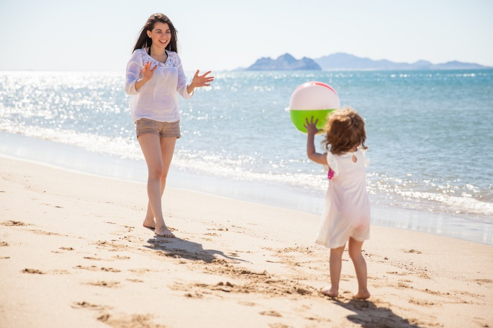
Summer is a wonderful time for children to discover the hidden mathematical wonders that surround them. In our classrooms, teachers aid in cultivating math skills by incorporating them into daily routines and engaging activities. They encourage students to observe and discuss patterns found on the playground, graph their favorite vacation spots, and participate in math scavenger hunts.
This summer, as you embark on vacations or road trips, you can continue supporting your child’s math skills by turning these experiences into fun and educational opportunities. Below are some ideas. Get ready to go on a mathematical adventure together!
Infants (0-1 year)
Engage your baby in an activity that combines sensory exploration and counting. While at the beach, encourage them to feel the texture of the sand by saying, "Let’s feel the sand. It's so soft and grainy." Incorporate counting by finding seashells. Count them aloud by saying, "Let's see how many seashells we found. One, two, three!"
Toddlers (1-2 years)
Roll or throw a ball back and forth with your toddler. Count each time the ball leaves their hands. Begin with counting from one to three, and gradually increase the count as your child becomes more comfortable. Encourage them to actively say the numbers aloud as they catch and throw the ball.
Beginners (2-3 years)
Play a game of “I Spy” on your next road trip to help your child observe patterns and practice their observation skills. Encourage them to point out objects found during the drive. For example, ask them to find a red and black car, a tall green tree, and a yellow sign.
Intermediates (3-4 years)
Take your child on a nature walk to collect materials such as leaves, sticks, and rocks. Encourage your child to sort the materials into different categories and then count each item in each category. Record the findings in a bar graph to determine which material was the most and least collected.
Pre-K/Pre-K 2 (4-5 years)
While shopping for your vacation essentials, give your child coupons and ask them to help you find the pictured items in the store. It’s a fun scavenger hunt, as well as a great opportunity for you to talk about money. Say the price of the items as you place them into your cart, for example, “Goggles are usually $10 each, but we save $2 by using a coupon.”

