Raising Thankful Kids: 5 Books to Instill
Gratitude in Your Preschooler

Building a sense of gratitude in young children is an essential part of their development. Through our Links to Learning curriculum, we continuously strive to cultivate an environment where appreciation is nurtured all year round. As we approach this joyous holiday season, we are particularly reminded of the significance of fostering an attitude of gratitude in our students and incorporate hands-on lessons related to empathy, kindness, and giving back.

A great way to continue the learning at home is through meaningful conversations with your child. Consider asking questions such as, "What made you smile today?" or "What are some ways we can show our friend that we are thankful for them?” and "What are you thankful for today?"

Books also provide an excellent platform for nurturing gratitude and inspiring discussions with your child. Take a look at some of our favorites below.

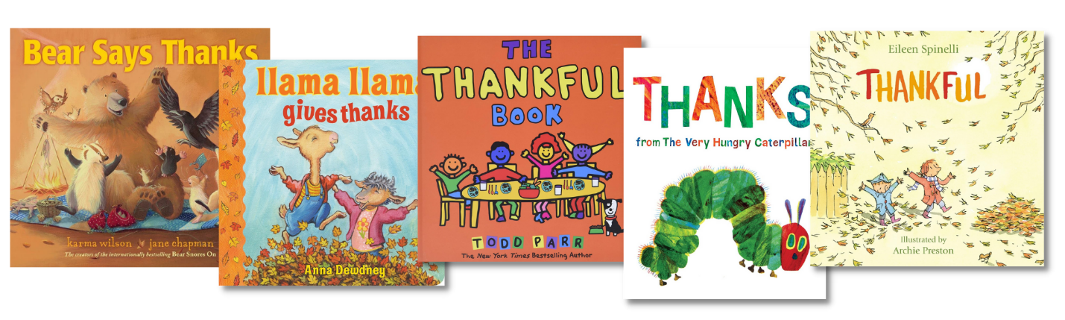

Bear Says Thanks by Karma Wilson
Your child will love the rhythmic text and engaging plot of Bear Says Thanks. Seamlessly weaving together the themes of sharing and thankfulness, this book follows Bear as he discovers the true meaning of gratitude. As Bear navigates his day, various situations prompt him to reflect on the significance of expressing appreciation for others.

Llama Llama Gives Thanks by Anna Dewdney
If your child loves the Llama Llama books, this is a perfect story to read together this season. Llama Llama embarks on a journey to discover the true meaning of Thanksgiving, guided by the loving support of family and friends. The book encourages readers to embrace the spirit of gratitude during the holiday season and beyond.

The Thankful Book by Todd Parr
This enchanting book from Todd Parr not only fosters a sense of thankfulness, but also encourages children to embrace diversity and empathy. From the sunshine to our food, this story emphasizes the importance of acknowledging the wonderful things around us. It’s a timeless reminder to appreciate the little blessings that make life extraordinary.

Thanks From the Very Hungry Caterpillar by Eric Carle
Eric Carle’s iconic collage-style illustrations vividly capture the wonders of nature and the joy of friendship, inviting young readers to cherish the beauty of the world around them. Join the beloved Hungry Caterpillar as he encounters a host of animals, navigates the changing seasons, and learns to give thanks for the simple joys each moment brings.

Thankful by Eileen Spinelli
Thankful beautifully highlights the importance of showing appreciation for the people who enrich our communities, from dedicated gardeners to selfless firefighters, whose contributions sometimes go unnoticed. With its charming rhyming text and whimsical illustrations, this book reminds us to cherish the small joys that fill our days.

