November Newsletter
A Note from Our Principal
Dear Families,
This month, we will embark on a journey of fostering connections and celebrating cherished family traditions, as we nurture the spirit of Thanksgiving and togetherness. Our preschoolers will be engaged in activities that inspire gratitude and kindness, such as creating festive crafts, sharing personal experiences, and learning about the importance of giving back to our community.

Thank you for entrusting us with the care and education of your children. We look forward to another month of joy and learning!
Sincerely,
Debbie Dry

Family Survey Reminder
Our enrolled family survey launched in October. If you have not received the email, please let us know so we can request it be resent. The survey provides the opportunity for you to give us feedback anonymously on our strengths and areas we can work on. Survey closes November 17.

Family Referral Bonus
Do you know a colleague who has recently had a baby, a friend in need of care who just relocated to the area, or a family member who is seeking a new preschool for their child? When you refer a friend and they enroll, you’re eligible for a free week of tuition. Ask us for details!
Cubby Refresh
As a reminder, please make sure to refresh the spare clothing in your child’s cubby. Take home anything that no longer fits and leave a spare set of well-fitting, weather-appropriate clothes.
Did You Know?
Children’s first communities are their home and their school — safe havens where they are supported and nurtured as they learn their own strengths and abilities and gain confidence.

American Indian & Alaska Native Heritage Month
November is American Indian & Alaska Native Heritage Month. It is a time to honor their culture, accomplishments, and contributions. When children acknowledge and appreciate diverse cultures, they are helping to build a community of belonging and inclusion. We will be celebrating in our classrooms by reading books with Native American characters and exploring nature which is an important part of the Native American culture!
Special Upcoming Visits from our Sister Elementary School!
This month one of the Kindergarten at our Chesterbrook Academy Elementary and Middle School, just down the street at 130 Towne Village Drive will visit our school on Nov. 1. She'll engage our Pre-K students in a robust discussion about the First Day of Kindergarten. We are thrilled to have an opportunity for students to participate in these rich learning experiences and get to know one of kindergarten teacher at our local Chesterbrook Elementary School. We will also have the art teacher to visit us on Nov. 10, and she will led the students in an art activity.
Important Dates
November 10 - School CLOSED for Professional Development & Veterans Day
November 23-24 - School CLOSED for Thanksgiving
November 30 - End-of-month folders go home
New On Our Preschool Blog
Splash-tastic Adventures:
Multi-Sensory Water Activities for Preschoolers

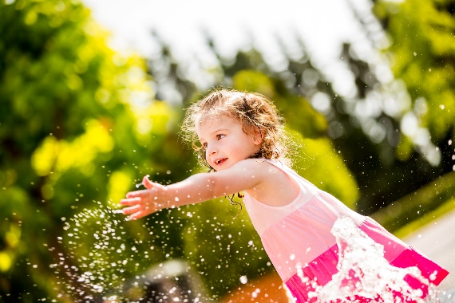
From splashing in puddles to playing with water toys, children love exploring the world of water. It may get messy, but the benefits are worth it. Water play serves as an excellent tool for promoting fine motor skills, hand-eye coordination, and sensory awareness, as well as opportunities for social interaction, taking turns, and sharing materials.
Our teachers leverage the fun of water to reinforce a variety of skills. For instance, students explore the science of melting ice cubes in the warm sunshine. We engage them in critical thinking by asking questions like, “What do you think will happen when we put the ice cube in the sun?” or “How long do you think it will take for the ice cube to melt?” Then, we discuss the results and encourage the students to reflect on the properties of water and the effects of temperature.
In addition to exploring the science of melting ice, we offer opportunities for students to engage in activities that tap into their desire to imitate grown-up tasks. For example, teachers may encourage them to participate in an interactive toy car wash using a bucket of soapy water, toy cars, and a clean towel to dry. This activity reinforces fine motor skills, while instilling a sense of responsibility and independence.
Continue the learning at home with these fun water activities that can be customized for children of any age.

1. Water Obstacle Course
Set up an obstacle course in your backyard or a safe outdoor area using different water play stations. Include activities like crawling under a sprinkler, tossing water balloons into a bucket, and stepping over shallow trays of water. This activity promotes gross motor skills, coordination, and following instructions.

2. Ice Excavation
Freeze small toys or figurines in ice using plastic containers or ice cube trays. Once frozen, place the ice blocks in a large tray. Equip your child with tools like spray bottles filled with warm water, spoons, or toy hammers to melt and excavate the toys from the ice. This engaging activity encourages your child to apply problem-solving skills as they discover new ways to release their frozen treasures.

3. Floating Boats
Foster creativity and engineering skills while experimenting with buoyancy this summer. Challenge your child to design and build their own boats using materials like foam sheets, plastic containers, popsicle sticks, and tape. Once their boats are complete, provide a small tray or inflatable pool filled with water for a boat race. Encourage your child to use straws to create wind to make their boat move across the water.

4. Water Painting
Looking for a mess-free art activity this summer? Provide your child with large paintbrushes and a bucket of water. Go outside and let them “paint” on a sidewalk or fence using the water. Watch as their art creations appear and then disappear in the heat.

