Little Hands, Big Hearts: Benefits of Teaching Children about Giving Back

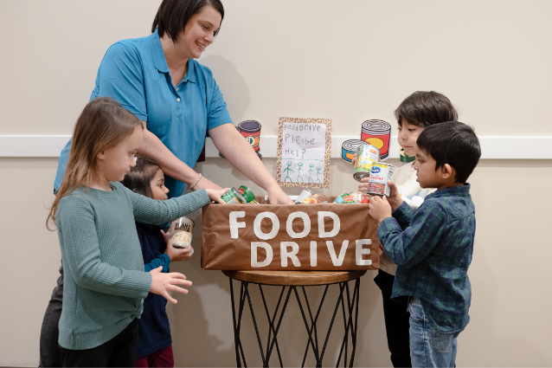
The holiday season is not just about festive decorations and presents. It’s a time to reflect on the past year, learn about different traditions, and most importantly, instill a spirit of charity.

Giving back is an integral part of our school. Whether we’re collecting food, toys, gifts, or clothing… it’s amazing how much joy simple acts of kindness can bring.

Here are just a few of the many lifelong benefits of involving children in giving initiatives.

Develops a sense of community
Giving back to those in need instills a sense of communal responsibility and provides children with tangible examples of how their actions directly affect others. Making holiday cards, for example, becomes more than a craft; it becomes a heartfelt gesture to bring joy to neighbors who may feel isolated during the holiday season. Children learn that their contributions, no matter how small, are integral to the well-being of the larger community.

Fosters empathy and gratitude
Empathy and gratitude are paramount to social-emotional development. When students participate in giving initiatives, they begin to understand the needs of others and the importance of compassion and kindness.
This exposure in the preschool years sets the stage for a lifelong positive and appreciative mindset.

Builds important life skills
Our students plan their community service events from brainstorm to implementation and learn valuable life skills, including teamwork, problem-solving, communication, and responsibility. These skills contribute to the development of well-rounded individuals. Not only are they academically prepared for what comes next, but they also exhibit social consciousness and work collaboratively to make a difference in their world.

Encourages a sense of pride
Successfully completing a service project instills a sense of pride and self-esteem in our students. When they recognize that their contributions have left a positive impact, it boosts their confidence and reinforces the notion that their actions matter.

