Four Must-Read Books for Children This Black History Month
Black History Month is an annual celebration of achievements by African Americans and a time for recognizing their central role in U.S. history. In our classrooms, students will learn about local and influential African Americans through engaging books, learning experiences, and thoughtful discussions.

Below are four age-appropriate books to read with your child to continue the celebration and conversation. These stories not only entertain, but also serve as windows into the diverse and inspiring narratives that make Black History Month a time of reflection, learning, and unity.

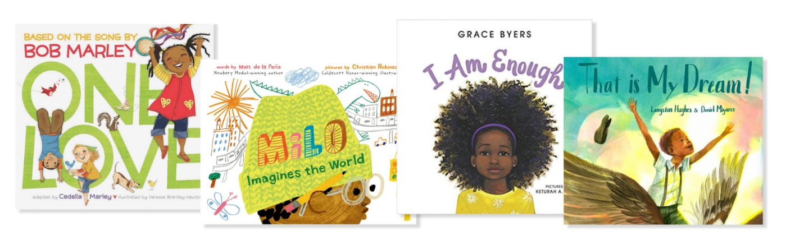
One Love by Cedella Marley (ages 1-3 years)
Adapted from Bob Marley’s hit song, One Love reimagines the iconic tune for a new generation of children. The book is filled with colorful pictures and introduces themes of unity, joy, and the beauty of coming together as one. One Love is more than a story; it’s a shared celebration of positivity and solidarity that will resonate with both you and your child.

Milo Imagines the World by Matt de la Peña (ages 3+ years)
Milo Imagines the World tells the story of Milo who rides the subway with his sister and imagines a life beyond the train – a world filled with wonders and adventures. He uses his creativity and thinks about the lives of everyone he encounters, including a boy in a suit, a man doing crossword puzzles, and a woman wearing a wedding dress. Milo soon realizes that you can’t really know anyone just by looking at their face.

I Am Enough by Grace Byers (ages 3+ years)
This story celebrates the beauty of diversity and empowers children to embrace their individuality, build self-confidence, and recognize their worth. With an important message and vibrant illustrations, I Am Enough showcases the importance of navigating life’s ups and downs and trying again after failure.

That is My Dream by Langston Hughes (ages 4+ years)
That is My Dream is a picture book adaptation of Hughes’ acclaimed poem “Dream Variations”. It brings readers on a journey of one African American boy’s day, how he is treated differently, and his dream of a more united world. Through vivid illustrations and poetic storytelling, this book sparks meaningful discussions about equality, hope, and diversity.

