Exploring Valentine’s Day at School and at Home
Valentine’s Day is a favorite holiday among our students. They love exchanging cards and treats with their classmates and participating in all the themed activities we plan throughout the month.

Activities include learning about different types of flowers typically given for the holiday, how to care for them, and where they are grown. Students also learn about the postal service and practice their writing skills by making and mailing cards. We also integrate conversations and books about kindness, friendship, and family throughout our day.

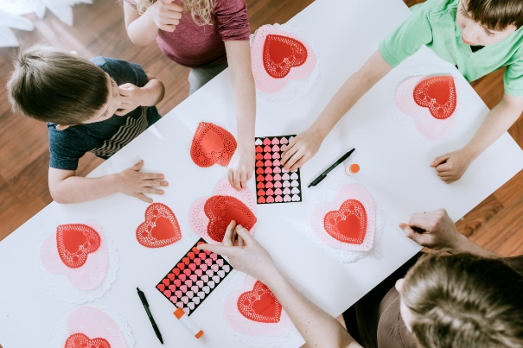
Below are four activities to continue the learning and fun at home with your little one.

Sink the Candy Heart Boat
For this fun sink vs. float experiment, you'll need a bucket or tray filled with water, candy conversation hearts, and lightweight plastic containers. Place the containers in the water and ask your child to guess how many candy conversation hearts will sink the container. Encourage your child to count as they fill the container one candy heart at a time. They may find that the container sinks faster depending on where the candy hearts are placed!

Sponge Painting
Create colorful heart prints using sponges and paint. Cut heart shapes out of sponges and provide them to your child along with pink, white, and red paint. Ask them to pick up the sponge, dip it into the paint, and press it onto paper to create festive prints. This is a great project to foster creativity and to practice fine motor skills. Encourage older children to use the prints to create Valentine’s Day cards for family or friends.

Indoor Heart Hopscotch
Put your child’s balance and gross motor skills to the test by playing a fun game of hopscotch. Gather markers, 10 pieces of construction paper, and painter’s tape. Draw a large heart on each piece of paper, add a number from 1-10 inside each heart, and tape it to the floor to create a hopscotch board. You can make the game as easy or difficult as you’d like. Some ideas include asking your child to say the numbers aloud as they hop, jumping over specific numbers, or encouraging them to create their own game.

Valentine’s Day Books
Valentine’s Day is a perfect time to reinforce themes of love, kindness, friendship, and acceptance through books. Some of our favorites include, Llama Llama I Love You by Anna Dewdney, The Day It Rained Hearts by Felicia Bond, The Night Before Valentine’s Day by Natasha Wing, and Little Blue Truck’s Valentine by Alice Schertle.

